SET09115 – Introduction to Graphics Programming

Contents

Lesson 1 Getting Started with GLFW 1

1.1 Getting Started 1

1.2 Downloading GLFW 1

1.3 Creating a New Visual Studio Project 1

1.3.1 Visual Studio Property Sheets 3

1.4 Your First GLFW Application 6

1.4.1 Setting Clear Colour 9

1.4.2 Checking Keyboard Input 9

1.4.3 Clearing the Screen and Swapping the Buffer 9

1.5 Exercises 10

Lesson 2 Drawing a Triangle 11

2.1 Working with Old-Style OpenGL 11

2.1.1 Drawing a Triangle 11

2.2 Exercise 12

Lesson 3 Drawing a Quad 14

3.1 With Triangles 14

3.2 With Quads 14

3.3 With Triangle Strips 15

3.4 With Lines 16

3.5 With Line Strips 16

3.6 Exercise 17

Lesson 4 Transformations 18

4.1 Vectors 18

4.1.1 Adding Vectors 18

4.1.2 Scaling Vectors 18

4.1.3 Length of a Vector 18

4.1.4 Normalising a Vector 19

4.1.5 Dot Product 19

4.1.6 Cross Product 20

4.2 Matrices 21

4.2.1 Adding 21

4.2.2 Scaling 21

4.2.3 Multiplying 21

4.3 Transformation Matrices 23

4.3.1 Translation 23

4.3.2 Rotation 23

4.3.3 Scale 23

4.3.4 Combining Matrices 24

Lesson 5 Getting Started with GLM 25

5.1 Rotating Triangle 25

5.2 Exercises 28

Lesson 6 Moving Quad 29

6.1 Initial Render Code 29

6.2 Using a Position 30

6.3 Translating the Quad 30

6.4 Exercises 31

Lesson 7 Challenge – Point Based Sierpinski Gasket 32

7.1 What is the Sierpinski Gasket 32

7.2 Getting Started 32

7.3 Generating Points 33

7.3.1 Challenge 33

7.4 Rendering the Points 33

7.5 Exercises 34

Lesson 8 Drawing a Cube 35

8.1 Working with Projection 35

8.2 Using GLM 35

8.2.1 Initialise Method 35

8.3 Rendering a Cube 36

8.4 Adding Depth 38

8.5 Exercises 39

Lesson 9 Transforming the Cube 40

9.1 Translating the Cube 40

9.2 Rotating the Cube 41

9.3 Scaling the Cube 42

9.4 Exercises 44

Lesson 10 Indices 45

10.1 What is Indexing? 45

Lesson 11 Indexed Cube 46

11.1 Defining Our Cube 46

11.2 Initialisation 47

11.3 Rendering 47

11.4 Exercises 48

Lesson 12 Challenge – Sierpinski Gasket 2 49

12.1 Getting Started 49

12.2 Challenge Part 1 50

12.3 Challenge Part 2 51

12.4 Challenge Part 3 51

Lesson 13 Quaternions 52

13.1 Why use Quaternions? 52

13.2 What are Quaternions? 52

13.3 Using Quaternions to Represent Rotation 53

13.4 Combining Rotations 53

13.4.1 Quaternion Multiplication 53

13.5 Converting a Quaternion to a Matrix 54

13.6 GLM to the Rescue 55

Lesson 14 Rotating Cubes with Quaternions 56

14.1 Getting Started 56

14.2 Update Code 56

14.3 Render Code 56

14.4 Exercises 57

Lesson 15 Generic Geometry Structure 58

15.1 Creating a Geometry Structure 58

15.2 Using the Geometry Structure 58

15.3 Rendering 59

15.4 Exercises 60

Lesson 16 Generic Object Structure 61

16.1 Transformation Structure 61

16.2 Render Object Structure 62

16.3 Updated Application 62

16.4 Exercises 64

Lesson 17 Box 65

17.1 Updating the Geometry.h File 65

17.2 Implementing createBox 65

17.3 Main Application 66

17.4 Exercises 67

Lesson 18 Tetrahedron 68

18.1 Updating Geometry 68

18.2 Main Application 69

18.3 Exercises 70

Lesson 19 Pyramid 71

19.1 Geometry Files 71

19.2 Updating Main Application 72

19.3 Exercises 72

Lesson 20 Disk 73

20.1 Disk from Triangles 73

20.2 Working out Triangle Vertices 73

20.3 Getting Started 74

20.4 Exercises 75

Lesson 21 Cylinder 76

21.1 Cylinder from Triangles 76

21.2 Getting Started 76

21.3 Updating Main 77

21.4 Exercises 78

Lesson 22 Sphere 79

22.1 Getting Started 79

22.2 Using a Sphere 80

22.3 Exercises 80

Lesson 23 Torus 81

23.1 Getting Started 81

23.2 Using a Torus 82

23.3 Exercise 83

Lesson 24 Plane 84

24.1 Getting Started 84

24.2 Using a Plane 84

24.3 Exercise 85

Lesson 25 Challenge – 3D Sierpinski Gasket 86

25.1 Getting Started 86

25.2 Challenge Part 1 86

25.3 Challenge Part 2 87

Lesson 26 Using GLEW 88

26.1 Getting GLEW 88

26.2 New Default Application 88

Lesson 27 Shaders 91

27.1 What is a Shader? 91

27.2 How do Shaders Work? 91

27.2.1 Why Shaders are Fast? 92

27.3 Shader Types 92

27.3.1 Vertex Shader 92

27.3.2 Geometry Shader 92

27.3.3 Pixel (or Fragment) Shader 92

27.4 GLSL 93

27.5 Using Shaders 93

27.5.1 Compiling Shaders 94

27.5.2 Compilation Problems 94

27.5.3 Linking Programs 95

27.5.4 Linking Problems 95

27.6 Further Reading 95

Lesson 28 Loading Shaders in OpenGL 96

28.1 Shader Header File 96

28.2 Shader Code File 96

28.3 Simple Vertex Shader 98

28.4 Simple Fragment Shader 99

28.5 Test Application 99

28.5.1 Initialisation 99

28.5.2 Render 100

28.5.3 Clean Up 100

28.6 Exercises 101

Lesson 29 Your First Shader Program – Colours 102

29.1 Modifying render_object 102

29.2 Colour Vertex Shader 102

29.3 Colour Fragment Shader 102

29.4 Main Application 103

29.5 Exercises 105

Lesson 30 Your Second Shader Program – Transformations 106

30.1 Updated render_object 106

30.2 Vertex Shader 106

30.3 Fragment Shader 107

30.4 Main Application 107

30.5 Exercises 109

Lesson 31 Doing OpenGL Properly: Working with Buffers 110

31.1 Defining a Vertex Array Object 110

31.2 Updated transform.vert 112

31.3 Render 112

31.4 Exercises 113

Lesson 32 Buffered Cube 114

32.1 Updated Geometry Structure 114

32.2 Updating Create Box 115

32.3 Rendering the Cube 116

32.4 Exercises 117

Lesson 33 Updated Geometry 118

33.1 Updated Tetrahedron 118

33.2 Updated Pyramid 118

33.3 Updated Disk 119

33.4 Exercise 119

Lesson 34 Lighting 120

34.1 What is Lighting? 120

34.2 Light Source 120

34.3 Materials 120

34.3.1 Scattering 121

34.3.2 Absorption 121

34.4 Sensors 121

34.5 Recommended Reading 122

Lesson 35 Ambient Light 123

35.1 Examples 123

35.2 Ambient Light Equation 123

Lesson 36 Your Third Shader Program – Ambient Light 124

36.1 Ambient Vertex Shader 124

36.2 Ambient Fragment Shader 124

36.3 Updating Main Application 125

36.3.1 Main Application Variables 125

36.3.2 Initialisation 125

36.3.3 Update 126

36.3.4 Render Object 126

36.4 Exercise 127

Lesson 37 Diffuse Light 128

37.1 Examples 128

37.2 Diffuse Lighting Equation 128

Lesson 38 Normals 131

38.1 What is a Surface Normal? 131

38.2 Calculating Surface Normals 131

Lesson 39 Box Normals 132

39.1 Box Normals 132

39.2 Updating Geometry Structure 132

39.3 Updating Create Cube 133

Lesson 40 Your Fourth Shader Program – Diffuse Light Attempt 1 135

40.1 Diffuse Vertex Shader 135

40.2 Diffuse Fragment Shader 136

40.3 Updating the Main Application 136

40.3.1 Variables 136

40.3.2 Initialisation 136

40.3.3 Update 137

40.3.4 Render Object 138

40.4 Exercise 139

Lesson 41 Diffuse Light Attempt 2 140

41.1 Updated Vertex Shader 140

41.2 Updated Main 140

41.3 Exercises 141

Lesson 42 Calculating Normals for All 142

42.1 Tetrahedron 142

42.2 Pyramid 143

42.3 Disk 145

42.4 Cylinder 146

42.5 Sphere 147

42.6 Torus 148

42.7 Exercises 150

Lesson 43 Challenge – Lit Sierpinski Gasket 151

Lesson 44 Specular Light 152

44.1 Specular Lighting Equation 152

Lesson 45 Your Fifth Shader Program – Specular Light 154

45.1 Specular Vertex Shader 154

45.2 Specular Fragment Shader 155

45.3 Updating Main 155

45.4 Exercises 157

Lesson 46 Combined Lighting 158

46.1 Vertex Shader 158

46.2 Fragment Shader 159

46.3 Exercises 159

Lesson 47 Phong Shading 160

Lesson 48 Your Sixth Shader Program – Phong Shading 161

48.1 Phong Vertex Shader 161

48.2 Phong Fragment Shader 161

48.3 Exercises 163

Lesson 49 Materials and Lights 164

49.1 Adding a Material Structure 164

49.2 Adding a Lighting Structure 164

49.3 Shader Class 165

49.3.1 Shader Constructor 165

49.3.2 Shader Destructor 166

49.4 Set Material and Lighting 166

49.5 Updating Main Application 167

49.5.1 Updating Render 167

Lesson 50 Uniform Blocks 170

50.1 What are Uniform Blocks? 170

50.2 New Phong Fragment Shader 171

50.3 Updating the Main Application 172

50.3.1 Updating Shader 173

50.3.2 Updating Main 174

50.4 Exercise 175

Lesson 51 Challenge – Sphere by Subdivision 176

51.1 Technique 176

51.2 Getting Started 177

51.3 Implementation 177

51.4 Exercise 178

Lesson 52 Point Light 179

52.1 What is a Point Light? 179

52.2 Point Light Equation 179

52.3 Point Light Vertex Shader 179

52.4 Point Light Fragment Shader 180

52.5 Updating the Main Code Base 181

52.5.1 Updating Shader 181

52.5.2 Updating Main 182

52.6 Exercises 185

Lesson 53 Spot Light 186

53.1 What is a Spot Light? 186

53.2 Spot Light Equation 186

53.3 Spot Light Vertex Shader 186

53.4 Spot Light Fragment Shader 187

53.5 Updating the Main Code Base 188

53.5.1 Updating Main 189

53.6 Exercises 192

Lesson 54 Emissive Light 193

54.1 What is Emissive Light? 193

54.2 Updated Shaders 193

54.3 Updated Code Base 194

Lesson 55 Refactor Time 197

55.1 Components 197

55.2 Architecture 197

55.2.1 Render Object 197

55.2.2 Lighting 199

55.2.3 Effect 201

55.2.4 Overall Architecture 202

55.2.5 Overall Operation 202

55.3 Effect 203

55.4 Transform 208

55.5 Geometry 208

55.6 Material 210

55.7 Render Object 210

55.8 Light 211

55.9 Multi-Light Shader 213

55.9.1 Multi-Light Vertex Shader 213

55.9.2 Multi-Light Fragment Shader 213

55.10 Main 217

55.11 Exercises 223

Lesson 56 Using Config Files 224

56.1 Getting Boost 224

56.2 Scene Code 224

56.2.1 Helper Methods 225

56.2.2 Load Geometry 227

56.2.3 Load Materials 228

56.2.4 Load Transform 228

56.2.5 Load Object 229

56.2.6 Load Lighting 229

56.2.7 Loading Dynamic Lighting 230

56.2.8 Load Scene 230

56.3 JSON Files 231

56.3.1 Structure of JSON Files 231

56.3.2 Checking JSON Files 231

56.3.3 JSON File for the Scene 232

56.4 Updated Main Application 235

56.5 Exercises 237

Lesson 57 Cameras 238

57.1 What Do We Mean by Cameras? 238

57.2 Why Do We Need Cameras? 238

Lesson 58 Camera Class 239

58.1 Exercises 239

Lesson 59 Target Camera 240

59.1 Target Camera Definition 240

59.2 Target Camera Implementation 240

59.3 Updating Main 240

59.4 Exercise 243

Lesson 60 First Person Camera 244

60.1 First Person Camera Definition 244

60.2 First Person Camera Implementation 244

60.3 Updating Main 245

60.4 Exercise 246

Lesson 61 Arc Ball Camera 247

61.1 Arc Ball Camera Definition 247

61.2 Arc Ball Camera Implementation 248

61.3 Updating Main 248

61.4 Exercise 250

Lesson 62 Chase Camera 251

62.1 Chase Camera Definition 251

62.2 Chase Camera Implementation 251

62.3 Updating Main 252

62.4 Exercise 253

Lesson 63 Challenge – 3D Sierpinski Gasket 2 254

Lesson 64 Texturing 255

Lesson 65 Getting Started with DevIL 256

Lesson 66 Texture Coordinates 257

Lesson 67 Better Box Texture Coordinates 258

Lesson 68 Textured and Lit 259

Lesson 69 Multiple Shader Files 260

Lesson 70 Calculating Texture Coordinates 261

Lesson 71 Textured and Lit Scene 262

Lesson 72 Multi-texturing 263

Lesson 73 Blended Textures 264

Lesson 74 Mipmaps 265

Lesson 75 Anisotropic Filtering 266

Lesson 76 Texture Class 267

Lesson 77 Error Handling 268

Lesson 78 Refactor Time 2 269

Lesson 79 Tiled Texturing 270

Lesson 80 Dissolve Shader 271

Lesson 81 Cell Shading 272

Lesson 82 Cube Maps 273

Lesson 83 Skyboxes 274

Lesson 84 Reflective Skybox 275

Lesson 85 Tarnished 276

Lesson 86 Point Sprites 277

Lesson 87 Framebuffer Objects 278

Lesson 88 Renderbuffer Objects 279

Lesson 89 Texture Buffer Objects 280

Lesson 90 Post-processing 281

Lesson 91 Outputting to Memory 282

Lesson 92 Your First Post-process – Greyscale 283

Lesson 93 Using gDebugger 284

Lesson 94 Your Second Post-process – Blur 285

Lesson 95 Masking 286

Lesson 96 Normal Mapping 287

Lesson 97 Displacement Mapping 288

Lesson 98 Shaders in Scene Files 289

Lesson 99 Procedural Texture Generation 290

Lesson 100 Challenge – Checked Texture 291

Lesson 101 Terrain 292

Lesson 102 Water Effects 293

Lesson 103 Stencilling 294

Lesson 104 Shadowing 295

Lesson 105 Shadow Maps 296

Lesson 106 Meshes 297

Lesson 107 Procedural Mesh Generation 298

Lesson 108 Mesh Hierarchies 299

Lesson 109 Transforming Meshes 300

Lesson 110 Loading OBJ Models 301

Lesson 111 Using AssIMP 302

Lesson 112 Picking 303

Lesson 113 Frustum Culling 304

Lesson 114 Particle Effects 305

Lesson 115 Geometry Shaders 306

Lesson 116 Instancing 307

Lesson 117 Procedural Content 308

Lesson 118 Soft Body Effects 309

Lesson 119 Scene Graphs 310

Lesson 120 OpenGL Frameworks – Using OpenSceneGraph 311

Lesson 121 Spatial Partitioning 312

Lesson 122 Ambient Occlusion 313

Lesson 123 Fractals 314

Lesson 124 Noise 315

Lesson 125 Havok 316

Lesson 126 Scripting with Lua 317

Lesson 127 Tessellation 318

Lesson 128 Animation 319

Lesson 129 Ray Tracing 320

Lesson 130 Volumetric Rendering 321

Lesson 131 Marching Cubes 322

Lesson 132 OpenCL 323

References 324

# Getting Started with GLFW

## Getting Started

This is the first lesson for the graphics programming module, and we will start by setting up our runtime environment. In this module we will be using a number of different libraries which you can download and use for any future OpenGL applications. The main advantage with the approach we are taking is that it is generally platform independent (our approach can be used on Windows, Linux and Apple operating systems). However, in this module, we will consider that you are using Windows as a platform, and Visual Studio as a development tool. For other platforms and tools, please see the relevant documentation from the websites of the libraries we will be using, and the relevant documentation of the tools you are using. To get started, we will be downloading and using the GL Framework (GLFW).

## Downloading GLFW

GLFW is available from <http://www.glfw.org/>. From here, select the **Download** link, and download the relevant version for your platform. I will assume that you are downloading for Windows, which is available as a pre-built library on the GLFW website (under Binary Archive for Windows). This will provide you with a ZIP archive. Download this file, and unzip it, placing it somewhere sensible. I put the libraries that I work with in a folder with the address C:\Users\Kevin\Libraries.

## Creating a New Visual Studio Project

Start Visual Studio 2010 from the Start Menu. Once Visual Studio has started, you should see the following screen:



Now, select **File->New Project** from the menu, and find the entry for creating a new **Win32 Console Application** under the **Visual C++** heading:

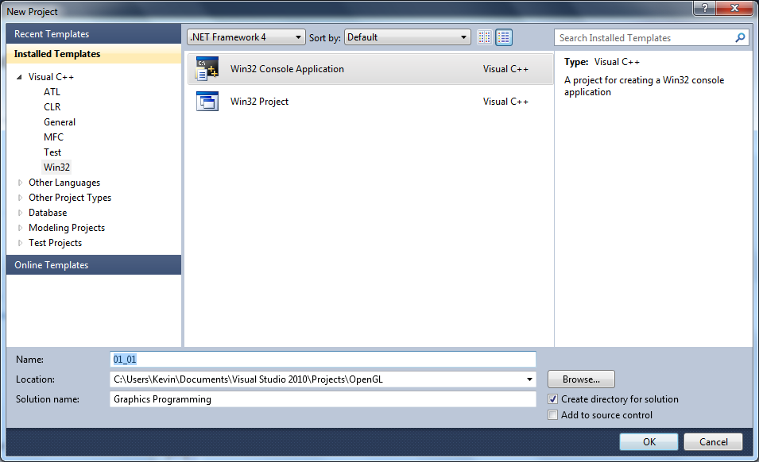

Call the project whatever you want, but you probably want to be systematic about your naming mechanism for the entire module. Once you've given the project a name, click **OK**.

On the next window, simply click **Next**.

You should now see the following window:

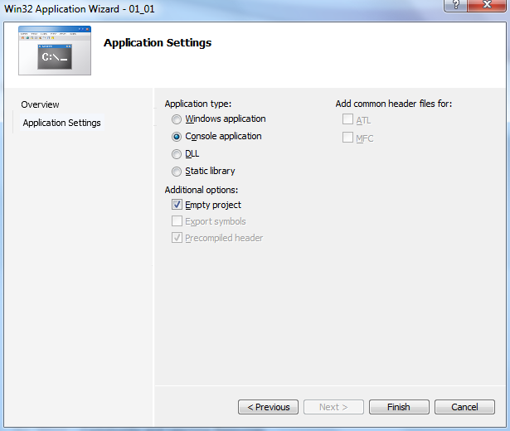

Make sure that you change your settings on this screen to the same as above. **This is very important**. We are essentially saying that we are creating a Console application, and we do not want Visual Studio to create any extra files for us. Click **Finish** and Visual Studio will create your project for you. Now we need to do some setup so that we can use GLFW.

### Visual Studio Property Sheets

You might be familiar with using external libraries using C# in Visual Studio, where we have to tell Visual Studio what library to use, and where to find it. For C++ programs, we need to tell it Visual Studio two different pieces of information - the location of our header files (where operations and classes are declared) which is usually in a folder called **include**, and also the location of our library files (where actual existing compiled code exists) which is usually in a folder called **lib**. Now, we are going to do this in a reusable manner, so that once we have done the set up once, we can use it in our future projects.

In Visual Studio, find the **Property Manager** window, which is usually attached to the **Solution Explorer**. Make sure your project is selected in this window, and select the **Add New Project Property Sheet** button:



This will bring up the new property sheet dialogue:

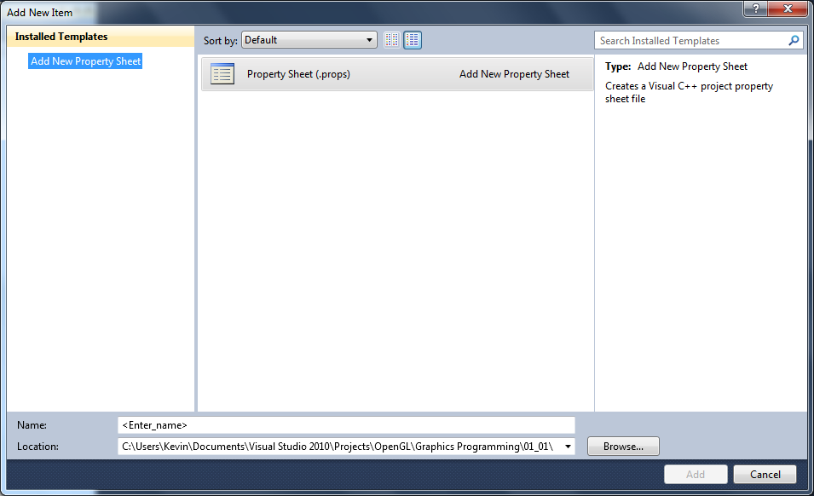

For the location entry, enter somewhere sensible again. I use the same location as I placed the unzipped GLFW files (C:\Users\Kevin\Libraries). Call the file **OpenGL** and click **Add**. This should make your Property Manager window look as follows:



**Double-click** the **OpenGL** entry to allow us to edit the property sheet. This will bring up the following window:

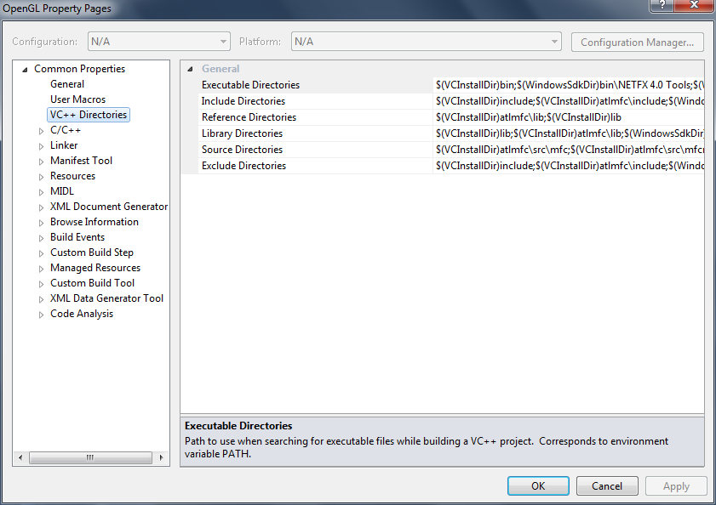

Select VC++ Directories on the left of the window. We are now going to modify two of the entries you see on the right - the **Include Directories** and the **Library Directories** entries. First, select the Include Directories entry and press the click the small triangle and select **Edit**.

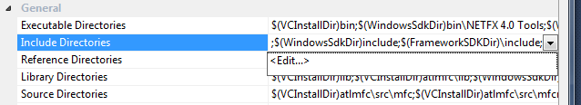

You will now see a new window which allows you to add entries to your Include Directories entry.

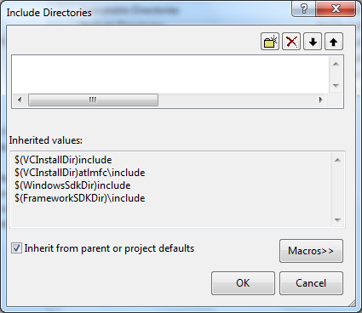

Click the **New Line** button (the little yellow folder with a star) and this will allow you to enter a new entry. **Click** the little button with three dots, and then **browse** to the location of the **Include** folder where you put GLFW (for example, mine will be C:\Users\Kevin\Libraries\glfw-2.7.2.bin.WIN32\include). **Click** the **Select Folder** button, and then **click OK** in the Include Directories window. Now Visual Studio knows where the header files for GLFW are.

Do the same process for **Library Directories** entry, but this time you will want to use the directory where the **release** versions of the GLFW **libraries** for Visual Studio 2010 are located. On my machine, this will be C:\Users\Kevin\Libraries\glfw-2.7.2.bin.WIN32\lib-msvc100\release. Once done, you can click **OK** on the **Property Sheet** window, and go back to just Visual Studio. We are now ready to get started.

## Your First GLFW Application

Now that we have Visual Studio up and running, we can create our first GLFW application. We need to add a code file to our Visual Project. If you are not familiar on how to do this, use the following steps.

First, **right-click** on the **Project** in the **Solution Explorer** and select **Add -> New Item**:

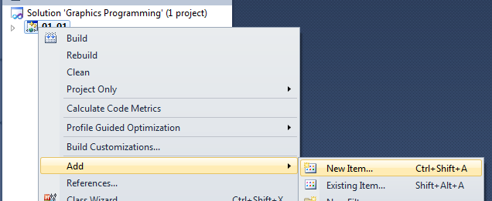

In the new item window, select **C++ File** and call it **main**. This will add a new code file to your project:

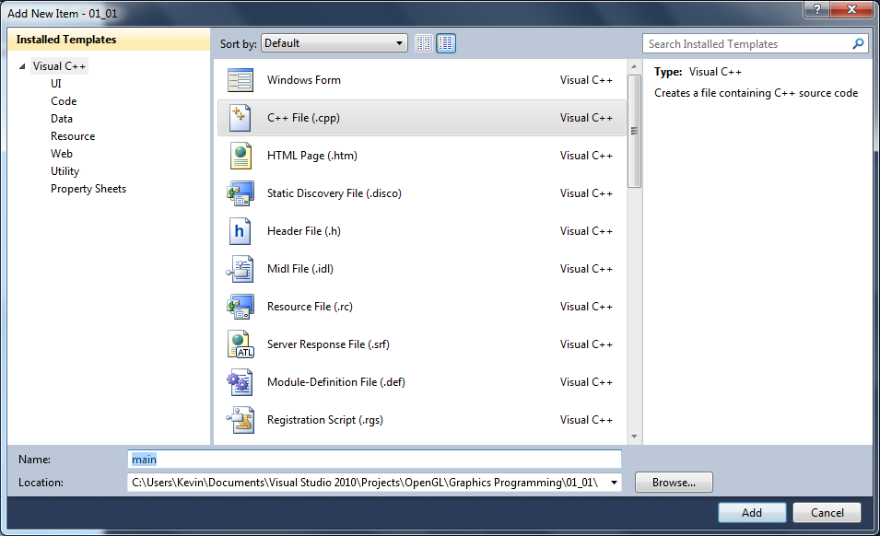

We are now ready to enter our code for our first GLFW application. The first two lines of code tell Visual Studio which libraries to include when building the final application. The lines of code are:

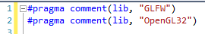

These lines of code are particular to Microsoft's C++ compiler and linker, and will not work in other development environments. We are just including these libraries in the link step, so if you are using another environment, refer to the relevant documentation.

The next line is where we include the header declaration for using GLFW:

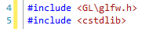

This is the only header files we will be using at present. The first line is for GLFW, and the second is for some standard C functions that we will be using (such as exit). Now, we are going to create a small skeleton to allow us to separate out our code. We will do this by creating three operations - **initialise, update** and **render**. Add the following code to your main file:

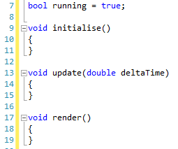

The running variable we will use to indicate that the application is still running. The first operation is where we will place any initialisation code we may want, the update operation is where any updates done during the frame are placed, and the render operation is where we perform our drawing. Now let us add the main operation:

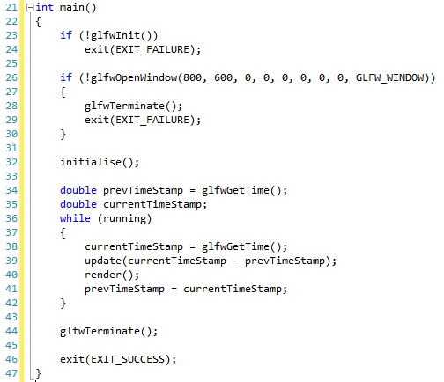

Line 23 we initialise GLFW by calling glfwInit. If this operation call responds with false (GLFW cannot be initialised) then we exit the application (line 24). We then try and open a window (line 26) giving it a size of 800 pixels by 600 pixels. If this fails, we terminate GLFW and exit (lines 28 and 29). We then call the initialise operation (line 32).

Once everything is initialised, we enter the main rendering loop. GLFW provides a method of getting the current time since the application started using glfwGetTime. We get the current time (line 34) and declare a value to store the current time (line 35). Then we enter the main application loop. While running is true (line 36), we get the current time (line 38) and then call update by subtracting the previous frame time from the current frame time (line 39) which gives us the time passed since the last frame. We then call render (line 40) and then set the previous frame time to the current time frame (line 41). This loop will continue until the running is set to false.

Once the main loop has been exited, we terminate GLFW, and exit the application.

You can run this application, and you should get a black window appearing on screen. If it doesn't then double check your code and setup, and if you are sure it is right, ask for help.

### Setting Clear Colour

Black is actually one of the worst clear colours we can use, as if we ever render something to the screen which isn't lit properly, or doesn't quite render correctly, the details will come out black, which means we cannot see any detail. Therefore, we are going to change the clear colour so we can better see problems. We do this in the initialise operation:

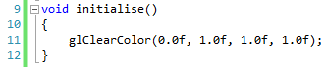

Here, we are setting the clear colour to 0% red, 100% green, 100% blue and 100% alpha (the colour is opaque).

### Checking Keyboard Input

We will also need to do some checking to see if the user wants to exit the application. We will do this by checking to see if Escape has been pressed. Add the following line to the update operation.

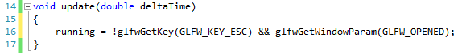

If we get GLFW_KEY_ESC and it returns true (button pressed) we set running to false (we also check that the window created by GLFW is still open, which is good practice).

### Clearing the Screen and Swapping the Buffer

Now all we need to do is perform standard drawing operations, such as clearing the screen and swapping the buffers (displaying what we have drawn). This involves just a couple of operation calls in the render operation:

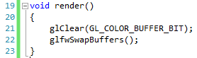

Line 21 clears the current colours on the screen, using the clear colour. Line 22 swaps the buffer with GLFW. If you run your application now you will see the following window:

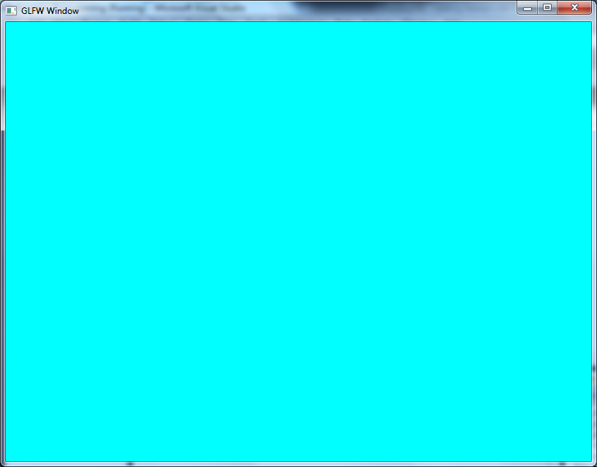

**Important** - the application you have now will form the basis for all our future applications. It would be a good idea to store this code somewhere.

## Exercises

Change the clear colour of the screen. Colours to get working are:

* 1. Red
  2. Green
  3. Blue
  4. White
  5. Black
  6. Yellow
  7. Cyan
  8. Magenta

# Drawing a Triangle

## Working with Old-Style OpenGL

Now that we have our basic GLFW application set up, we can start to do some rendering. OpenGL has changed quite a bit in the past few years, mostly to promote good practice and efficient rendering. However, to start with we will utilise the old (and technically deprecated) method of using OpenGL, which will give us a good background into the basic idea of drawing with triangles, before moving onto using modern techniques.

### Drawing a Triangle

3D objects in computer graphics are made up of a collection of polygons (2D shapes). There are two standard polygons used in 3D graphics - triangles (3 sided polygons) and quads (4 sided polygons). Generally, from a computation point of view, triangles are preferred. This is because any three points are guaranteed to make a polygon. When we introduce a fourth point, we are not guaranteed to form a polygon. However, you will find that many 3D modelling applications work in quads (modeller’s work guarantees that polygons will be created). That being said, we will be using triangles most of the time.

#### Screen Layout

Before we draw our first triangle, we need to understand how the screen is laid out. The following diagram will give you an idea:

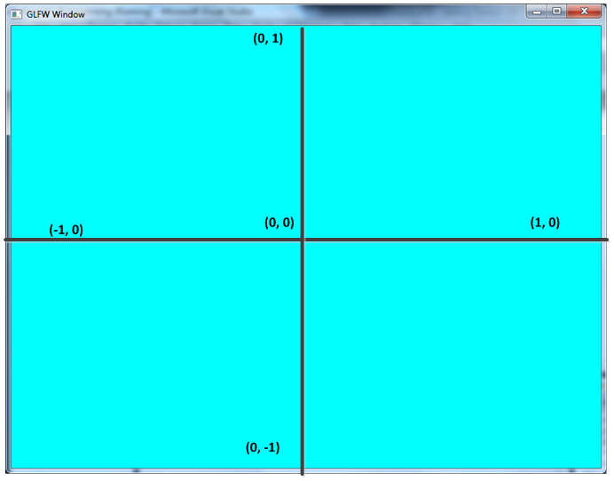

At the centre of the screen is position (0, 0). To the left, the X-coordinate goes down to -1 at the edge of the screen, and to the right X goes up to 1 at the edge of the screen. The top of the screen has Y value 1, and at the bottom it is -1. This is how an OpenGL window is configured with the default projection (we will learn more about projection next time). Now we know how the screen is set up, we can draw our first triangle.

#### Code

All we need to do now is update our render code so that we can draw a triangle (you may want to create a new project for this). Modify the render code to the following:

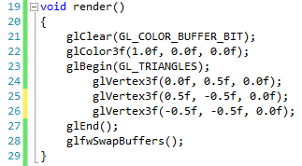

Line 22 sets the colour we are going to use (100% red, 0% green, 0% blue). We then begin a new set of triangles, defining three vertices (corners) (lines 24 to 26). Finally we end the set of triangles. If you run this version of the triangle, you get the following:

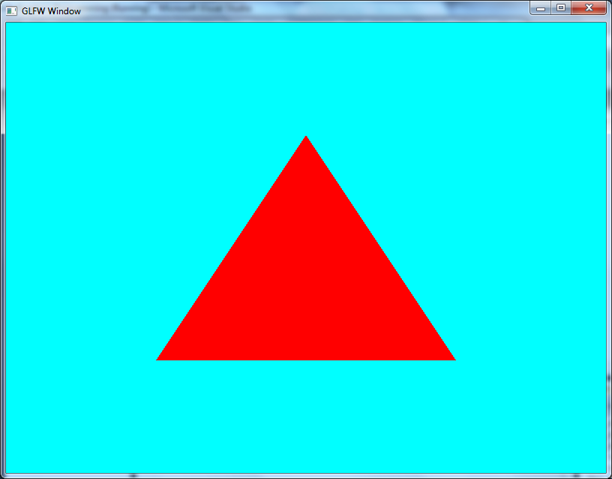

## Exercise

Try replacing the render code with the following:

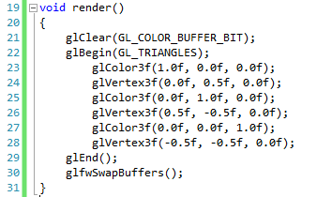

What is the result? Why do you think this is? What does it tell you about a particular vertex (point) when dealing with 3D graphics?

# Drawing a Quad

Now let us expand our triangle example to draw a quad. We are actually going to do this in a number of different ways, which will illustrate some of the different techniques we can use to draw items on the screen. First, we will modify the existing triangle example so that we draw two triangles to create a square.

## With Triangles

Modify your render operation to the following (again, you might want to create a new project):

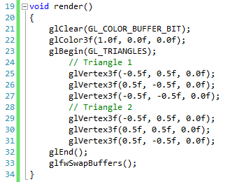

Here we are just define two triangles, and render both of these. The output is as follows:

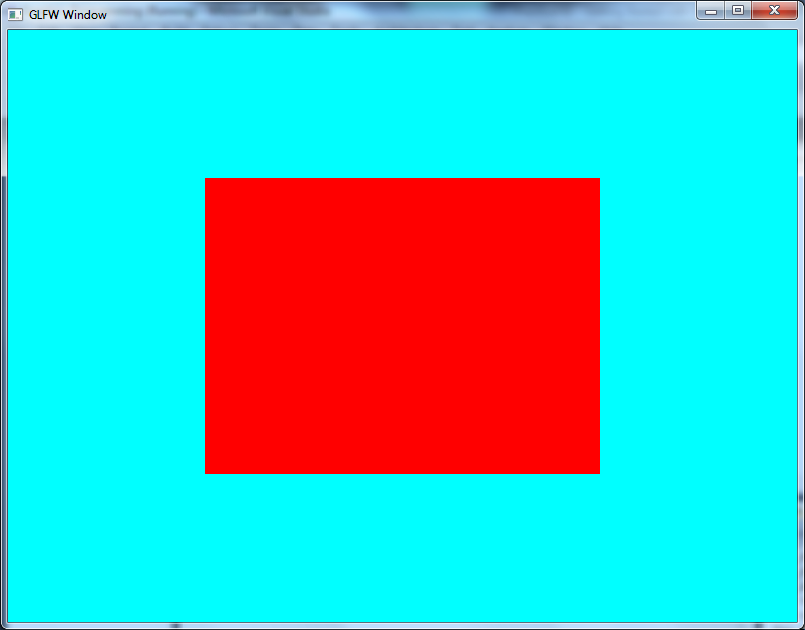

## With Quads

Let us now repeat this output but using a quad instead of two triangles. The new render code is as follows:

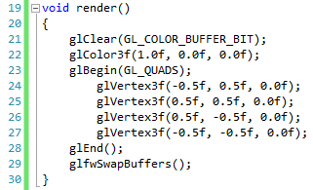

Notice that on line 23 now we are using GL_QUADS in the glBegin, and now we only need four vertices (lines 24 to 27) to define the quad, instead of the six we require using the GL_TRIANGLES approach. Now let us look at how we can just use the four vertices but still using triangles.

## With Triangle Strips

To save storage, it is often useful to work in the concept of strips of data. What these means is that we reuse previous vertices to create the current triangle. As an example, consider the following diagram:

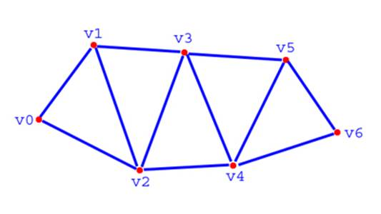

Triangle 1 is defined by v0, v1, v2. Triangle 2 is made from v1, v2, v3. Triangle 3 is made from v2, v3, v4, etc. For the actual call, all we need to define is the 7 vertices (0 - 7), but we still get 5 triangles.

To replicate this technique for our square, change the render code to the following:

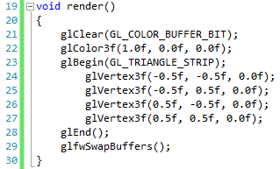

## With Lines

So far we have focused on using polygons to render our quads. Let us now do some rendering using just lines, therefore just drawing the outline of the quad. First, let us use a set of lines as we did with triangles. Modify the render code to the following:

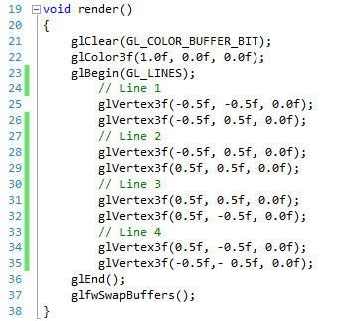

As you can see, lines are just defined as two separate vertices. To draw the outline of the quad, we define four lines.

## With Line Strips

Now let us perform the same effect, but this time using a strip of lines, as we did with the triangle strip. Modify the render code to the following:

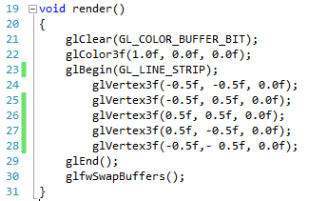

Notice that we are now just using 5 vertices. Line 1 uses 1 and 2, line 2 uses 2 and 3, etc.

## Exercise

Another type of line definition is the line loop (GL_LINE_LOOP). This call will only need four vertices. Can you modify your current code so that it uses GL_LINE_LOOP and only four vertices?

# Transformations

We have now got up and running with OpenGL, but so far we are only performing some basic rendering ideas. For one, we are writing a lot of code to draw very simple shapes (we will later look at buffers which allow us to draw triangles from data stored in memory). Two, we aren’t really doing anything about having our shapes move. This lesson discusses transformations, and although we won’t be coding any of these concepts right now, they are important aspects to understand.

## Vectors

Hopefully by now you understand what is meant by a vector as it is one of the most important constructs when working in games development. Vectors are used for both the positioning of objects in space (both 2D and 3D) and for the movement of these objects. As a quick refresher, a 3D vector can be defined as follows:

$$\left[\begin{matrix}x \\ y \\ z\end{matrix}\right]$$

The vector has three components – one for each of the distances along the relative axis. There are a number of standard operations we can perform on a vector.

### Adding Vectors

Adding vectors is relatively simple and we just add the individual components together:

$$\left[\begin{matrix}x_{1} \\ y_{1} \\ z_{1}\end{matrix}\right]+\left[\begin{matrix}x_{2} \\ y_{2} \\ z_{2}\end{matrix}\right]=\left[\begin{matrix}x_{1}+x_{2} \\ y_{1}+y_{2} \\ z_{1}+z_{2}\end{matrix}\right]$$

The same rule applies for subtraction.

### Scaling Vectors

Scaling a vector involves us just multiplying each component by the scalar value:

$$s\left[\begin{matrix}x \\ y \\ z\end{matrix}\right]=\left[\begin{matrix}sx \\ sy \\ sz\end{matrix}\right]$$

The same rule applies for division (assume that we are scaling by $\frac{1}{s}$).

### Length of a Vector

The length (or magnitude) of a vector can be determined using standard the standard Pythagoras theorem:

$$\left\|\left[\begin{matrix}x \\ y \\ z\end{matrix}\right]\right\|=\sqrt{x^{2}+y^{2}+z^{2}}$$

The brackets signify that we want the length of the vector. Notice that the length will always be positive.

### Normalising a Vector

Normalising a vector is an important operation when working with computer graphics (as you shall soon see). Normalising means converting a vector so that it still faces in the same direction, but has a unit length (length of 1). To do this, we only need to scale the vector by the inverse of its length:

$$\hat{u}=\left[\begin{matrix}\frac{x}{\left\|u\right\|} \\ \frac{y}{\left\|u\right\|} \\ \frac{z}{\left\|u\right\|}\end{matrix}\right]$$

Note that we use the accent to denote that we have a normalised vector.

### Dot Product

Multiplying two vectors together can be done in a number of ways. The first of these we will cover is called the dot product, and it is calculated as follows:

$$\left[\begin{matrix}x_{1} \\ y_{1} \\ z_{1}\end{matrix}\right]⋅\left[\begin{matrix}x_{2} \\ y_{2} \\ z_{2}\end{matrix}\right]=x_{1}x_{2}+y_{1}y_{2}+z_{1}z_{2}$$

Notice that the result of this operation is a scalar value, not another vector.

#### Properties of the Dot Product

The dot product between two vectors actually provides a number of useful properties of the two vectors. The first is that the dot product between two vectors has a relationship to the cosine of the angle between the two vectors:

$$u⋅v=\left\|u\right\|\left\|v\right\|\cos{θ}$$

$\left\|u\right\|$ means the length of vector $u$, and $θ$ is the angle between the two vectors.

Because there is a relation to the dot product and the cosine of an angle, we can also determine when two vectors are orthogonal (or perpendicular, at right angles), by the observation that $\cos{\frac{π}{2}}=0$, thus $\left\|u\right\|\left\|v\right\|\cos{\frac{π}{2}}=0$. Therefore, if the dot product of two vectors is 0, we know that they are orthogonal.

Furthermore, we can determine whether an angle is greater than or less than $\frac{π}{2}$ by the value of the dot product:

$$u⋅v<0⇒θ>\frac{π}{2} \\ u⋅v>0⇒θ<\frac{π}{2}$$

A final property of the dot product, again because of the cosine relation, is the calculation of the scalar project of a vector onto another vector. The scalar projection tells us how far along a vector another vector reaches, which can be useful in some applications. The scalar projection can be calculated as follows:

$$a_{b}=\left\|a\right\|\cos{θ}=\frac{a⋅b}{\left\|b\right\|}$$

### Cross Product

The cross product is another method of multiplying two vectors together. This time the result is another vector. The cross product of two vectors can be calculated as:

$$\left[\begin{matrix}x_{1} \\ y_{1} \\ z_{1}\end{matrix}\right]×\left[\begin{matrix}x_{2} \\ y_{2} \\ z_{2}\end{matrix}\right]=\left[\begin{matrix}y_{1}z_{2}-z_{1}y_{2} \\ z_{1}x_{2}-x_{1}z_{2} \\ x_{1}y_{2}-y_{1}x_{2}\end{matrix}\right]$$

Notice the pattern forms a cross for each individual component (hence the cross product).

#### Properties of the Cross Product

As the dot product, the cross product has certain properties that are of interest when manipulating geometry. The first is that when we calculate the cross product of two vectors, the new vector is orthogonal (perpendicular) to the two original vectors. That is:

$$u×v⊥u \\ u×v⊥v$$

This allows us to calculate vectors perpendicular to others, which will come in useful when we are dealing with cameras much later in the lessons.

Because the cross product of two vectors is orthogonal to the original two vectors, we can use this information to calculate surface normals (that is, vectors that are unit length and perpendicular to a surface). Consider that two vectors can create a surface as follows:



Then the cross product of $u$ and $v$ will be orthogonal to the surface created by the two vectors. To calculate the surface normal, we use the following:

$$a\hat{X}b=\frac{a×b}{\left\|a×b\right\|}$$

Surface normals are important when we consider lighting calculations later in the lesson schedule.

Finally, the cross product, like the dot product, has a relation to the size of the angle between the two vectors. However, this time the relation is with the sine value of the angle. The cross product is related to the sine of the angle between the two vectors as follows:

$$\left\|a×b\right\|=\left\|a\right\|\left\|b\right\|\sin{θ}$$

## Matrices

Now that we have refreshed ourselves with vectors, we can move onto matrices. A matrix is a $m×n$ grid of values such as:

$$\left[\begin{matrix}1 & 0 & 0 \\ 0 & 1 & 0 \\ 0 & 0 & 1\end{matrix}\right]$$

From a 3D graphics point of view, we are only interested in matrices of size $4×4$. We will see why shortly. For now, let us consider some basic operations for matrices.

### Adding

Adding two matrices together is similar to vectors, and just involves us adding the separate components together:

$$\left[\begin{matrix}a_{00} & a_{01} & a_{02} \\ a_{10} & a_{11} & a_{12} \\ a_{20} & a_{21} & a_{22}\end{matrix}\right]+\left[\begin{matrix}b_{00} & b_{01} & b_{02} \\ b_{10} & b_{11} & b_{12} \\ b_{20} & b_{21} & b_{22}\end{matrix}\right]=\left[\begin{matrix}a_{00}+b_{00} & a_{01}+b_{01} & a_{02}+b_{02} \\ a_{10}+b_{10} & a_{11}+b_{11} & a_{12}+b_{12} \\ a_{20}+b_{20} & a_{21}+b_{21} & a_{22}+b_{22}\end{matrix}\right]$$

The same rule applies for subtraction.

### Scaling

Scaling a matrix is also similar to vector operations, and involves us scaling the separate components:

$$s\left[\begin{matrix}m_{00} & m_{01} & m_{02} \\ m_{10} & m_{11} & m_{12} \\ m_{20} & m_{21} & m_{22}\end{matrix}\right]=\left[\begin{matrix}{sm}_{00} & {sm}_{01} & sm_{02} \\ {sm}_{10} & {sm}_{11} & {sm}_{12} \\ {sm}_{20} & {sm}_{21} & sm_{22}\end{matrix}\right]$$

The same division approach with vectors also applies to matrices.

### Multiplying

Multiplying two matrices together requires some more work. Let us consider two $3×3$ matrices as follows:

$$\left[\begin{matrix}a_{00} & a_{01} & a_{02} \\ a_{10} & a_{11} & a_{12} \\ a_{20} & a_{21} & a_{22}\end{matrix}\right] \left[\begin{matrix}b_{00} & b_{01} & b_{02} \\ b_{10} & b_{11} & b_{12} \\ b_{20} & b_{21} & b_{22}\end{matrix}\right]$$

We can actually consider the first matrix as three vectors as follows:

$$\left[\begin{matrix}a_{0x} \\ a_{1x} \\ a_{1x}\end{matrix}\right]$$

That is three row vectors $\left[\begin{matrix}a_{00} & a_{01} & a_{02}\end{matrix}\right]$, $\left[\begin{matrix}a_{10} & a_{11} & a_{12}\end{matrix}\right]$ and $\left[\begin{matrix}a_{20} & a_{21} & a_{22}\end{matrix}\right]$. We can also consider the second matrix as three vectors as follows:

$$\left[\begin{matrix}b_{x0} & b_{x1} & b_{x2}\end{matrix}\right]$$

That is three column vectors $\left[\begin{matrix}b_{00} & b_{10} & b_{20}\end{matrix}\right]$, $\left[\begin{matrix}b_{01} & b_{11} & b_{12}\end{matrix}\right]$ and $\left[\begin{matrix}b_{02} & b_{12} & b_{22}\end{matrix}\right]$. We can now define matrix multiplication as follows:

$$\left[\begin{matrix}a_{00} & a_{01} & a_{02} \\ a_{10} & a_{11} & a_{12} \\ a_{20} & a_{21} & a_{22}\end{matrix}\right]×\left[\begin{matrix}b_{00} & b_{01} & b_{02} \\ b_{10} & b_{11} & b_{12} \\ b_{20} & b_{21} & b_{22}\end{matrix}\right]=\left[\begin{matrix}a_{0x}⋅b_{x0} & a_{0x}⋅b_{x1} & a_{0x}⋅b_{x2} \\ a_{1x}⋅b_{x0} & a_{1x}⋅b_{x1} & a_{1x}⋅b_{x2} \\ a_{2x}⋅b_{x0} & a_{2x}⋅b_{x1} & a_{2x}⋅b_{x2}\end{matrix}\right]$$

A possibly easier visualisation of this is taken from Wikipedia:

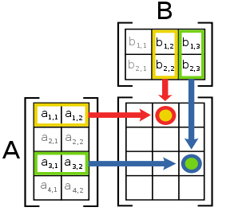

Notice that matrix multiplication can only take place for $m×n$ and $n×p$ matrices, and results in a matrix that is $m×p$ in size.

From the point of view of 3D graphics, it has already been mentioned that we are interested in $4×4$ matrices. Multiplying these together is not an issue. We are also interested in vectors, which in 3D terms look like a $3×1$ matrix:

$$\left[\begin{matrix}x \\ y \\ z\end{matrix}\right]$$

We will be manipulating our 3D vectors with $4×4$ matrices, and therefore we will be representing our vectors as follows:

$$\left[\begin{matrix}x \\ y \\ z \\ 1\end{matrix}\right]$$

This will allow us to perform vector transformations by multiplying our vectors by our matrices:

$$Mu=\left[\begin{matrix}M_{00} & M_{01} & M_{02} & M_{03} \\ M_{10} & M_{11} & M_{12} & M_{13} \\ M_{20} & M_{21} & M_{22} & M_{23} \\ M_{30} & M_{31} & M_{32} & M_{33}\end{matrix}\right]\left[\begin{matrix}x \\ y \\ z \\ 1\end{matrix}\right]=\left[\begin{matrix}M_{0x}⋅u \\ M_{1x}⋅u \\ M_{2x}⋅u \\ M_{3x}⋅u\end{matrix}\right]$$

## Transformation Matrices

There are a number of standard transformation matrices we can generate to manipulate our geometry. We will cover the most common here, and how they are generated.

### Translation

Translation is when we wish to move our object in 3D space. We do this by applying a translation vector ($\left[\begin{matrix}t_{x} \\ t_{y} \\ t_{z}\end{matrix}\right]$) in our matrix. A translation matrix looks as follows:

$$\left[\begin{matrix}1 & 0 & 0 & t_{x} \\ 0 & 1 & 0 & t_{y} \\ 0 & 0 & 1 & t_{z} \\ 0 & 0 & 0 & 1\end{matrix}\right]$$

### Rotation

Rotation comes in three forms, based on the axis that we are rotating around. In 3D, we can rotate around the X-axis (pitch), Y-axis (yaw) or Z-axis (roll). Each of these rotation types has a different matrix associated with them, and we will look at each of these in turn.

#### Pitch

The matrix for applying a rotation around the X-axis is:

$$\left[\begin{matrix}1 & 0 & 0 & 0 \\ 0 & \cos{θ} & -\sin{θ} & 0 \\ 0 & \sin{θ} & \cos{θ} & 0 \\ 0 & 0 & 0 & 1\end{matrix}\right]$$

Where $θ$ is the angle to rotate around the X-axis.

#### Yaw

The matrix for applying rotation around the Y-axis is:

$$\left[\begin{matrix}\cos{θ} & 0 & \sin{θ} & 0 \\ 0 & 1 & 0 & 0 \\ -\sin{θ} & 0 & \cos{θ} & 0 \\ 0 & 0 & 0 & 1\end{matrix}\right]$$

#### Roll

The matrix for applying rotation around the Z-axis is:

$$\left[\begin{matrix}\cos{θ} & -\sin{θ} & 0 & 0 \\ \sin{θ} & \cos{θ} & 0 & 0 \\ 0 & 0 & 1 & 0 \\ 0 & 0 & 0 & 1\end{matrix}\right]$$

### Scale

Scale allows us to change the size of a piece of geometry on one of its three axes. Therefore, scale can also be represented as a 3D vector $\left[\begin{matrix}S_{x} \\ S_{y} \\ S_{z}\end{matrix}\right]$. The scale matrix is defined as:

$$\left[\begin{matrix}S_{x} & 0 & 0 & 0 \\ 0 & S_{y} & 0 & 0 \\ 0 & 0 & S_{z} & 0 \\ 0 & 0 & 0 & 1\end{matrix}\right]$$

### Combining Matrices

To combine our matrices together, all we need to do is multiply them together. However, we do need to concern ourselves with the order that we do this, as matrix multiplication is not commutative. The order we wish to multiply the matrices together is:

$$S×R×T$$

That is $scale×rotation×translation$. Doing the calculation in a different order will result in a different (and incorrect) output.

We will be using a library called GLM to do most of our mathematical work. This is what the next lesson is about.

# Getting Started with GLM

The GLM (GL Maths) library is available from <http://glm.g-truc.net/>. This library provides many of the standard mathematical constructs for working with OpenGL. The library itself is what is known as a header only library, and therefore does not require libraries or DLLs. When you download the library, you only need to point the include directories to the GLM folder (remember what we did for GLFW in Lesson 1). To test that everything has worked out correctly, try the following program:

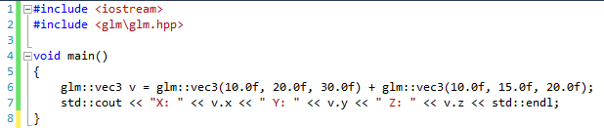

If you run this (use Debug 🡪 Start without Debugging to make the console window wait), you should get the answer of adding these two vectors together.

We will be using GLM when working with OpenGL from now on, so remember and include the necessary headers. In general, we will require:

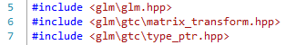

We may require others as we work through the material. Try and use the GLM documentation to discover which headers to include.

## Rotating Triangle

We are going to create a simple application which rotates our triangle. To start with, we are going to use the following render code (again, you probably want a new project):

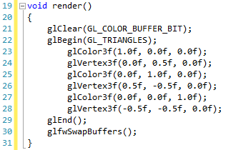

This will provide you with a window as follows when run:

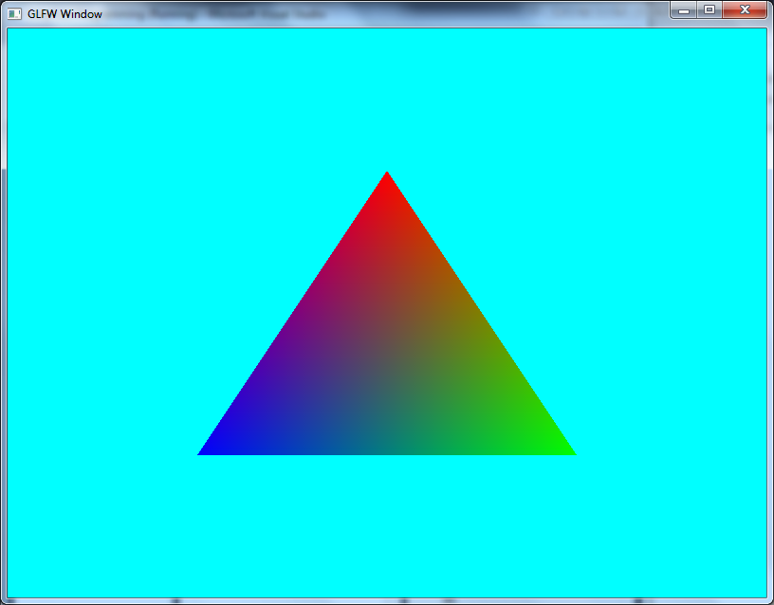

The first new line of code we need is a declaration for the orientation of the object. We declare this at the top of our current code file:



We then need to update this orientation every update (remember – the update is where we do our movement type code):

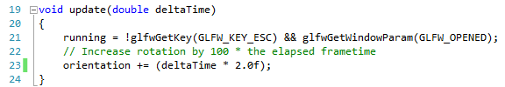

Now all we need to do is update the render code so that we use the orientation of the object. This involves us creating a transformation matrix, and applying this to OpenGL in our render code:

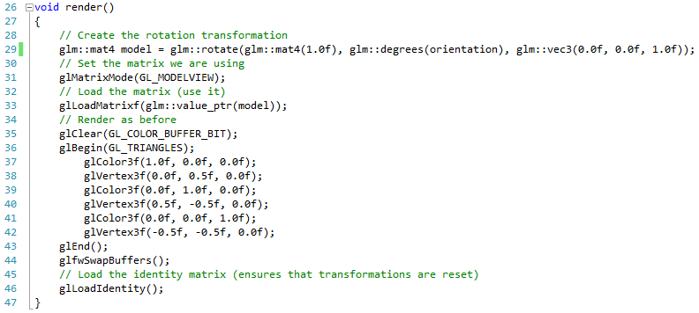

On line 29 we create our model transformation matrix. We supply this method with three values:

1. The matrix to apply the rotation to – here we apply the rotation to the identity matrix (mat4(1.0f)).
2. The rotation we wish of apply – this is the orientation value we declared. Notice that we convert our value to degrees. Currently, we are working in radians – mainly because this is good practice, but also because the standard trigonometric functions expect to work in radians. GLM using degrees for rotation is actually not so good.
3. The axis we wish to rotate on – here we have set the Z-axis (0.0f, 0.0f, 1.0f).

Once we have created our axis, we need to set the matrix mode in OpenGL (there are a few different matrix modes, we are interested in the model). Then we can load the transformation matrix (line 33). Notice we use the glm::value_ptr operation to convert the matrix into something that OpenGL can use. We will do this quite a lot. Then we render as before, before finally loading the identity matrix (line 46) to reset any transformations we may have done. Running this application will give you the following:

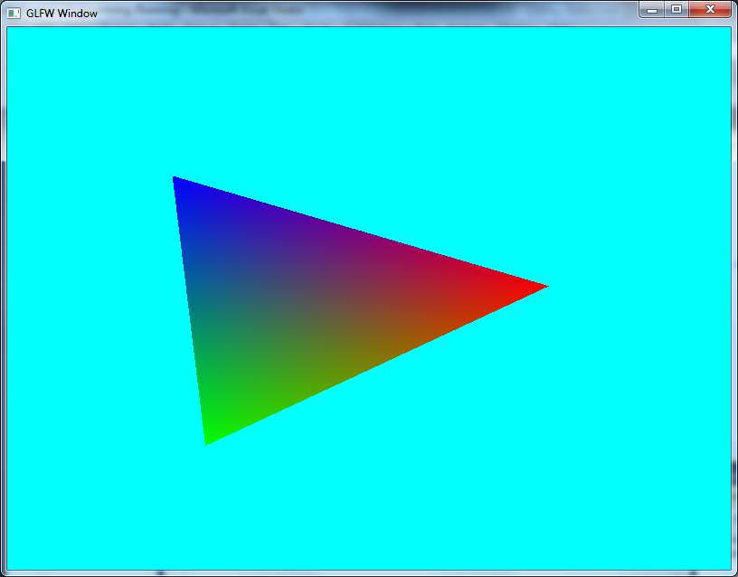

## Exercises

1. Try rotating the triangle on a different axis. What are the results for X-axis, Y-axis, and arbitrary axis?
2. Try scaling the triangle. You will need to find the operation to create the scale matrix.
3. Can you work out how to scale and rotate the triangle?

# Moving Quad

Let us now expand our simple triangle rotation example to allow us to move a quad. This is actually quite a simple change.

## Initial Render Code

Our initial render code for our quad will be as follows:

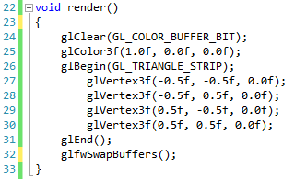

This will provide us with a red rectangle as follows:

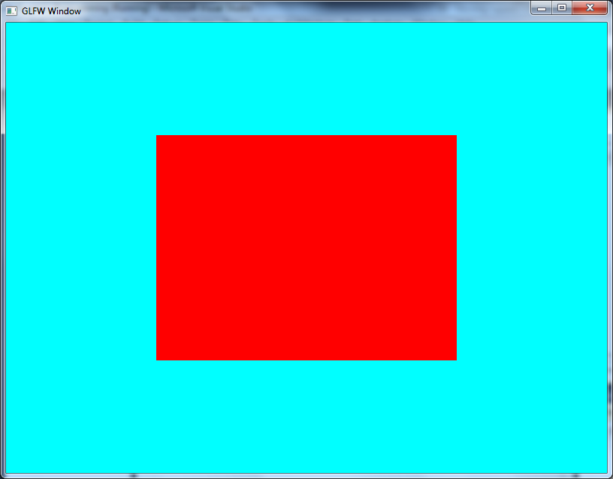

Now that we have an initial rectangle, let us add some code so that we can move it around the screen using the keyboard.

## Using a Position

The first thing we need to do in our new application is to maintain the position of the quad. This we do by defining a vector as an attribute at the top of our file:



Next we need to add some code to our update so that we process keyboard input and act accordingly. Our new update code is as follows:

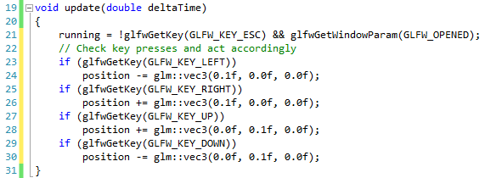

We now have enough code to perform our translation code.

## Translating the Quad

We are essentially going to do the same as we did before with rotations, but this time applying a translation. Our new render code is as follows:

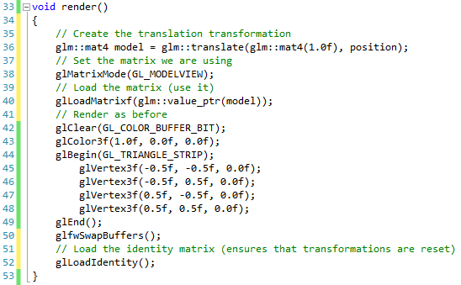

When you run it, you will be able to move the quad around as follows:

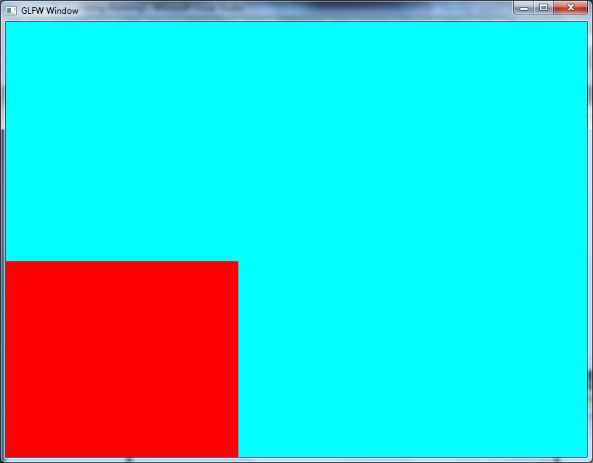

## Exercises

1. Modify your code so that you cannot move the quad off the edge of the screen.
2. Try and apply a rotation, translation and scale to your object. What happens when you change the order of the calculations?

# Challenge – Point Based Sierpinski Gasket

We have come quite a long way already in our understanding of fundamental graphics programming (we are using old style OpenGL – we will be going beyond this shortly). Let us now try and create something a bit more exciting. This example is taken from the *book Interactive Computer Graphics: A Top-Down Approach* by Edward Angel and David Shreiner [1]. We have adapted it slightly to suit our style of development.

## What is the Sierpinski Gasket

The Sierpinski Gasket is a form of fractal. The Sierpinski Gasket can be defined recursively and randomly. Basically, the shape is defined by sub-dividing triangles like so:

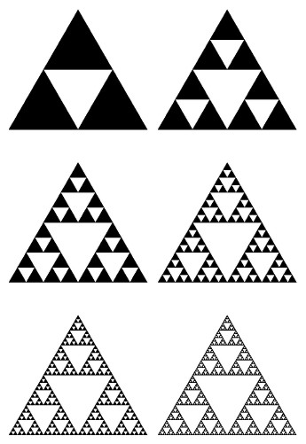

The first algorithm we are going to use for this is a simple random operation where we create an array of random points which will form our Gasket. Let us see how we do this.

## Getting Started

The first thing we need to do is create an array to store our randomly generated points in. This we declare at the top of our code:

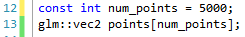

We are going to generate 5000 vec2 objects, and use these as the positions of our points. Next we need to generate these points. This is where the challenge comes in.

## Generating Points

The random algorithm we are going to use requires some initial values to get started. Our initialise method takes the following form:

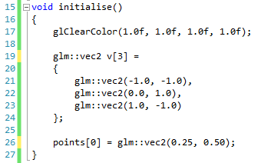

We define the dimensions of the Gasket as a triangle reaching from the top of the screen to the bottom left and right corners (the three vectors defined as v). We then set our initial point within the array.

### Challenge

The algorithm to generate the Gasket is as follows:

$$point\left(k\right)=\left(point\left(k-1\right)+rand(v)\right)/2$$

The rand function used in the definition just states that we randomly select one of the three values defined in v (defined in lines 19 to 24 above). You will have to generate all the required points in the array.

## Rendering the Points

To render the points, we only need the following code:

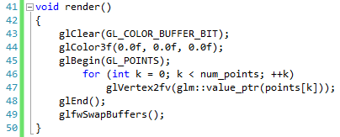

We begin and end as before, but we now use a loop to iterate through the array of points and initialise them accordingly. When run, your application should look a little like this:

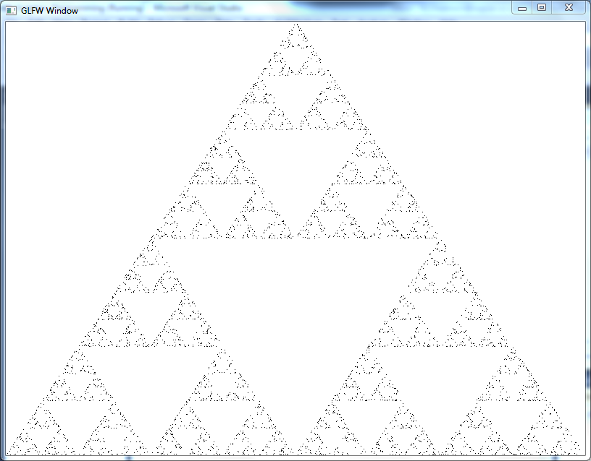

## Exercises

1. Try increasing the number of points generated. Try 50000, 500000, etc. What is the result?
2. Try and also implement the transformation concepts we discussed in the last two lessons. Can you make the Gasket rotate, scale, transform, etc.?

# Drawing a Cube

We have so far kept our drawing code to 2D shapes. Of course, this is great if we only want to do 2D work, but really we want to work in 3D. To do this, we will have to modify the way we have been working with OpenGL up to this point.

## Working with Projection

Up until now, we have actually been rather weak with how we render our shapes. This is because we are using what is known as an orthogonal projection technique. Orthogonal projection will basically render everything in 2D, even if we define it in 3D. Objects look flat, and we can have trouble visualising the actual 3D nature of our objects.

What we want to use is a perspective projection technique, where objects appear to get smaller the further away part of them moves. The following picture (taken from *Interactive Computer Graphics: A Top-Down Approach* [1]) should help:

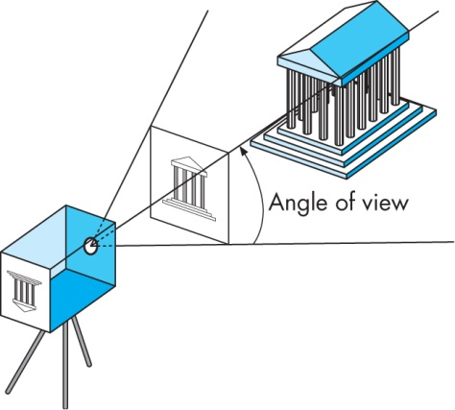 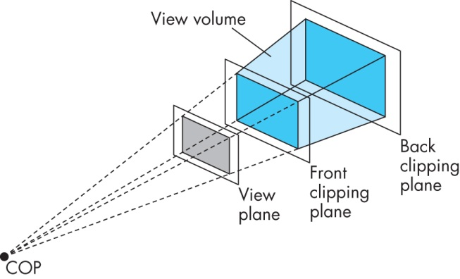

What we do when working out a perspective projection is work out how our 3D object looks (is projected) against the view plane (the screen). We need to know the near and far clipping planes (where we can see objects), and the size of the view plane we are using and the angle of view. These values make up our perspective projection. We also need a number of values to define the view. We have a number of values we need for this – the position of the viewer, the direction it is facing, and the up direction (so we can rotate),

When we get these values, we use them to generate another two transformation matrices that we apply to our vertices to project them onto the screen. The first matrix is the projection matrix. The second matrix is called the view, and is traditionally combined with the model matrix to provide the output we require.

## Using GLM

Thankfully, GLM will take care of our projection matrix and view matrix calculations for us, just as it does for other matrix types. All we need to do is pass it the required values, and it will calculate the matrix we require. First off, create a new project with our most basic structure. Now, all we need is the values required generating our projection matrix.

### Initialise Method

Let us just define the code for our initialise method, and then break down what we are doing:

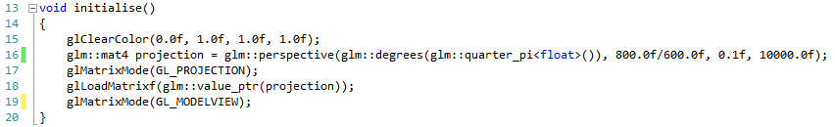

On line 16 we are creating our projection matrix using the glm::perspective function. This function takes four values:

1. The field of view or angle we see at. Typically $\frac{π}{4}$ is used for this value. You will have to include the header glm\gtx\constants.hpp to use the quarter_pi function.
2. The aspect ratio of the window. Here we use the fixed window size we have been using thus far (800 width / 600 height).
3. The near plane (the minimum distance something can be before we stop seeing it).
4. The far plane (the furthest something can be before we stop seeing it).

There is another perspective function (perspectivefov) which takes the actual screen width and height and not an aspect ratio, but we won’t worry about using this function.

Lines 17 and 18 should be familiar from our previous work on transformations. Here we are setting the projection matrix rather than the model-view matrix. Notice however that we go back to the model-view matrix at the end of the method. This is important. We do not want to apply the model view matrix to the projection matrix.

## Rendering a Cube

We are now ready to render our cube. To do this, we will need to create the cube data, but also the view matrix. Let us do the second item first:

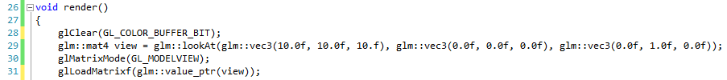

Out view matrix creation uses the glm::lookAt function. This requires three vector values:

1. The position of the viewer (the camera position)
2. What the viewer is looking at (look at position)
3. The up direction (here we use straight up on the y-axis)

We then use this value as our model view matrix (lines 30 to 31).

Now let us look at the rest of our render code:

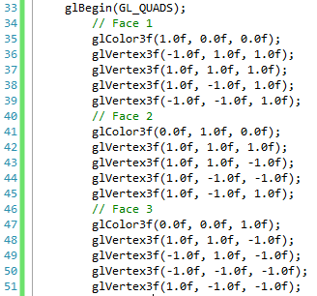

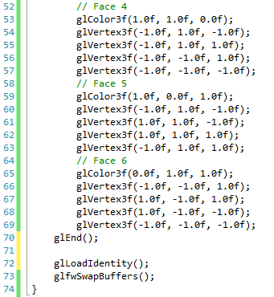

There is quite a bit here, but hopefully you can see that we are just defining our six sides of the cube. If you run this version of the application, you should get the following result:

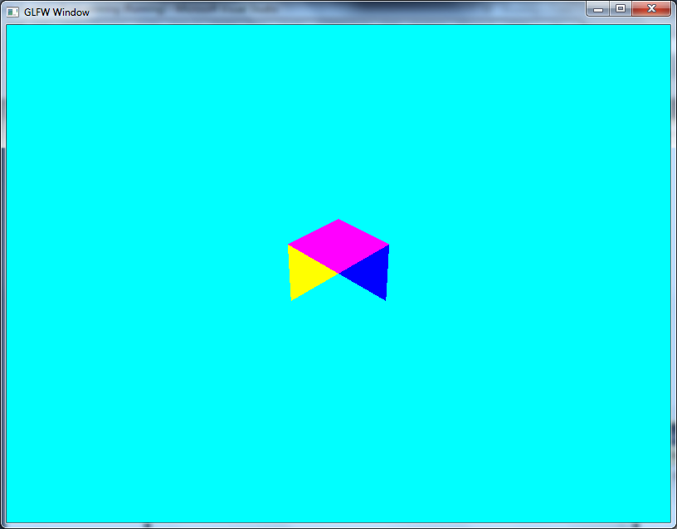

Oh no. We have obviously done something wrong. But what is it? Well, we haven’t told OpenGL to take into account the depth of our objects (which objects get drawn in front of others). This is actually a quick fix.

## Adding Depth

Turning on depth testing only requires that we add two more lines. The first we will do in the initialise method:

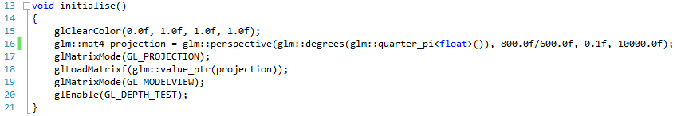

The new line is line 20, and this simply tells OpenGL to enable depth testing. We also need to tell OpenGL to clear the depth buffer (depth is stored in buffers – we will learn more about this much later). This is done in the render method:

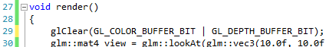

Notice that we now tell OpenGL to clear both the colour and the depth buffers on line 29. If you run this version, you should get the following:

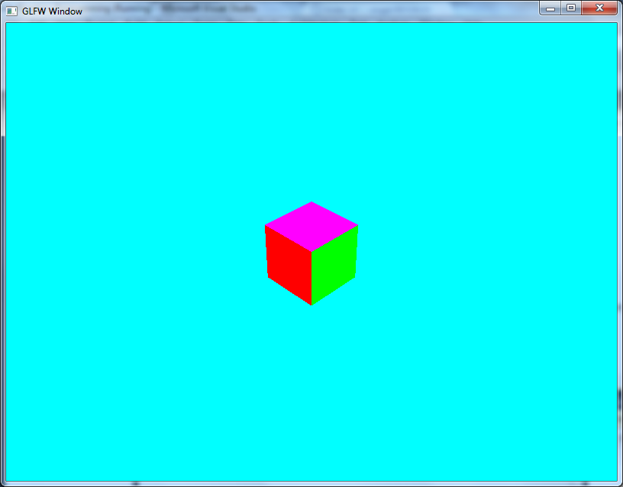

## Exercises

1. Try changing the up vector for the camera. Try and rotate the camera around so that the up vector goes from (0.0, 1.0, 0.0) to (1.0, 0.0, 0.0) to (0.0, -1.0, 0.0) to (-1.0, 0.0, 0.0) and back to (0.0, 1.0, 0.0). Basic trigonometry will let you do this.
2. Try making the camera rotate around the cube. Consider that the camera is a fixed distance from the cube, and work out the position as you rotate it around. Again, basic trigonometry will suffice here.

# Transforming the Cube

We have now drawn our first 3D shape – a simple Cube. Now let us look at what happens when we apply transformations in 3D. Let us look at what happens when we apply our transformations in 3D. Create a new project, but reuse the code from the previous practical.

## Translating the Cube

Remember that translation refers to us moving the position of the cube. Therefore, we need to maintain this position in a variable. Add the following to the top of the code file:

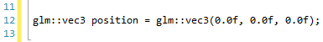

Next we need to modify our update code to respond to key presses. Let us assume that up and down modify the Z-axis, left and right the X-axis, and we will use w and s for the Y-axis:

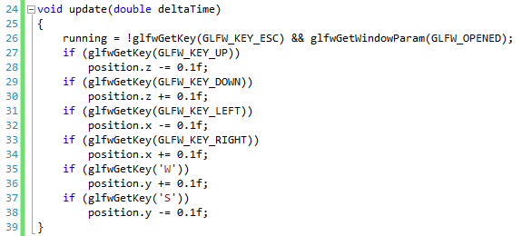

Notice that we use capitals for the W and S keys. Now all we need to do is change our render code:

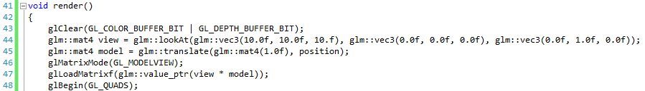

We create a model matrix on line 45, and then multiply the view matrix by the model matrix on line 47. If you run this application, you will be able to move your cube about.

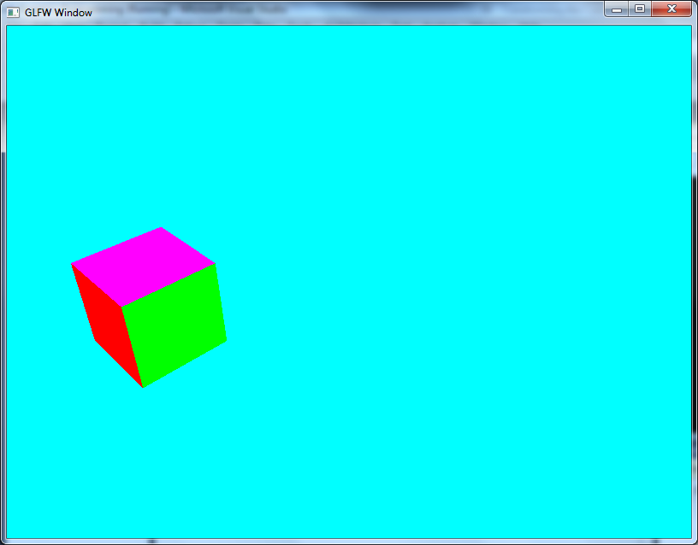

## Rotating the Cube

Let us now apply the same idea to rotating the cube. First, we need a rotation vector:



Each component of the vector will represent rotation on one of the axis. Now we need to modify our update code to change the rotation:

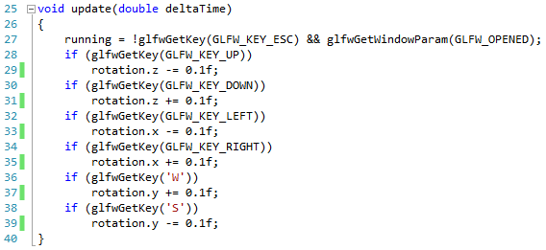

Then finally all we have to do is modify the render code:

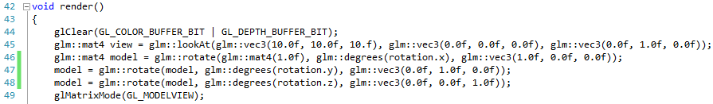

We have added three new lines (46 to 48). We rotate the model matrix on each of the axes, and then apply this matrix to our view. You should now be able to rotate the cube:

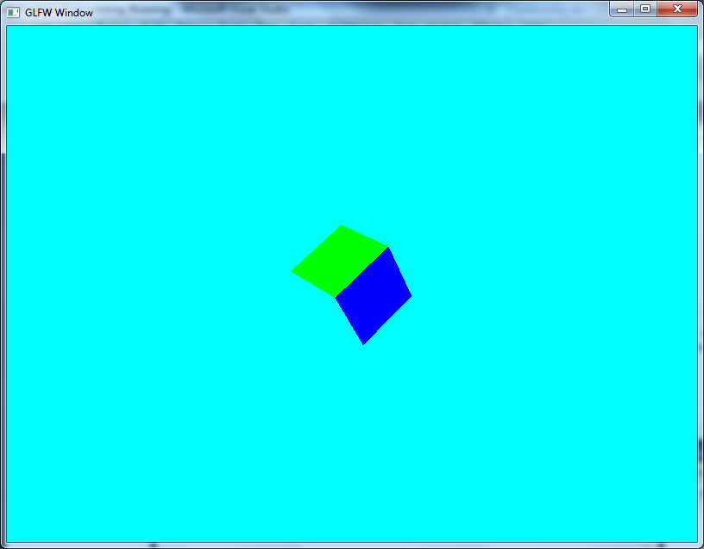

**Word of warning –** the rotation will occasionally act strangely depending on how you rotate the object. This is an artefact called Gimble lock. We will look at techniques that help us try and avoid Gimble lock later.

## Scaling the Cube

Finally let us apply scaling to our cube. We can do this by using a 3D vector again:



Notice that we set the components to 1.0f this time (scaling to 0 will mean the object disappears). Now we need to modify our update code:

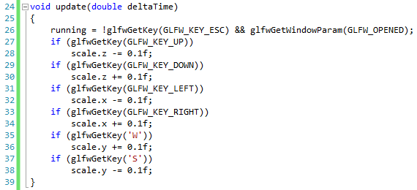

Now we just need to update the render code:

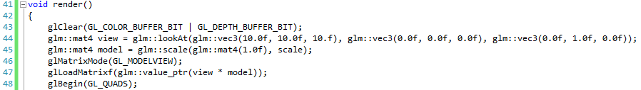

On line 45 we utilise the glm::scale function to modify the scale of the model. If you run this version, you will be able to modify the scale of the box:

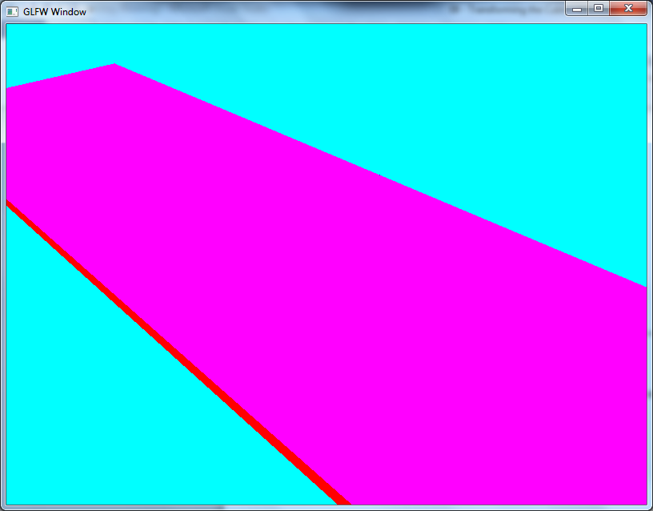

## Exercises

1. With the scale, try and scale so that the value becomes negative. What happens, and why?
2. Try and combine all three transformations. You will have to add some more key inputs, and also worry about the order you multiply your matrices.

# Indices

Up until now we have been writing quite a lot of code to draw very simple shapes. As you can imagine, we don’t really want to be writing a line of code for every single vertex of our shapes (imagine doing this for a 3D character model). As we work through the lessons, we will explore a few different methods to remove the amount of code we have to write just to handle the geometry. The first approach we will use is indexing.

## What is Indexing?

Let us consider how we draw a quad using triangles at the moment. Basically, we are defining two separate triangles:



Obviously the triangles are connected in our actual application, but this is for illustrative purposes. If you look at what we are doing, we are defining six separate vertices to define a shape that only has four separate vertices. This is not very efficient. So what if we could reuse vertices. Well we can. Consider the following:



We can consider each vertex of the quad as numbered above. In this instance, we can define our two triangles as follows:

$$\left\{0, 1, 2\right\} \\ \{0, 2, 3\}$$

This is how indexing works. We can define an array of vertices, and then define shapes as collections of these vertices. For example, a cube is just eight vertices, but defined by twelve triangles. If we didn’t use indexing, then we would have to declare thirty-six vertices. Using indexing, we declare eight, and then define our twelve triangles as collections of three indexes in the array of eight vertices. Let us now see how we use indexing in OpenGL.

# Indexed Cube

Now that we know how indexing works, let us apply this knowledge into a new indexed version of our cube. We will be working slightly differently than before with OpenGL, but nothing too different. First, create a new project using the basic code we defined (not the cube code, but the first skeleton project).

## Defining Our Cube

Our cube is essentially 8 points (the corners of the cube) and 12 triangles (2 per side, 6 sides). What we need to do first is define our 8 vertices (the corners). We do this at the top of our basic code file:

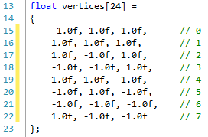

As we have eight vertices, they are essentially indexed from 0 to 7 (as indicated in the comments). We can use these numbers to define our individual triangles. This is the indices array:

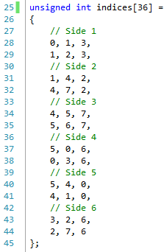

We now have enough information to create our cube application using indices.

## Initialisation

Our initialisation operation still needs to handle setting up our projection matrix. We also need to tell OpenGL that we are using an array for vertices. Our initialise operation looks as follows:

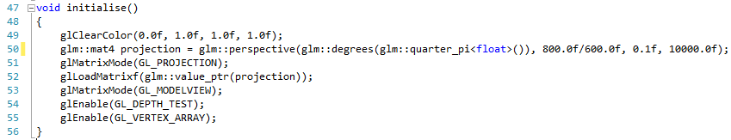

A new line is 55 where we enable the use of a vertex array. The other lines should be familiar.

**ACTUALLY LINE 55 SHOULD BE glEnableClientState(GL_VERTEX_ARRAY).**

## Rendering

Now we are ready to perform our render. This will look a little different than before. The render code is as follows:

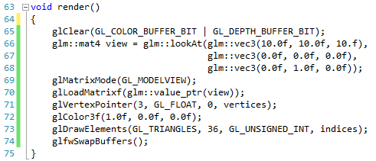

We set up our view matrix as before (lines 65 to 70). We are now also setting a vertex pointer (we point to the array of vertices we defined) and using this to draw. The glVertexPointer operation (line 71) takes four values:

1. The size of the vertices being used. This can be 2 (for 2D vectors), 3 (for 3D vectors) or 4 (for 4D vectors). 4D vectors have a particular usage in graphics rendering which we will come to later.
2. The type used in the vector. Vectors can actually use integers and other data types besides float. However, we will use floats so we set this as GL_FLOAT.
3. The stride of the data. Stride refers to how far apart individual vectors are placed. We can actually put more data than just positions in our vectors (more on this later in the practical series). As we only store positions, we set stride to 0.
4. The array of vertices we are using.

We call the glDrawElements operation to actually draw the geometry. This call takes 4 parameters:

1. The type of geometry being rendered. These are the same types used in glBegin.
2. The number of indices being used. We have 36 (12 triangles, each with 3 vertices).
3. The type of the index. We are using unsigned ints so we use GL_UNSIGNED_INT.
4. The array of indices.

If you run this version you will see the following:

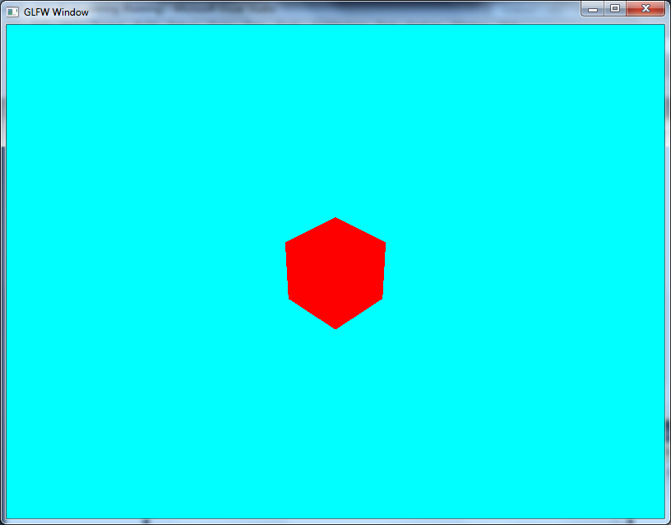

## Exercises

1. Try adding transformation code to this example so you can manipulate the cube. Is it correctly defined?
2. Can you get colour to work using indexes. You will have to look at colour arrays to support this. What is the problem with defining the cube in the manner we have for having individual sides coloured?

# Challenge – Sierpinski Gasket 2

We now know enough to do the Sierpinski Gasket example using a recursive algorithm and triangle sub-division. This approach requires us to store our data in an array (we will actually use a vector to make our code easier – a vector is just an array which can expand in size), and then draw the array. For the challenge, you will have to implement the division function.

## Getting Started

Start with the basic code file, and add the following variable:



You will also need to include the vector header file. We also need a method to define a triangle:

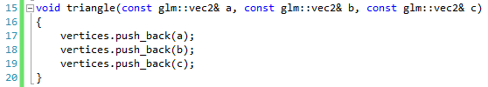

This operation just takes three vec2 objects and adds them to the end of the vertices vector. The three vec2 objects make up an individual triangle.

Let us also declare our divide_triangle operation (you will have to implement this shortly):



Now all we need to do is create our initialisation method:

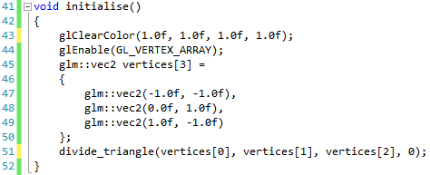

At the moment we will do no subdivisions for our Gasket. This will make the initial challenge easier. Now all we need is our render code:

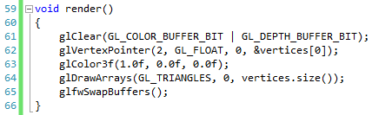

We set our vertex pointer to the start of the vertices array. The &vertices[0] code simply gets the address (the & operator is used as the address of operator) of the 0th (first) element of the vertices variable. This will give us the address of the internal array in the vertices vector, which is what we require. We then just tell OpenGL to draw an array (line 64) of type GL_TRIANGLES, starting at element 0, for size of the vector vertices.

## Challenge Part 1

For 0 subdivisions, our output is just the triangle defined by the three vectors:

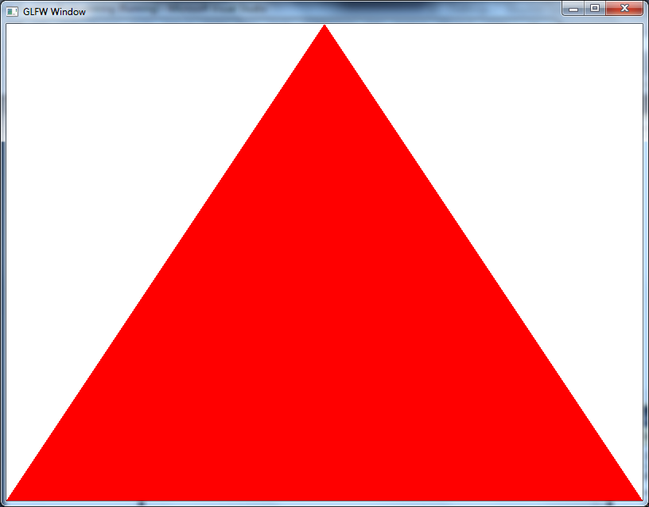

Create an initial version of divide_triangles which checks if the count is 0, and if so uses the incoming vertices as the triangle definition.

## Challenge Part 2

To subdivide the triangle for the Sierpinski Gasket, we need to use the following idea for the first subdivision:



From our first triangle we simply work out the midpoints on each side, and from these midpoints and the original points we define three new triangles.

Your challenge now is to implement the version that works for one subdivision of the Gasket. Don’t worry about the recursive version yet.

## Challenge Part 3

The next subdivision follows the same rule for each of its triangles. The second subdivision looks as follows:

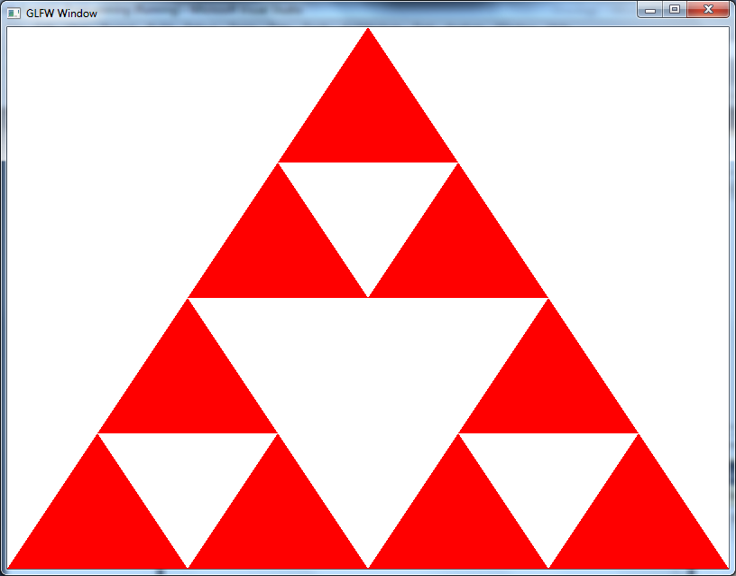

Your goal now is to modify your current version of the divide_triangle operation to provide a generalised recursive solution which will work for any number of subdivisions.

# Quaternions

We have now covered quite a bit of basic work with OpenGL, and about 10 to 15 years ago this would have stood you in good stead when working with OpenGL. We are now going to do some work with geometry, and look at building up a collection of geometric primitives to allow us to build more complicated scenes. However, first of all we are going to look at a better method for handling our rotations – using quaternions.

## Why use Quaternions?

Quaternions have a number of advantages over using rotations when it comes to working with 3D graphics. The main ones normally mentioned are:

* They utilise less space than a matrix when storing a rotation. However, this could be considered a lesser argument these days, and also typically we convert the quaternion into a matrix for use in our transformations anyway.
* Fewer arithmetic operations when concatenating (multiplying together) quaternions as opposed to transformation matrices. This can be very important in rendering applications.
* Quaternions can provide smoother animation.

## What are Quaternions?

A quaternion can be thought of as a four dimensional vector, defined as follows:

$$q=〈w,x,y,z〉=w+xi+yj+zk$$

If you are unfamiliar with the second notation, then let us take a look at the definition. Although you are probably used to seeing a three-dimensional vector defined as a collection of three values as follows:

$$\left[\begin{matrix}x & y & z\end{matrix}\right]$$

We can also define a vector as the addition of the scaled unit vectors. Here we have the following definitions:

$$i=\left[\begin{matrix}1 & 0 & 0\end{matrix}\right] \\ j=\left[\begin{matrix}0 & 1 & 0\end{matrix}\right] \\ k=\left[\begin{matrix}0 & 0 & 1\end{matrix}\right]$$

This means that the following two definitions are equal:

$$\left[\begin{matrix}5 & 7 & 8\end{matrix}\right]=5i+7j+8k$$

Sometimes you may see a quaternion defined as follows:

$$q=s+v$$

Here, $v$ is the three-dimensional vector part, and $s$ is a scalar representing the $w$ part of the quaternion definition.

## Using Quaternions to Represent Rotation

There are a number of other properties of quaternions that we could go into. However, for our purposes we only need concern ourselves with using them for rotations. We will use quaternions to store cumulated rotations – that is we will be adding rotations together to create a final rotation. This is a property of rotations proved by Euclid, which basically means that any combination of rotations can be represented as one rotation around an arbitrary axis. This is what we will be using quaternions for.

Remember that our definition of a quaternion is thus:

$$q=〈w,x,y,z〉=w+xi+yj+zk$$

The $〈x,y,z〉$ part is the axis that the rotation is being performed around (this will be a unit vector – one unit in length). All we need to do now is determine how to represent the angle. A quaternion representing a rotation, $θ$, around an arbitrary axis $〈x,y,z〉$ is defined as follows:

$$q=\left[\begin{matrix}\cos\left(\frac{θ}{2}\right) & x\left(\sin\left(\frac{θ}{2}\right)\right) & y\left(\sin\left(\frac{θ}{2}\right)\right) & z\left(\sin\left(\frac{θ}{2}\right)\right)\end{matrix}\right]$$

For example, if we wish to rotate an object π around the x-axis, we would build a quaternion as follows:

$$q=\left[\begin{matrix}\cos\left(\frac{π}{2}\right) & 1\left(\sin\left(\frac{π}{2}\right)\right) & 0\left(\sin\left(\frac{π}{2}\right)\right) & 0\left(\sin\left(\frac{π}{2}\right)\right)\end{matrix}\right] \\ q=\left[\begin{matrix}0 & 1 & 0 & 0\end{matrix}\right]$$

If we wanted to rotate an object $\frac{π}{2}$ around an axis pointing down the y-axis and z-axis, we would get:

$$q=\left[\begin{matrix}\cos\left(\frac{π}{4}\right) & 0\left(\sin\left(\frac{π}{4}\right)\right) & \frac{1}{\sqrt{2}}\left(\sin\left(\frac{π}{4}\right)\right) & \frac{1}{\sqrt{2}}\left(\sin\left(\frac{π}{4}\right)\right)\end{matrix}\right] \\ q=\left[\begin{matrix}\frac{1}{\sqrt{2}} & 0 & \frac{1}{2} & \frac{1}{2}\end{matrix}\right]$$

## Combining Rotations

So we now know how to represent a rotation using a quaternion. However, we also need to consider how we can combine the quaternions together to form rotations from a collection of rotations. We do this by multiplying quaternions.

### Quaternion Multiplication

The cross product operation of a quaternion is calculated as follows:

$$q_{1}=\left[\begin{matrix}w_{1} & x_{1} & y_{1} & z_{1}\end{matrix}\right]=\left[\begin{matrix}w_{1} & v_{1}\end{matrix}\right] \\ q_{2}=\left[\begin{matrix}w_{2} & x_{2} & y_{2} & z_{2}\end{matrix}\right]=\left[\begin{matrix}w_{2} & v_{2}\end{matrix}\right] \\ q_{1}q_{2}=\left[\begin{matrix}w_{1}w_{2}-x_{1}x_{2}-y_{1}y_{2}-z_{1}z_{2} \\ w_{1}x_{2}+w_{2}x_{1}+y_{1}z_{2}-y_{2}z_{1} \\ w_{1}y_{2}+w_{2}y_{1}+z_{1}x_{2}-z_{2}x_{1} \\ w_{1}z_{2}+w_{2}z_{1}+x_{1}y_{2}-x_{2}y_{1}\end{matrix}\right]$$

Let us test this. Consider that we want to rotate an object $\frac{π}{2}$ around the y-axis, and $\frac{π}{2}$ around the z-axis. This will give us the following:

$$q_{1}=\left[\begin{matrix}\cos\left(\frac{π}{4}\right) & 0\left(\sin\left(\frac{π}{4}\right)\right) & 1\left(\sin\left(\frac{π}{4}\right)\right) & 0\left(\sin\left(\frac{π}{4}\right)\right)\end{matrix}\right]=\left[\begin{matrix}\frac{1}{\sqrt{2}} & 0 & \frac{1}{\sqrt{2}} & 0\end{matrix}\right] \\ q_{2}=\left[\begin{matrix}\cos\left(\frac{π}{4}\right) & 0\left(\sin\left(\frac{π}{4}\right)\right) & 0\left(\sin\left(\frac{π}{4}\right)\right) & 1\left(\sin\left(\frac{π}{4}\right)\right)\end{matrix}\right]=\left[\begin{matrix}\frac{1}{\sqrt{2}} & 0 & 0 & \frac{1}{\sqrt{2}}\end{matrix}\right] \\ q_{1}q_{2}=\left[\begin{matrix}\frac{1}{\sqrt{2}}×\frac{1}{\sqrt{2}}-0×0-\frac{1}{\sqrt{2}}×0-0×\frac{1}{\sqrt{2}} \\ \frac{1}{\sqrt{2}}×0+\frac{1}{\sqrt{2}}×0+\frac{1}{\sqrt{2}}×\frac{1}{\sqrt{2}}-0×0 \\ \frac{1}{\sqrt{2}}×0+\frac{1}{\sqrt{2}}×\frac{1}{\sqrt{2}}+0×0-\frac{1}{\sqrt{2}}×0 \\ \frac{1}{\sqrt{2}}×\frac{1}{\sqrt{2}}+\frac{1}{\sqrt{2}}×0+0×0-0×\frac{1}{\sqrt{2}}\end{matrix}\right]=\left[\begin{matrix}\frac{1}{2} & \frac{1}{2} & \frac{1}{2} & \frac{1}{2}\end{matrix}\right]$$

The equation can also be written in a simpler form:

$$q_{1}=\left[\begin{matrix}w_{1} & x_{1} & y_{1} & z_{1}\end{matrix}\right]=\left[\begin{matrix}w_{1} & v_{1}\end{matrix}\right] \\ q_{2}=\left[\begin{matrix}w_{2} & x_{2} & y_{2} & z_{2}\end{matrix}\right]=\left[\begin{matrix}w_{2} & v_{2}\end{matrix}\right] \\ q_{1}q_{2}=\left[\begin{matrix}w_{1}w_{2}-v_{1}⋅v_{2} & w_{1}v_{2}+w_{2}v_{1}+v_{1}×v_{2}\end{matrix}\right]$$

Using this calculation for our previous example, we get:

$$q_{1}=\left[\begin{matrix}\cos\left(\frac{π}{4}\right) & 0\left(\sin\left(\frac{π}{4}\right)\right) & 1\left(\sin\left(\frac{π}{4}\right)\right) & 0\left(\sin\left(\frac{π}{4}\right)\right)\end{matrix}\right]=\left[\begin{matrix}\frac{1}{\sqrt{2}} & 0 & \frac{1}{\sqrt{2}} & 0\end{matrix}\right] \\ q_{2}=\left[\begin{matrix}\cos\left(\frac{π}{4}\right) & 0\left(\sin\left(\frac{π}{4}\right)\right) & 0\left(\sin\left(\frac{π}{4}\right)\right) & 1\left(\sin\left(\frac{π}{4}\right)\right)\end{matrix}\right]=\left[\begin{matrix}\frac{1}{\sqrt{2}} & 0 & 0 & \frac{1}{\sqrt{2}}\end{matrix}\right] \\ q_{1}q_{2}=\left[\begin{matrix}\frac{1}{\sqrt{2}}×\frac{1}{\sqrt{2}}-0 & \left[\begin{matrix}0 & 0 & \frac{1}{2}\end{matrix}\right]+\left[\begin{matrix}0 & \frac{1}{2} & 0\end{matrix}\right]+\left[\begin{matrix}0 & \frac{1}{\sqrt{2}} & 0\end{matrix}\right]×\left[\begin{matrix}0 & 0 & \frac{1}{\sqrt{2}}\end{matrix}\right]\end{matrix}\right] \\ q_{1}q_{2}=\left[\begin{matrix}\frac{1}{2} & \left[\begin{matrix}0 & 0 & \frac{1}{2}\end{matrix}\right]+\left[\begin{matrix}0 & \frac{1}{2} & 0\end{matrix}\right]+\left[\begin{matrix}\frac{1}{2} & 0 & 0\end{matrix}\right]\end{matrix}\right] \\ q_{1}q_{2}=\left[\begin{matrix}\frac{1}{2} & \frac{1}{2} & \frac{1}{2} & \frac{1}{2}\end{matrix}\right]$$

This is the same result, but with fewer multiplication operations (and hence faster).

## Converting a Quaternion to a Matrix

Once we have a quaternion representing a rotation, we need a method to convert the quaternion into a matrix so that we can use it in our transformations. This is done using the following equation:

$$M_{r}=\left[\begin{matrix}1-2\left(y^{2}+z^{2}\right) & 2\left(xy-wz\right) & 2\left(xz+wy\right) & 0 \\ 2\left(xy+wz\right) & 1-2\left(x^{2}+z^{2}\right) & 2\left(yz-wx\right) & 0 \\ 2\left(xz-wy\right) & 2\left(yz+wx\right) & 1-2\left(x^{2}+y^{2}\right) & 0 \\ 0 & 0 & 0 & 1\end{matrix}\right]$$

Using our example from before, we would create a rotation matrix defined as follows:

$$M_{r}=\left[\begin{matrix}1-2\left(\frac{1}{4}+\frac{1}{4}\right) & 2\left(\frac{1}{4}-\frac{1}{4}\right) & 2\left(\frac{1}{4}+\frac{1}{4}\right) & 0 \\ 2\left(\frac{1}{4}+\frac{1}{4}\right) & 1-2\left(\frac{1}{4}+\frac{1}{4}\right) & 2\left(\frac{1}{4}-\frac{1}{4}\right) & 0 \\ 2\left(\frac{1}{4}-\frac{1}{4}\right) & 2\left(\frac{1}{4}+\frac{1}{4}\right) & 1-2\left(\frac{1}{4}+\frac{1}{4}\right) & 0 \\ 0 & 0 & 0 & 1\end{matrix}\right] \\ M_{r}=\left[\begin{matrix}0 & 0 & 1 & 0 \\ 1 & 0 & 0 & 0 \\ 0 & 1 & 0 & 0 \\ 0 & 0 & 0 & 1\end{matrix}\right]$$

If we create the two rotation matrices we would normally develop using standard transformations, we get the following:

$$M_{r}=M_{1}M_{2}=\left[\begin{matrix}0 & 0 & 1 & 0 \\ 0 & 1 & 0 & 0 \\ -1 & 0 & 0 & 0 \\ 0 & 0 & 0 & 1\end{matrix}\right]×\left[\begin{matrix}0 & -1 & 0 & 0 \\ 1 & 0 & 0 & 0 \\ 0 & 0 & 1 & 0 \\ 0 & 0 & 0 & 1\end{matrix}\right] \\ M_{r}=\left[\begin{matrix}0 & 0 & 1 & 0 \\ 1 & 0 & 0 & 0 \\ 0 & 1 & 0 & 0 \\ 0 & 0 & 0 & 1\end{matrix}\right]$$

Which is the same answer as above (but with fewer machine operations).

## GLM to the Rescue

Knowing about quaternions is one thing, but using them in our code is another. Thankfully, we don’t have to worry ourselves with the inner workings of quaternions as GLM has quaternion functionality built in for us. We will simply exploit this in our code in the future. It is handy to know what a quaternion is, and roughly how they operate. If you want to know more (including the theoretical underpinnings) then read Section 4.6 of *Mathematics for 3D Game Programming and Computer Graphics* [2].

# Rotating Cubes with Quaternions

As with transformations, GLM can take care of our quaternion code also. In this practical we will simply utilise GLM’s quaternion constructs to rotate our simple cube example.

## Getting Started

Create a new project, and use the code from the indexed cube practical. To use quaternions in GLM, we need to include the necessary header file:



Also we will need to declare a quaternion variable:



Now let us modify the update code to rotate the quaternion.

## Update Code

Our update code takes the following form:

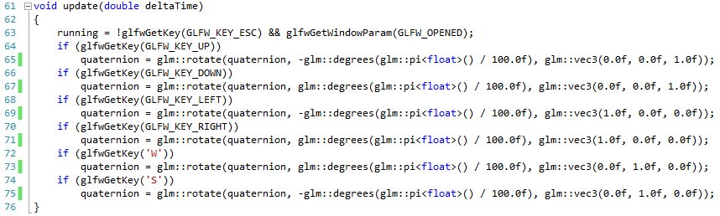

This should look fairly familiar from our previous work in rotations. Now what we are doing is rotating the quaternion using the rotate function. This takes three arguments:

1. The quaternion to rotate.
2. The angle to rotate by (we are doing 100th of a half-rotation or π / 100).
3. The axis to rotate around. For example to rotate around the X-axis we use (1.0f, 0.0f, 0.0f).

Now all we need to do is modify our render code to support quaternions also.

## Render Code

Our render code is very similar to before, and looks as follows:

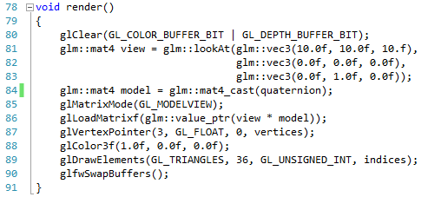

The new line is 84 where we convert the quaternion to a matrix using the quaternion::mat4_cast function. With this code in place, we can simply run our application and we will be able to rotate our cube quite easily:

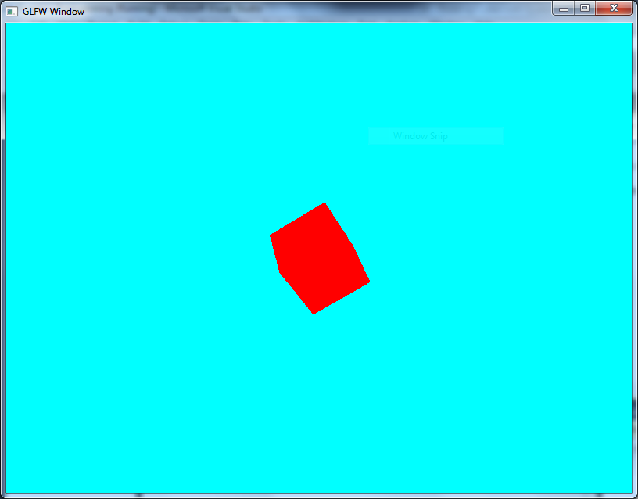

## Exercises

Experiment with this rotating cube to see if the same adverse effects from previous rotations are in effect.

# Generic Geometry Structure

We now know enough to start developing a reusable framework for dealing with rendering objects. The next two lessons will develop this simple framework. First of all, we need to define a geometry structure.

## Creating a Geometry Structure

In Visual Studio, right click on your new project and select **Add -> New Item…** Select **Header File(.h)** and call your file **geometry**. When the new file opens, add the following code:

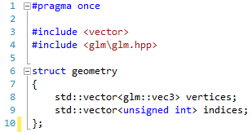

A header file just contains a collection of definitions which we can use elsewhere in our code. The #pragma once statement ensures that the header is only included once, hence avoiding conflicts with your code. Now let us look at how we can use this geometry structure.

## Using the Geometry Structure

First we need to declare a new geometry object in our code. We do this near the top as always:



We will also use our index data as before:

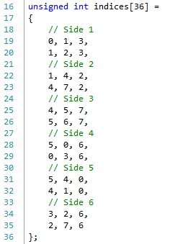

Then our initialise method is as follows:

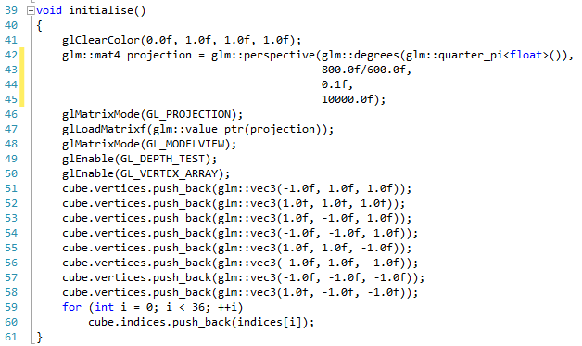

The first few lines should be familiar. Lines 51 to 58 show how we add our cube vertices to our vertices vector in the geometry. We just add one at a time, pushing them onto the back, extending the array. Finally, we push all the defined indices onto the indices vector.

## Rendering

Our render code is now quite simple:

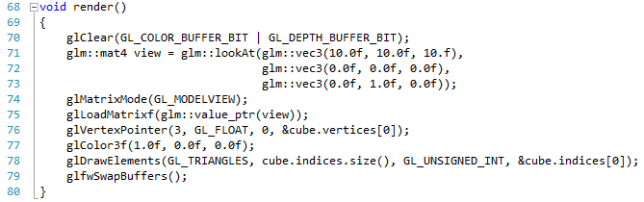

We clear and set up the model-view matrix as before. We then set the vertex pointer to the array stored in the vertices vector of the geometry (line 76). All we need to do is then call glDrawElements using the address of the array stored in the indices vector of the cube geometry (line 78). If you run this, you get the following:

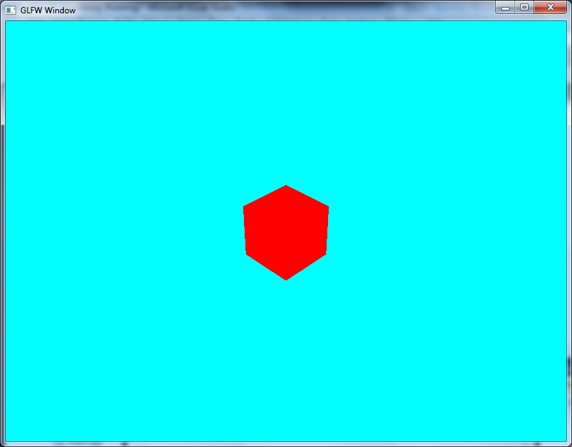

## Exercises

1. Try and apply a transformation to the cube so it draws in a different location.
2. Can you use two transformations to draw two different cubes? You can reuse the geometry quite easily.
3. Can you add many cubes to the scene?

# Generic Object Structure

Although our generic geometry structure is useful, we need to develop an even more generic approach that utilises transformations. This structure will essentially contain a pointer to a geometry structure (so we can reuse the geometry) and a transformation to apply to the geometry. Let us first define our transformation structure.

## Transformation Structure

Create a new project and copy across your main code file from the previous practical and your geometry.h file. The first thing we are going to do is add a transform struct to the geometry.h file:

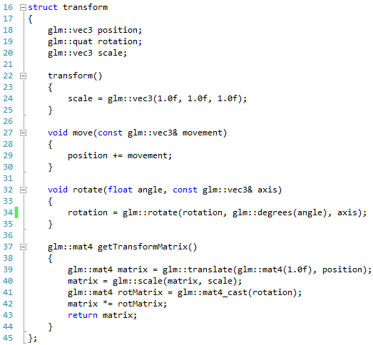

A transform has three values – its position, its rotation, and its scale. We utilise a quaternion for the rotation. Our constructor (lines 22 – 25) initialises the scale to 1.0f for all axes. We also supply methods to move (lines 27 to 30) and rotate (lines 32 to 35) the object.

The important new method is the getTransformMatrix method. This method allows us to generate the transformation matrix from the translation, scale and rotation of the object. We will see how to use this shortly. First we need to define our object structure.

## Render Object Structure

Our render_object structure also goes in our geometry.h file. This is just a structure that contains a pointer to a geometry object and a transform:

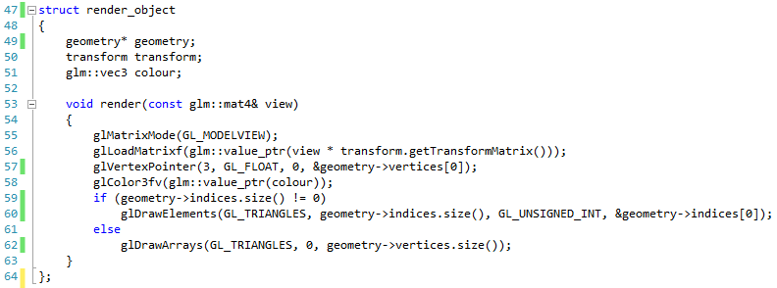

We have also included a vec3 to represent the colour. Our render operation simply takes the view matrix, multiplies this by the transform and then applies it to the model view matrix. We then set up our vertex pointer and colour. We then check if we have indices, and if so we use the glDrawElements call, otherwise glDrawArrays is called.

## Updated Application

Let us now use our new updated render object in our main application. First, we need to update our variables to the following:

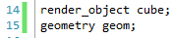

The geom variable will contain our geometry data. We will use this object in the cube render_object. This means that our initialise also requires updating:

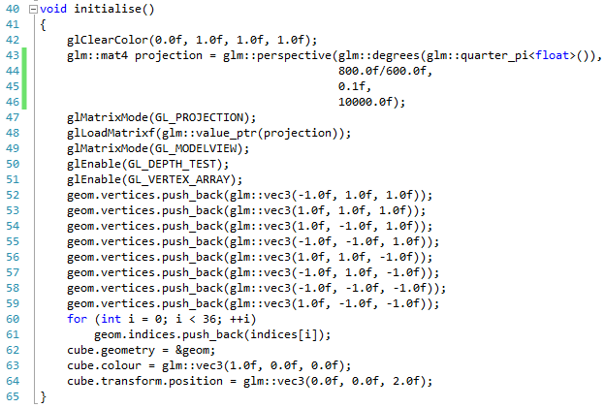

We are still setting up our geometry as before, but now we assign it to our cube render_object (line 62), set the cube colour (line 63), and set the position of the object (line 64). Now our render code becomes much simpler:

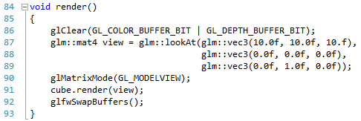

We create our view matrix as before (line 87) and then pass this into the cube render_object when we tell it to render. Our render is now very simple. The output should be as follows:

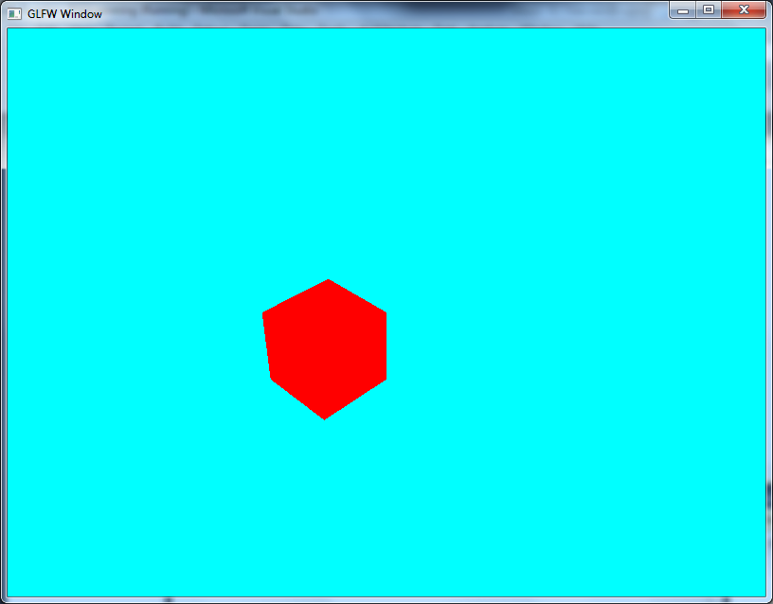

## Exercises

1. Add keyboard input to allow manipulation of the object.
2. Add some other cubes to the scene. Reuse the geometry but have other render_objects which have other colours and transforms.

# Box

Let us now start developing some basic procedures to build standard geometric objects. We will start with our existing box definition, and implement it in a reusable manner.

## Updating the Geometry.h File

The geometry header only needs one update – a new definition for a createBox procedure. Add the following line to the end of the geometry.h file:

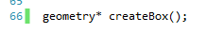

Now we need to define this code. This will require a geometry.cpp file.

## Implementing createBox

Add a new cpp file to your project called geometry.cpp. This code will contain a number of procedures as we build our reusable toolkit. Just now we are just going to implement our existing box code. Add the following to the geometry.cpp file:

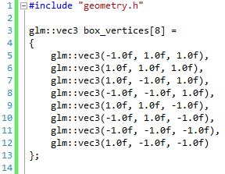

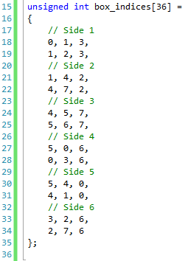

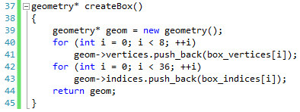

None of this code should be unusual. Notice we create a pointer to the geometry object, using new to allocate the storage on the heap. We can now reuse this box creation code as many times in our application. Let us do this now.

## Main Application

Our main application is now simplified. We need a render_object variable:



Our initialise code is also simpler, and calls createBox to create our geometry:

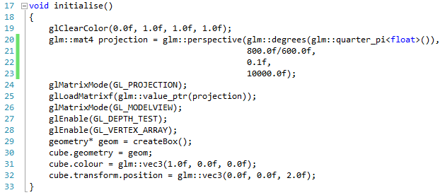

Our render code remains the same as last time. If you run this version, you should get the same result as before:

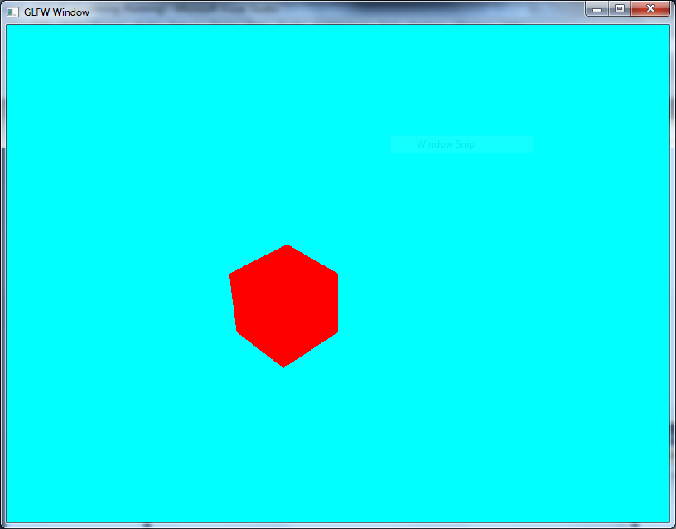

## Exercises

Again, repeat having multiple versions of the cube represented with different transformations, but reusing the same geometry.

# Tetrahedron

Let us now add a new shape to our geometry – a tetrahedron. A tetrahedron is like a box, but only has four sides (four triangles). The following picture (taken from Wikipedia) should give an impression of what a tetrahedron is:

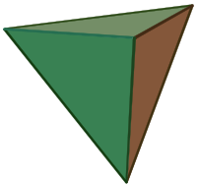

As you can probably imagine, the definition for a tetrahedron is similar to a cube, just with fewer vertices.

## Updating Geometry

First of all we need to declare our createTetrahedron procedure in geometry.h:



Next we need to add the necessary code to geometry.cpp. This code should be simple to understand by now:

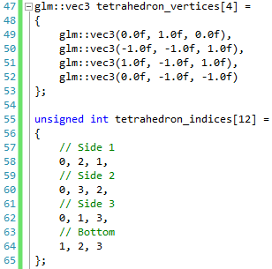

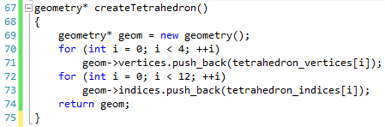

## Main Application

To build a tetrahedron we just need to change the call to createBox to createTetrahedron in initialise as shown below (line 25):

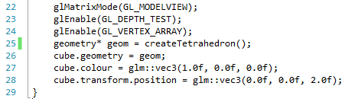

If you run this new application you will have a tetrahedron instead of a box:

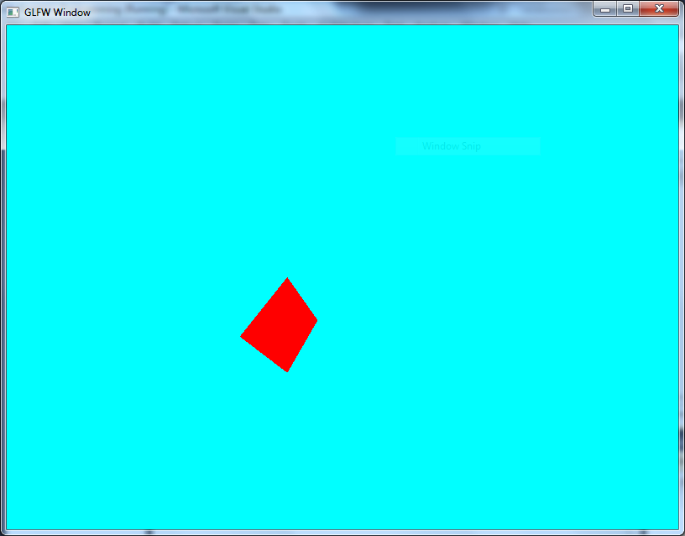

## Exercises

1. Add code to perform transformations to the tetrahedron. Use keyboard input to manipulate the position, rotation, and scale of the tetrahedron.
2. Create a scene with boxes and tetrahedrons.

# Pyramid

Let us create another piece of geometry using hard coded values before moving onto more interesting shapes using procedural code. The geometry we will create this time is a pyramid, which has triangle sides and a square base.

## Geometry Files

Our geometry.h file only needs a simple update as before:



Our geometry.cpp file required our vertices and indices definition, as well as the implementation of createPyramid:

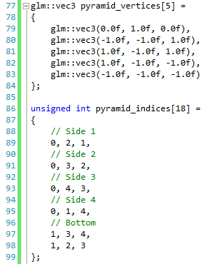

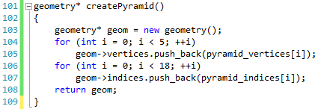

Again, this code should be familiar by now.

## Updating Main Application

Our update to the main code file again only involves us changing one line of code (line 25 below):

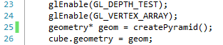

When run, we now get a pyramid:

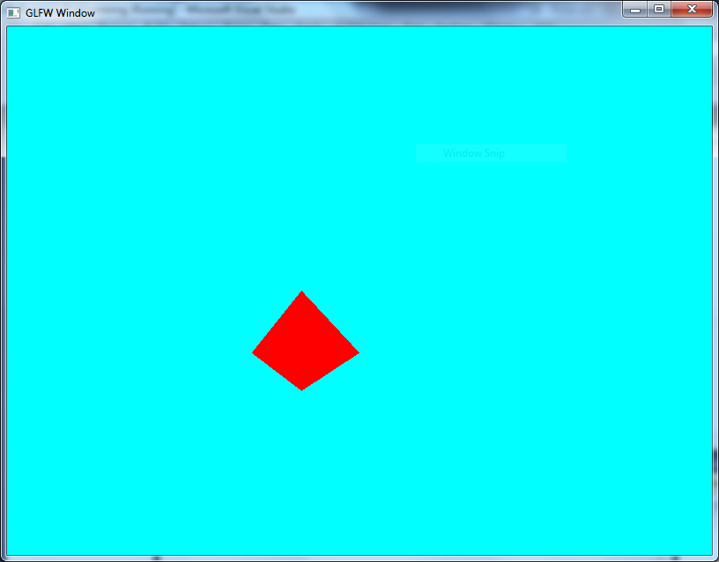

## Exercises

Can you create an application where the two pyramids are attached at the bottom (creating a crystal like structure)? Try and add the ability to rotate and move the object so that the crystal stays formed.

# Disk

Now that we have created some “hard coded” geometry, let us create more procedurally generated geometry. Our first piece of geometry we will create is a disk (or circle). This is a very simple piece of geometry to create, once you realise the process.

## Disk from Triangles

Remember that we are always dealing with triangles when working with 3D geometry (we could use quads as well, but triangles are easier in many regards). What we need to do is see how we can create a disk by using triangles. The technique we will use is best summarised using this diagram:



As can be seen, a hexagon can be made by 6 triangles. Now imagine that we use triangles with smaller and smaller angles at the centre. We can make a heptagon with 7 triangles, an 8 octagon with 8 triangles, etc. At a certain point, the triangle outer edges with become so short so that it gives the illusion of a disk (or circle). This is the technique we will be using.

## Working out Triangle Vertices

Now we know our technique, we need a simple method to work out the position of the vertices to make up our triangle. To do this, we use some simple trigonometry as follows:



If we know the angle created by the triangles edge, we can work out the length and height of the triangle very simply. We know this angle (it is 2π / number of triangles in the disk), and we will assume that the length of the hypotenuse is always 1 (we create a unit circle). We will also create the triangle aligned on the X and Z axis. We can therefore generalise our circle definition as follows:

$$Centre=\left(\begin{matrix}0 & 0 & 0\end{matrix}\right)$$

$$Vertex_{0}=\left(\begin{matrix}1 & 0 & 0\end{matrix}\right)$$

$$Vertex_{n}=\left(\begin{matrix}\cos\left(i×x\right) & 0 & \sin\left(i×x\right)\end{matrix}\right)$$

$$Triangle_{n}=\left\{Centre,Vertex_{n-1},Vertex_{n}\right\}$$

We will implement this function in our new code.

## Getting Started

We must first create the definition for our createDisk operation, which looks as follows:



The parameter slices represents the number of triangles that will make up the disk. Now let us implement our operation:

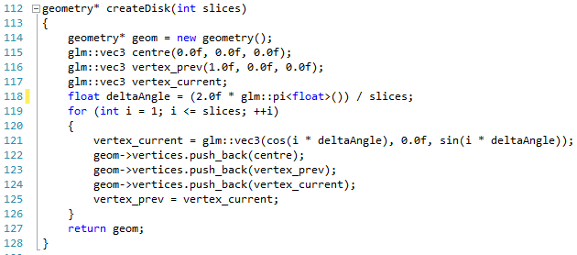

Examine the code and make sure you understand the similarity between this code and our functional definition above. It is quite important as we come to define more complex definitions.

All you need to do now is use this new operation in your main code to allow the creation of a disk (line 25):

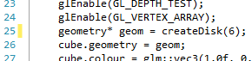

If you run this version, you should get the following:

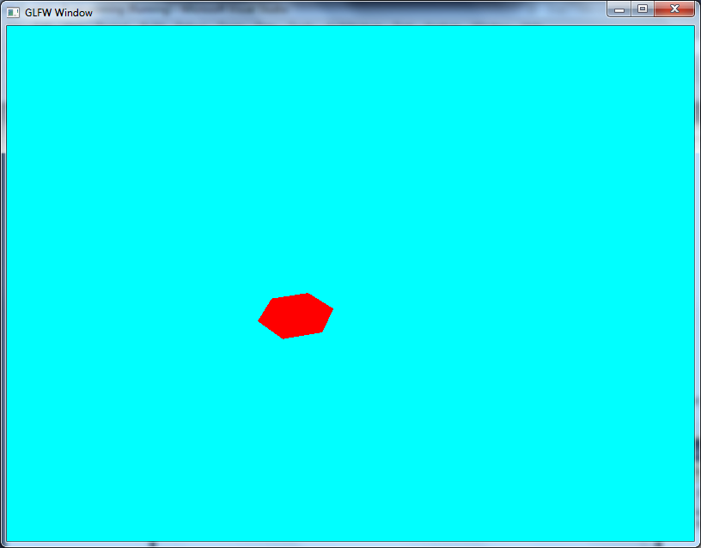

## Exercises

1. Try and find the number of triangles required to make the disk look like a circle.
2. Add some other disks by reusing the geometry and applying other transformations to the objects.
3. Add transformation code to your application to see what happens as you scale and rotate the disk.

# Cylinder

Let us now apply our generation method onto a (slightly) more complex piece of geometry – a cylinder. Again, once you know the trick with this you will see that it is quite easy to create.

## Cylinder from Triangles

A cylinder is just two disks (the top and the bottom) connected in the middle. You can think of it like this:

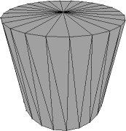

Our definition of a cylinder is a little bit more than this in that we have multiple “stacks” (sections that make up the centre piece of the geometry). Because of this, we can just use our disk based code and the notion of top and bottom of a stack to represent the Y component of the vertices.

## Getting Started

The first thing we need to do is declare our operation in the geometry.h file:



The implementation of this operation is split into three parts:

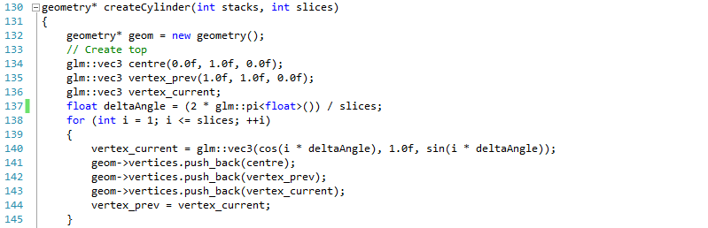

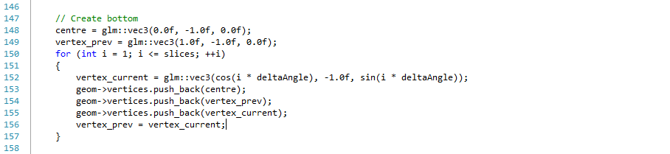

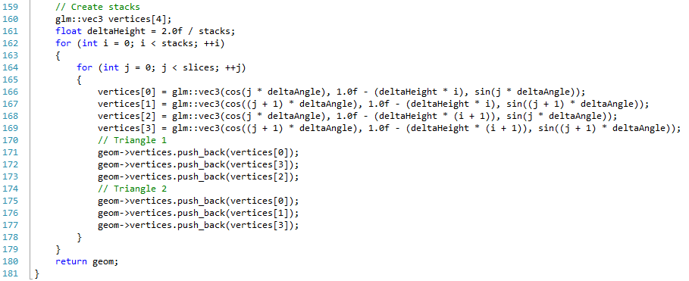

The top is just a disk with a Y component value of 1.0f. The bottom is a disk with a Y component of -1.0f. We then go through creating the individual stacks. We get the vertices that make up a quad of the stack (lines 166 to 169), and then use these to create the two triangles required for our geometry. We iterate through each slice creating these quads (the for loop starting on 163) and iterate through the stacks to create each of those (the for loop starting on line 161).

## Updating Main

To use our new createCylinder code we just need to call it in our initialise operation (line 25):

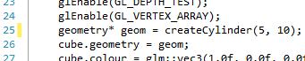

If you run this version, you will have a cylinder rendered on the screen:

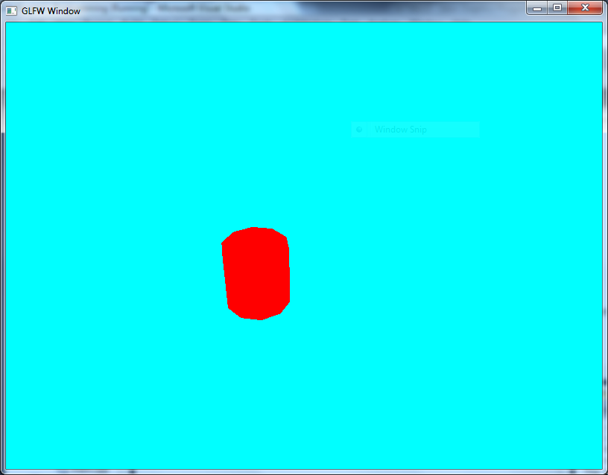

## Exercises

Try and create an application that will have three cylinders on top of each other, the top cylinder being red, the middle green, and the bottom blue. Can you rotate them in so that they stay together?

# Sphere

Let us apply the same technique we used to create a cylinder to create a sphere. The same principles essentially apply here as they did for a cylinder, except we do not have a top or bottom, and we also have to take into account the arc of the sphere when working out the width of the stacks. A 3D wireframe representation of a sphere is shown below:

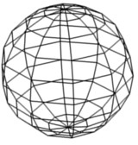

When dealing with a cylinder, we only worried about one delta angle. With a sphere, we worry about two. We will call these angles $θ$ (theta) and $ρ$ (rho). Apart from this consideration, we will still be using our stack and slice based approach to generate the geometry.

## Getting Started

First we need to declare our create sphere operation in geometry.h:



Now let us look at how we implement this method in geometry.cpp:

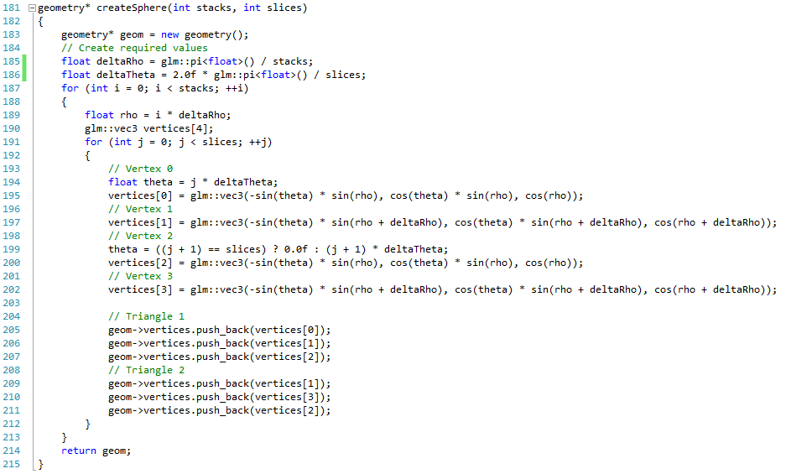

We first calculate the delta changes to the two angles for the sphere (lines 185 and 186). For $ρ$ this is only for the half the sphere circumference (we start from the top and go to the bottom – we don’t go top to bottom and back to top again). We then iterate through each stack (for loop starting on line 187) and then each slice (for loop starting on 191). We then just use simple trigonometry to work out the vertices for a quad (lines 194 – 202), and use these vertices to create our sphere (lines 205 – 211). Now let us see how we can use this.

## Using a Sphere

All we need to do to use our sphere is modify our initialisation code:

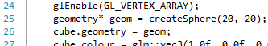

The modified line is 25. If you run this application, you will get the following output:

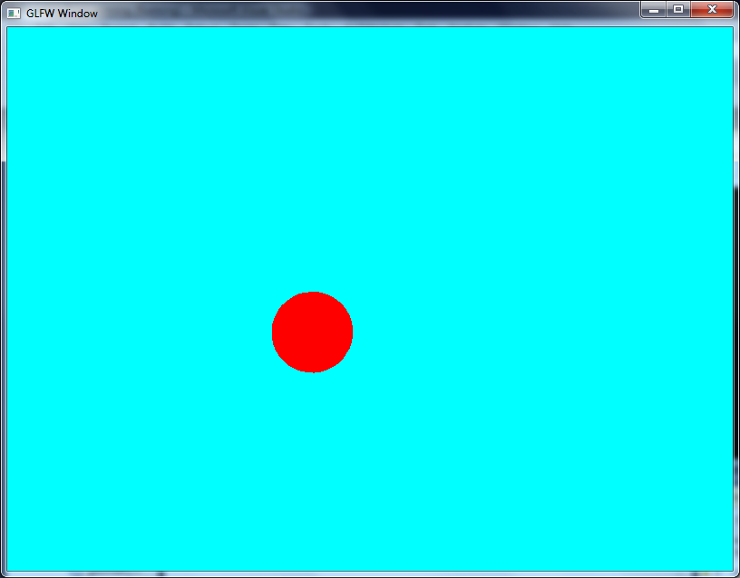

## Exercises

Explore what will happen when you modify the scale of the object on different axis. Does the scaling behave as you would expect?

# Torus

Let us now look at a more interesting shape which is commonly used in 3D due to its geometry – the torus. A torus is essentially a ring / doughnut shape:

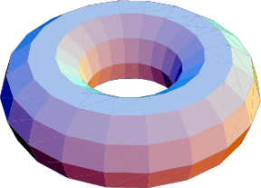

The above image also gives you an impression of how we develop this geometry – by using a stack and slice approach similar to the cylinder. This time however, the shape has no top or bottom and is continuous. Let us look at how we code this.

## Getting Started

First, add the following line to the geometry.h file:



We now have a radius value added to the operation which represents the radius of the torus. Some implementations of torus use two radius values – a major radius and a minor radius (the minor radius represents the radius of the actual torus body). Our implementation assumes a minor radius of one – we can then scale accordingly if we want.

The actual torus creation code is as follows:

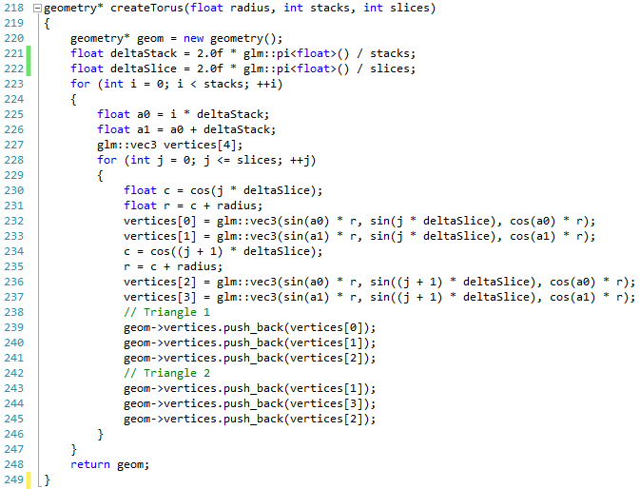

The code is similar to the cylinder code, except for two points:

1. The cylinder would not be sitting upwards
2. The Z component of the vertices is based on the current angle of the slice

## Using a Torus

Now we can create a simple application using the torus. This is just a simple change to initialisation as before:

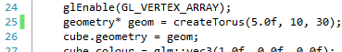

Line 25 is updated as always. Now if you run the application you will see the following:

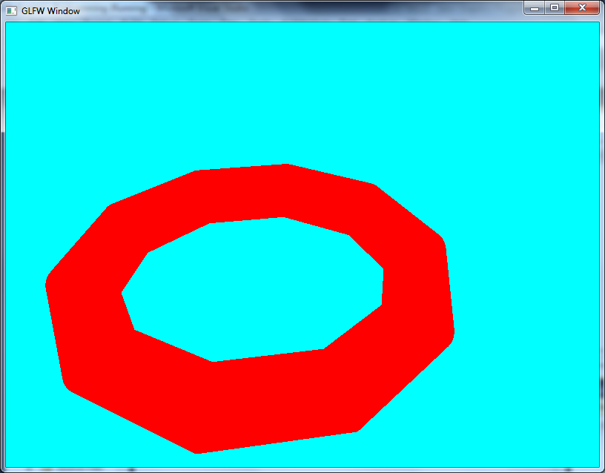

## Exercise

Try experimenting with the radius, slices and stacks values to see the result. What values are required to create a nice ring shape?

# Plane

Our last piece of procedurally generated geometry is a plane, which is essentially just a flat surface. This is actually a simple piece of geometry to create, so we will just get on with it.

## Getting Started

As always, we need to update our geometry.h file:



We only need two values to create a plane – the width of the plane and the height of the plane. Let us look at how we use these values to create a plane in geometry.cpp:

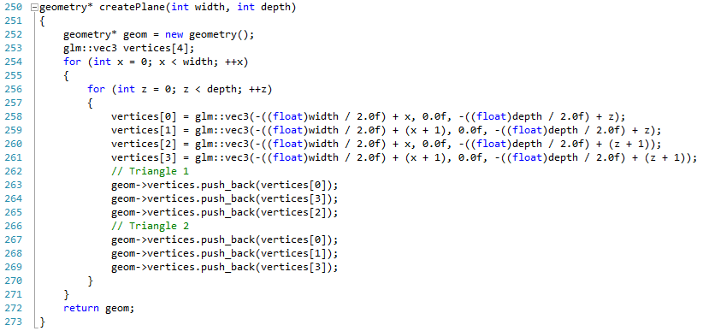

What we are interested in is how we define the vertices. We are assuming that the centre of the plane is at (0, 0, 0), and therefore we start at one corner (-width / 2, 0, -depth / 2). We then iterate towards the opposite corner (width / 2, 0, depth / 2). Now let us look at how we create a plane.

## Using a Plane

Again, we only need to change a single line of use our plane:

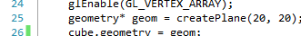

As always, line 25 is the changed line. If you run this application, you will get the following:

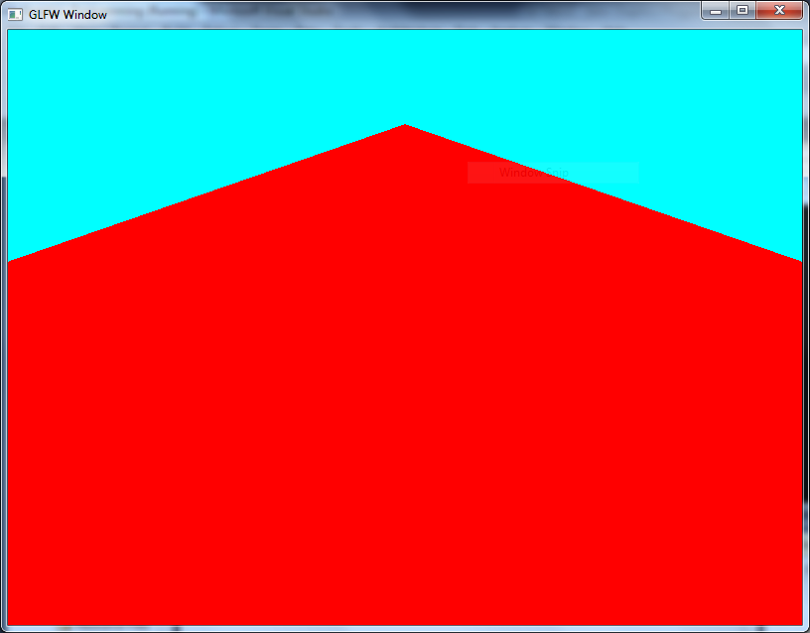

## Exercise

This exercise will take a bit of effort. Try and recreate the following scene:

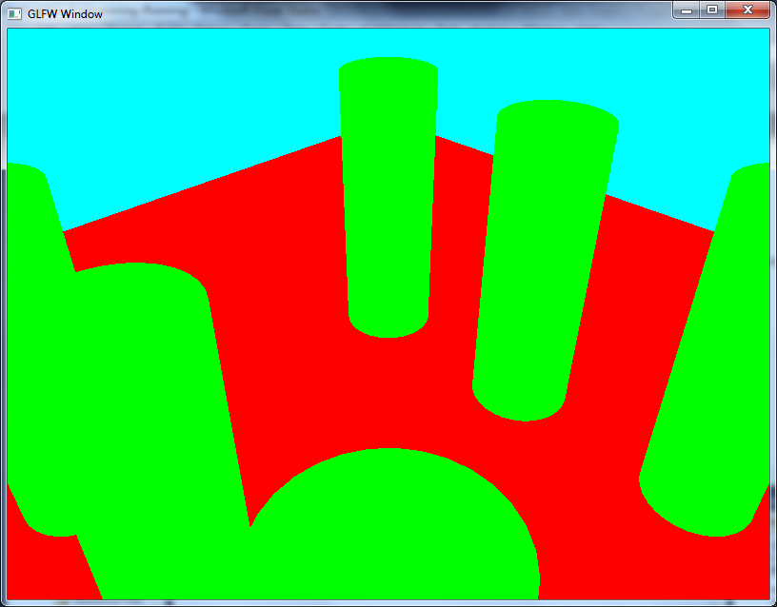

# Challenge – 3D Sierpinski Gasket

It’s been a while since we did a challenge, and also looked at Sierpinski’s gasket. Now let us try to create a 3D version of the gasket using the same recursive technique we did before.

## Getting Started

We are going to create code that utilises our geometry framework thus far. Therefore, you need to add the following line to the geometry.h file:



The divisions value represents the number of divisions we will make for the gasket. The geometry.cpp implementation for this operation is as follows:

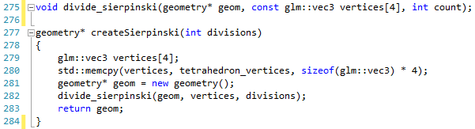

Notice that we are using the tetrahedron vertices defined before. All you have to do is implement the divide_sierpinski operation.

## Challenge Part 1

Your first goal is to implement the divide_sierpinski for a zero divisions (in other words just the tetrahedron). This should be fairly straight forward, and requires only adding the vertices to the geometry structure. Once implemented, you should be able to run the application and get the following output:

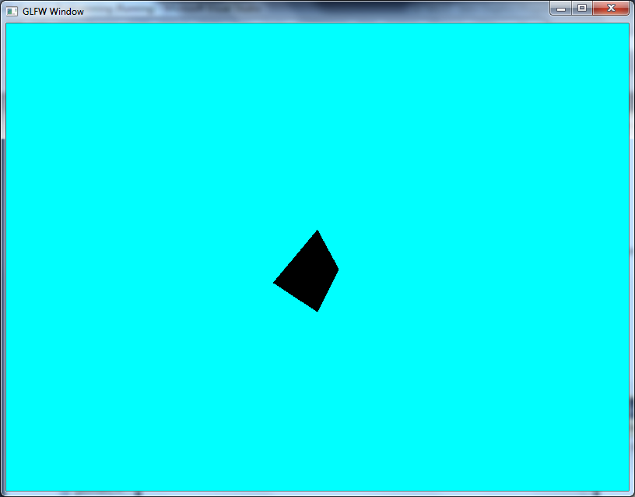

## Challenge Part 2

To get the division code to work, you need to think in the same manner as we did for the original 2D Sierpinski gasket (Section 12.3) but this time think about tetrahedrons rather than triangles. The logic is the same, but we now have to consider the 3D nature of the shape. Once created, you should be able to run the application and get the following output for 3 divisions:

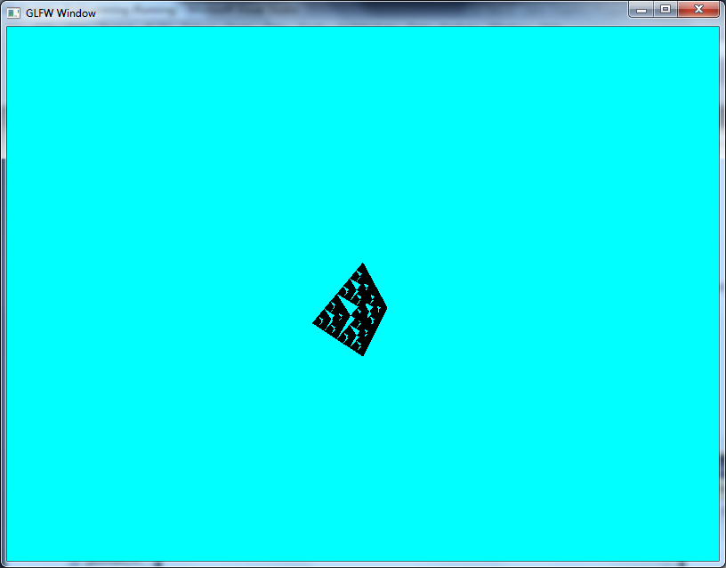

You might want to change the scale of the object to give yourself a better view.

# Using GLEW

Up until now, we have been doing OpenGL the old, deprecated, and most importantly the wrong way. From this point on, we are going to start using OpenGL properly. We do this by using the GLEW (GL Extension Wrangler) library. GLEW allows us to utilise shaders (GPU programming) and buffers (optimised rendering data) in our applications.

## Getting GLEW

GLEW can be downloaded from Sourceforge at <http://glew.sourceforge.net/>. You should be able to work out how to set up GLEW by our previous work, but there are install instructions available on the website. Once you have set up GLEW, we need to create a simple application to test the setup. In fact, we will use this opportunity to create a new default application structure.

## New Default Application

The following code is for our new default main code file:

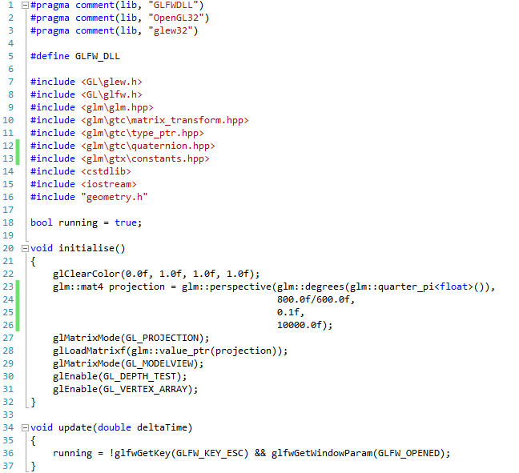

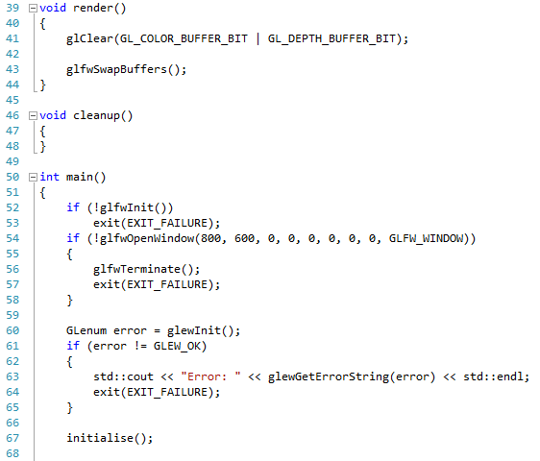

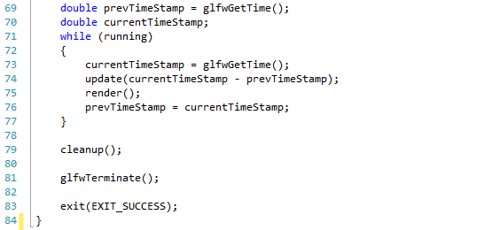

There is quite a bit of new code here, so let us go through it all.

Our first change is on line 1 where we state that we are now using GLFWDLL.lib instead of just GLFW.lib. This is for compatibility reasons. We also add a new define (GLFW_DLL) on line 5 because of this.

We also add another new lib file on line 3 (glew32). This is the GLEW library which allows us to use modern OpenGL functionality. Our include files are also updated accordingly.

Initialise is still the same as we have been working with, as is the basic update and render operations. We have also added a cleanup operation (line 46). We will use this to clean up used resources in the application.

Finally, our main operation has been updated to utilise GLEW. Notice that we just call glewInit and then check for an error. If we get an error, we display it to the console, otherwise we continue on as normal. After running is set to false (exiting the main loop) we call cleanup.

If you run this application it should display no errors on the console, and should compile and run OK displaying the empty blue screen. If not, you have done something wrong and need to backtrack a little, or ask for some help.

# Shaders

Now that we have got GLEW set up and working, we can move onto actually using GLEW to improve our rendering. The first technique we are going to look at is graphics card programming, using what is called shaders. Graphics card programming is the technique that allows us to create far more realistically rendered scenes with just some simple modifications to our existing approach.

## What is a Shader?

To put it simply, a shader is just a program that runs on the GPU, allowing us to create a particular effect based on input values, geometry, textures, etc. A shader is programmed in a separate language to the main application. Typically the language is C-like, and there are a number to choose from based on the platform you are working on:

* High Level Shader Language (HLSL) – a DirectX language.
* GL Shader Language (GLSL) – an OpenGL language.
* Cg – an nVidia proprietary language.

For our work we will be using GLSL, for obvious reasons.

A shader integrates into what is called the programmable pipeline, which can be visualised as follows:

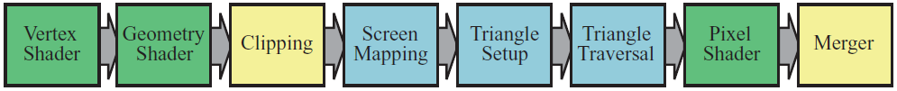

This image is taken from *Real-Time Rendering* [3]. The parts of the pipeline we are most interested in are coloured green. These are the programmable parts of the graphics pipeline. Each serves a different purpose, and we will look at these shortly.

## How do Shaders Work?

A shader is just one part of the process that converts our geometric data and other information into the image you finally see on the screen. As the previous image illustrated, there are actually three different types of shader programs that operate on the graphics pipeline. Each of these has a different purpose. At the start, the vertex shader is responsible for taking in raw geometric data, and positioning it world space (along with some other possible functions). Its main responsibility is to take a single vertex (a vertex shader is written to work on one piece of vertex information at a time), and convert the vertex’s position into world space (using the transformation matrices we have already discussed). At the opposite end of the pipeline, the pixel shader (or fragment shader as it is called in OpenGL terms) is responsible for determining the individual pixel colours associated with a triangle when represented on screen. This can include texture information, information from the vertex shader, or other lighting considerations.

### Why Shaders are Fast?

A good question to ask now is why shaders are fast at producing rendering effects. The main advantage shaders have is that although you develop a single program, multiple copies of this program are running on the GPU at one time. This is possible because each individual vertex can be transformed independently, and each individual triangle can also be worked on independently. This allows the GPU to run many versions of your programs, each operating on one piece of geometry information at a time. One the GPU has processed all information for a single piece of geometry (e.g. a cube, a 3D character, etc.), then other information and programs can be run through the GPU, producing a different part of the screen.

## Shader Types

As was illustrated in Section 27.1, there are three shader types (actually there are now four – but we won’t concern ourselves with the new tessellation shader). We will look at these in the following sub-sections.

### Vertex Shader

A piece of geometry sent to the graphics card could be considered just a triangle mesh (a collection of triangles making up a shape). Each triangle is made up of vertices (which it is the vertex shader’s responsibility to manipulate). These vertices can contain more than positional information – and in fact it is more common that they do contain more than just positional data. Colour, texture coordinates, normals, and any other information relative to a single vertex can be sent into the vertex shader. It is the job of the vertex shader to use this information to output the world position of the vertex, and also output any other generated information which might be useful to the later programmable stages.

### Geometry Shader

Whereas the vertex shader deals with an individual vertex, the geometry shader works on a single primitive piece of geometry (e.g. a triangle, a line, a point, etc.). This input primitive is then used to generate zero or more output primitives. This allows the geometry shader to add more geometry to a scene if required by the shader program. This allows such effects as fur and other concepts.

The geometry shader also allows data to be output from the GPU at this stage. What this means is that we can process a collection of vertex data into other geometry data, and then use this data for some other effect later in the render (in other words we don’t output our draw to screen, but rather to memory).

We won’t look at the geometry shader till much later in the module.

### Pixel (or Fragment) Shader

The pixel shader is responsible for determining the individual pixel colours represented on screen. This involves determining what colour the triangle is, using such techniques as normal colour, lighting, or texturing.

As with the geometry shader, it is also possible to output to memory rather than the screen at this stage. However, this time rather than raw data, we are creating a texture in memory which we can use for some other part of the render process.

## GLSL

As we are working in OpenGL, we will be using GLSL as our shader language. The goal here is not to describe all the fine details of GLSL, but rather build up your understanding by working through examples.

GLSL is a C-like language, and in general you should be familiar enough with the syntax we will discuss. To give you a brief example of what some shader code may look like, examine the following:

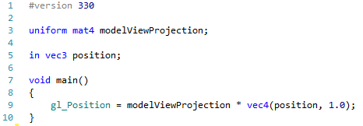

We won’t examine this code now, but hopefully you can see that there is nothing unusual about GLSL as a language.

## Using Shaders

There are actually a number of stages to loading and using a shader, which we will elaborate upon as we work through the rest of the module. Essentially we have to go through the following stages:

1. Read in the file containing the shader code
2. Create a shader object
3. Attach the read in text from the file to the shader object
4. Compile the shader object
5. Repeat 1 – 4 for all the shaders you want to load
6. Create a program object
7. Attach the necessary shader objects to the program object (can be many)
8. Link the program object
9. Repeat 6 – 8 for all the programs you want to create

We have used the word object here, but this isn’t the same idea as we use when developing object-oriented systems. OpenGL keeps track of the shader and program objects for us, assigning each a number when we create it. For example, we declare a variable for our shader and program as follows:

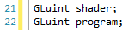

(A GLuint is just an unsigned int). We can then create an object using an OpenGL command. For example:



The type parameter is the type of shader we want to create (vertex shader, fragment shader, etc.). The glCreateShader command returns a value that is essentially an index for the created shader object (for example, the first created object returns a value of 1, the second 2, etc.). This means OpenGL manages the actual object for us; we just need the shader index number to call commands upon it. This is a common approach in OpenGL, and you will see us using this technique in many other places.

You may ask the reason why we use uint for our shader value. The answer is that we will never have values in the negative range, so there is no point having a signed value. Also, we can check if the object has been initialised correctly by checking that the value of shader is not equal to 0 (the same as if we were checking that an object was not equal to null).

### Compiling Shaders

When it comes to loading and compiling shader objects, we go through the steps illustrated by the code below (you aren’t adding this code yourself yet – that is the next lesson):

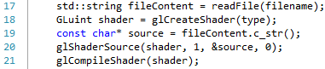

We read in the text from the file (line 17). We then create a shader object of the necessary type (line 18). We then get the underlying character array of the string (line 19) and use this to attach as the shader source for the glShaderSource command on line 20. OpenGL relies on character arrays rather than C++ strings, as it is essentially C based rather than C++. Hence we have to get the character array as above. The glShaderSource command takes four parameters:

1. The shader object index to use with this source
2. The number of character arrays that are to be used as source for the shader
3. A pointer to an array of character arrays used for our source
4. A pointer to an array of uint that contains the length of each character array. We use 0 (null) as this means OpenGL assumes the character arrays are null terminated. In our case they are as we have used a string to read in the file in the first place.

### Compilation Problems

It may be the case that we have a problem when we compile the shader. From our application point of view, we will get an error that wouldn’t really reflect the problem in our shader code. Because of this, we have to get the compilation log from OpenGL. We do this as follows:

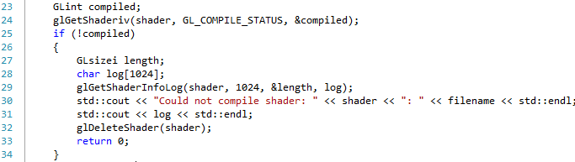

We get the state of the compilation by calling the glGetShaderiv command on line 24. We then check to see if the shader compiled OK. If not, we create a small buffer (technically we should get the length of the log and then create the correct sized buffer – we are being a bit lazy here), and then get the compilation log by calling glShaderInfoLog. We then print out the log accordingly. This can be a very useful piece of information when our applications don’t run.

### Linking Programs

Creating and linking programs follows a similar approach, although now we are attaching shader objects to a program rather than source code. The following shows the general process:

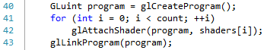

We create a program object (line 40), and then attach all the necessary shader objects to the program (assuming an array of shader objects, then we use the for loop defined on line 41) using the glAttachShader command. Finally, once all the necessary shader objects are attached we call glLinkProgram on the program object.

### Linking Problems

As with compiling shaders, we may hit a problem when linking. The following code is similar to checking for compilation problems:

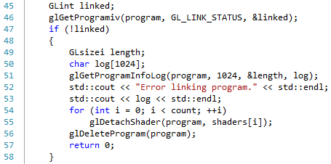

You should be able to determine what we are doing from the previous description.

## Further Reading

The two main texts for the module [1], [3] should help you in exploring shader concepts further. In particular, chapters 2 and 3 of *Real-Time Rendering* are a good starting point.

# Loading Shaders in OpenGL

Now that we know what a shader is, let us start building a simple shader framework to allow us to use these effects in our programs. We are going to start with a simple (and also deprecated) shader, but we are really just making sure that our application works first before moving onto more elaborate shaders.

## Shader Header File

First of all, let us create our header file for working with shaders (shader.h). This file just needs a couple of declarations:

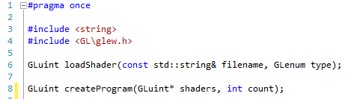

We will look at the implementation of these two operations shortly. The first operation is simply a helper operation to load a shader file of a particular type (vertex, fragment). The second operation takes an array of shaders and then uses them to create a particular shader program (a complete effect). Let us look at how we define these operations.

## Shader Code File

Our shader code (shader.cpp) file looks as follows:

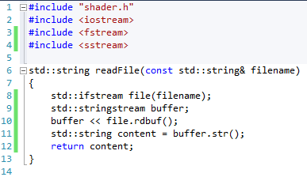

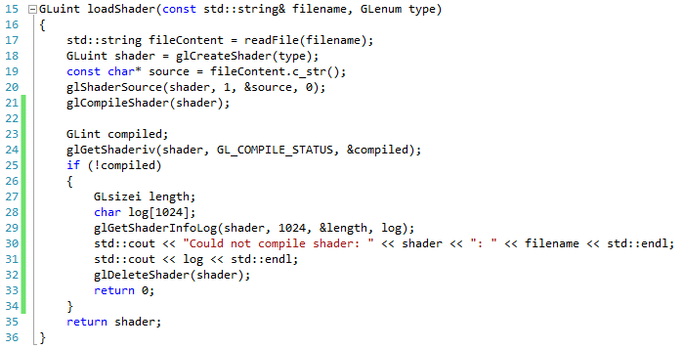

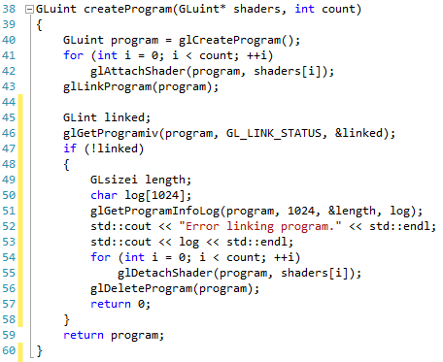

The first operation we define isn’t in our header declaration, and therefore is only visible to the shader.cpp file. This operation allows us to load in a file, and this is the standard C++ method of doing this. We go through the following steps:

1. Open the file as in input file stream (ifstream) – line 8
2. Create a string stream to act as a buffer to read the file into – line 9
3. We read the file into the buffer – line 10
4. We get the internal string of the buffer and use it as our file content – line 11

Our next operation is the load shader operation. This operation has the task of loading in the file and attempting to compile it. For this operation, we go through the following steps:

1. Read in the file of the given name – line 17
2. Create a shader object of the relevant type given – line 18
3. Get the underlying character array from the read in file – line 19
4. Set the shader source for the created shader object to the character array – line 20
5. We compile the shader – line 21
6. We check to see if the shader has compiled – lines 23 – 24
7. If not compiled, we get the shader compiler log, allocating space to read this into – lines 25 to 34
8. We return the shader object – line 325

The final operation is create program. In this operation we take an array of shader objects (a GLuint means we have a pointer to a GLuint, or the start of an array of GLuint – hence why we need a count), attach them to a program object, and then link the program. We perform the following steps:

1. Create a program object – line 40
2. Attach all the shader objects to the program – lines 41 and 42
3. Link the program – line 43
4. Check to see if the program linked OK – lines 45 and 46
5. If the link failed, we get the program link log, allocating space to read this into – lines 47 to 58
6. We return the program object

Basically, we will be performing the following steps when we start working with shaders:

1. Create the vertex shader object
2. Create the fragment shader object
3. Create the program object from the vertex and fragment shader

Let us now see what our simple vertex and fragment shaders look like.

## Simple Vertex Shader

Create a new **text file** in your project called **first.vert**. The code to put into this file is as follows:

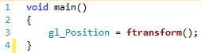

This program is very simple, and we will never use this functionality again (it is deprecated). The main role of the vertex shader is to set the position of the vertex in world space. This is done by transforming the original vertex position by the model, view and projection matrices. Normally, we would provide these values as parameters to the shader, but in old style GLSL we can use the ftransform function to get these values from OpenGL. The gl_Position value is the updated vertex position. Now let us look at the fragment shader.

## Simple Fragment Shader

Add another text file, this time called **first.frag**. The code for the fragment shader is as follows:

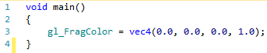

The job of the fragment shader is to set the pixel colour for the displayed object, based on whatever factors our code utilises. Here we are just setting our colour to black (0 red, 0 blue, 0 green, 1 alpha). Again, we are using deprecated features here to a certain degree, but we will quickly move onto doing this properly. Now let us build our test application.

## Test Application

The first thing we have to do is declare our necessary program variables. We do this near the top of the main code file:

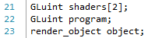

We declare two shader objects (line 21) and one program object (line 22). We also declare a render_object for our geometry. Let us look at how we now do our initialisation and rendering:

### Initialisation

Our initialise operation is where we are going to load in our shader programs. It looks as follows:

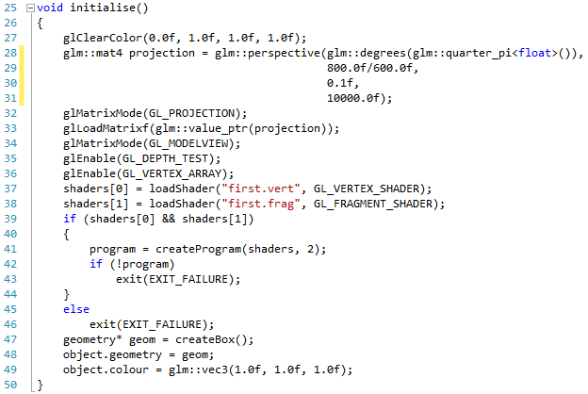

Lines 27 to 36 are as before. On line 37 we load in our vertex shader (using GL_VERTEX_SHADER), and on line 37 we load in our fragment shader (using GL_FRAGMENT_SHADER). We then make sure that both shader programs have been created (if they have not, then they will each be equal 0 – which equates to false in C++). If they have, we create the program on line 41, and then check that this succeeded on line 32. If any stage fails, we exit the application.

On lines 47 to 49 we create a box. Notice that we have set the colour of the box to white (line 46). Our shader however is set to output the box to black. Can you guess which colour the box will be? We will see shortly.

### Render

Our render code is similar in many regards to our original render code, except now we need to tell OpenGL to use our shader program. The render operation looks as follows:

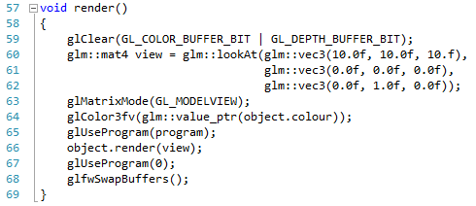

We clear the screen and create the view matrix as before (lines 59 to 63). We also set the colour of the object as before (line 64). Our new line is 65, where all we say is that we are using the program we created. We then call render as before (line 66), and then tell OpenGL to stop using the program (line 67). Not much to change to get the application to use the shader. Let us finish up by looking at the cleanup operation.

### Clean Up

Our cleanup operation is designed to free up any used resources by our application. All it has to do is cleanup any used resources, such as shaders and geometry. As we work towards a better rendering framework, we will start letting object destructors take care of this. The cleanup code looks as follows:

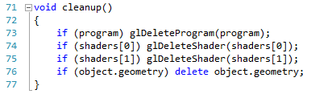

All we do is check if the objects are created (not equal to 0), and then delete accordingly - simple. If you run the application, you should see the following:

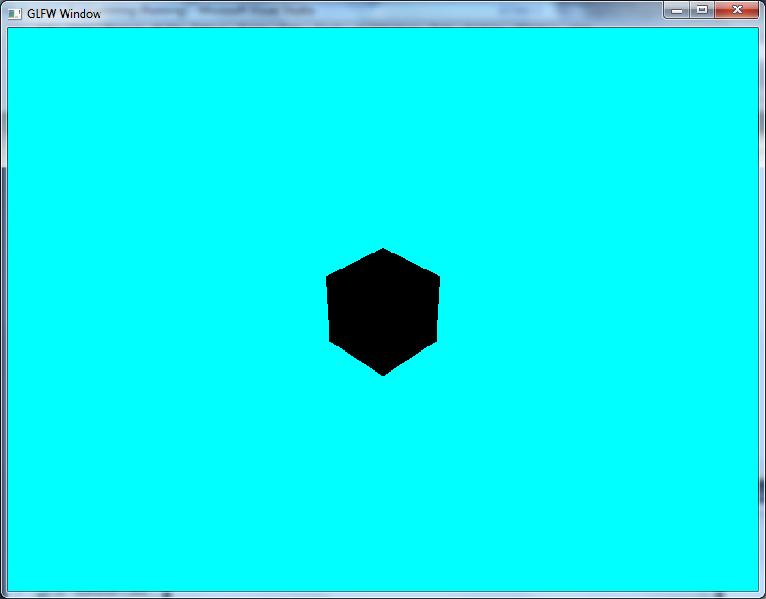

Our box is black – just as the shader said it would be. We now have enough of a framework to do a couple more shaders before moving onto buffers. First finish the exercises.

## Exercises

1. Try experimenting with the output colour of the shader to convince yourself that it is making the decision on the object colour.
2. Can you add some controls to the application so that you can manipulate the object? Pick whatever transformation you want, but make sure you are using keyboard input to control it.

# Your First Shader Program – Colours

We are now ready to start setting some values in our shaders, thus allowing us to have more control of the output at runtime. We are going to start simple by creating a colour shader, which will just output the object in the given colour rather than a hard coded value. First, we will do a little modification to our render_object struct.

## Modifying render_object

Up until now, we have been using three dimensional vectors to represent colour (red, green and blue). This is fine to a point, but colour in OpenGL (and computer graphics in general) has a fourth component – alpha (or opacity). Therefore, now that we have moved onto shaders, let us modify our render_object definition in geometry.h to use four value colour:

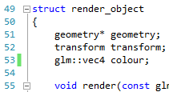

The modified line is line 53. We have simply changed from a vec3 to a vec4. Now let us look at our shader definitions.

## Colour Vertex Shader

Create **colour.vert** and use the following code:

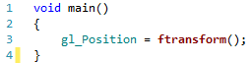

This is just the same as first.vert and needs no explanation.

## Colour Fragment Shader

Our colour.frag file is where we do some new things:

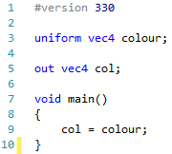

On line 1 we have a pre-processor definition for our fragment shader telling OpenGL which version we are using (in this case 3.3). This allows us to use more modern features (as of writing version 4.2 is possible, but 3.3 should work on most current hardware).

Line 3 declares a uniform of type vec4 called colour. A uniform is a value set on the shader which is the same for all incoming values used for this program. As a GPU can deal with many individual vertices and fragments in parallel, a uniform is just a value that is set for all these incoming values. We will see how varying values work in later lessons.

On line 5 we declare an out value of type vec4 called col. This out value is the output colour from the fragment shader, and is therefore used to display the colour on the screen. We also have in values which we will see later.

Our main shader code now just takes the uniform colour value, and then sets the outgoing col value to equal this. Our shader is still very simple, but the point here is that we are now using uniforms. We now need to see how we use these in our main operation.

## Main Application

We access uniforms defined in a shader program by probing the shader program for the location of these uniforms, and then using this location to set their value. Because of this, we need to have an attribute to store the location of the uniform. This goes at the top of our application:

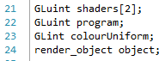

The new line is 23. Now we need to set this value in our initialise operation:

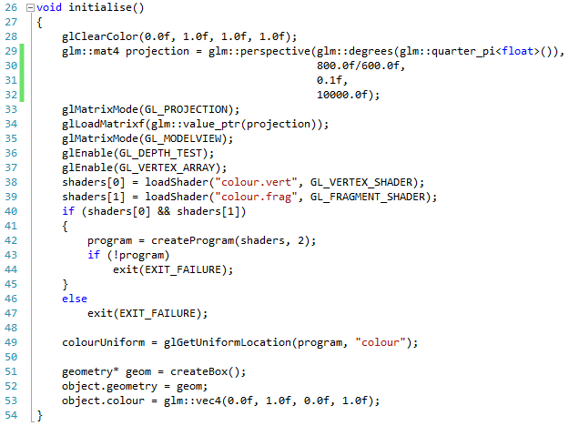

There are a couple of changes here. First, we need to load colour.vert and colour.frag (lines 38 and 39). Second, we need to get the uniform location. This is done on line 49. As you can see, the process is fairly straightforward. Also notice we set the colour of the object to green (line 53). We just need the program and the name of the uniform we want. To use this uniform, we need to modify our render operation:

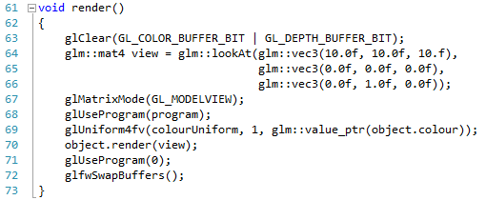

The only new line is 69, where we set the colour uniform to be the colour of the object. Notice that we set the uniform after we have said that we are using the program. This is important. Now, if you run the application you will get the following:

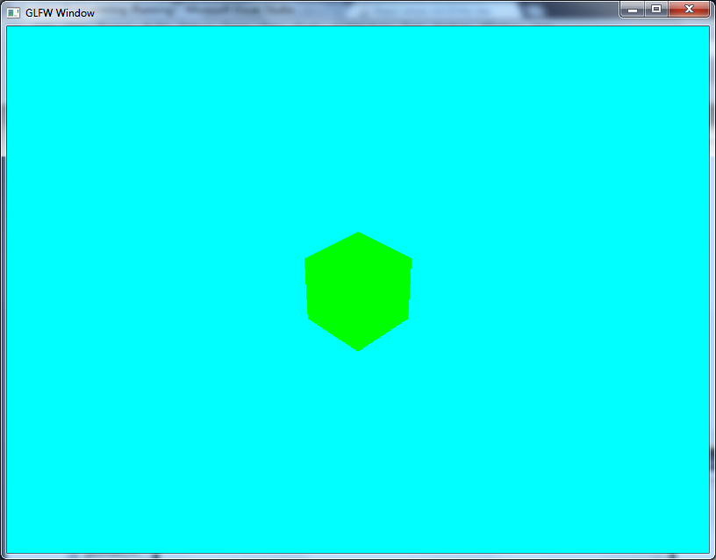

## Exercises

Add multiple pieces of geometry to your scene, each with a different colour. Use the shader, and set the uniform accordingly to render these objects so that their colour is correct. Also remember to use different transforms so that the objects aren’t all in the same location.

# Your Second Shader Program – Transformations

Our previous shader looked at setting the colour by using a uniform. This time, we are going to see how we set a uniform for the vertex shader (hint – it’s the same as doing so for the fragment shader), but in particular modifying our vertex shader so that it does things properly (non-deprecated). As before, we need to do a little modification to our geometry.h file due to the changes we are making.

## Updated render_object

Up until now, render_object took in the view matrix from the main application, and used this to set the model-view matrix of OpenGL. Now, we will be letting the shader handle this calculation, and therefore, render_object does not need to know about the view matrix – its sole purpose will be to send geometry to the GPU. Therefore, we need to modify our render method accordingly. The updated render_object code is as follows:

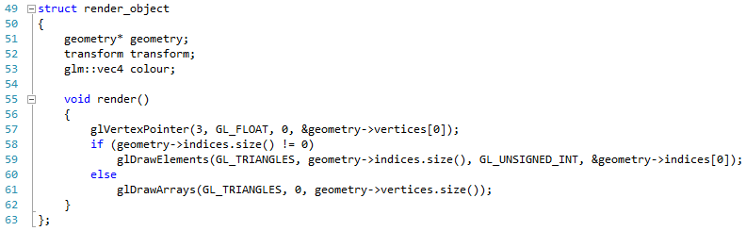

As you can see, this is much simpler and cleaner than our previous version. We will look at how we utilise our new render approach shortly, but first let us look at the shaders we will be using this time.

## Vertex Shader

Our transform.vert shader file looks as follows:

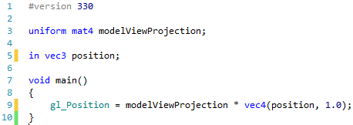

On line 1 we declare our version number as we did in our previous fragment shader. Then on line 3 we declare a modelViewProjection uniform of type mat4. This will be our combined model, view and projection matrices from our application. We also have an incoming vec3 called position (line 5). This is the vertex position sent in from OpenGL.

Our main shader code now sets the gl_Position value by multiplying modelViewProjection by the position (line 9). Notice that we need to make the position into a vec4 with 1.0 as the final component. This is so that we can perform our transformations correctly. The vec4 version of the position is known as a homogenous coordinate if you are interested. (As an aside, we could make all our geometry data work with vec4 and be a bit more efficient – however we are keeping things simple to avoid changing our existing code base. You can do this if you wish).

## Fragment Shader

Our transform.frag code is just the same as colour.frag:

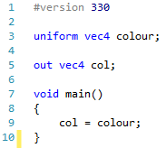

## Main Application

We are now ready to use our new shader. First we need to declare our new uniform in our attributes:

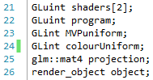

Line 23 is the declaration for our new uniform. Also notice that on line 25 we declare the projection matrix. We now need to store this as we need it for our shader.

Next, we need to modify our initialisation operation in a few places:

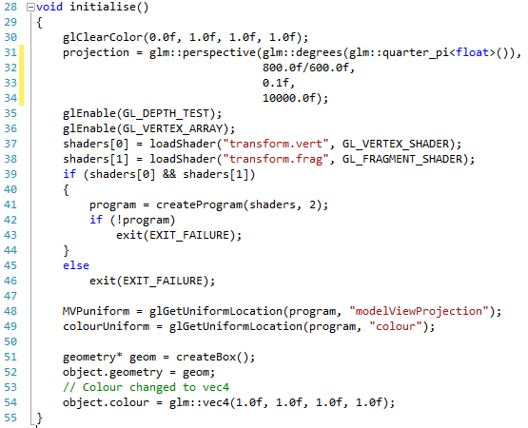

First notice that we are now just setting our projection matrix value instead of loading it into OpenGL (line 31). Next we change the name of the shaders we are loading (lines 37 and 38). Finally, we are also getting the location of the modelViewProjection uniform from the shader program (line 48). All we need to do now is see how we perform our render:

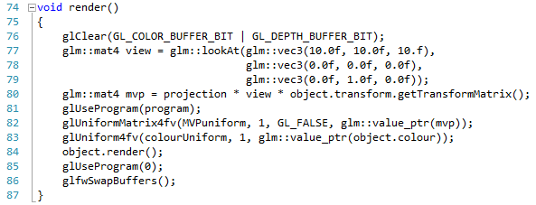

On line 80 we calculate our model-view-project matrix by multiplying projection by view by the transform of the object. We then set this value in the program (line 82), before calling render on the object (line 84). If you run this application, you should get the following (depending on what colour you set the box to):

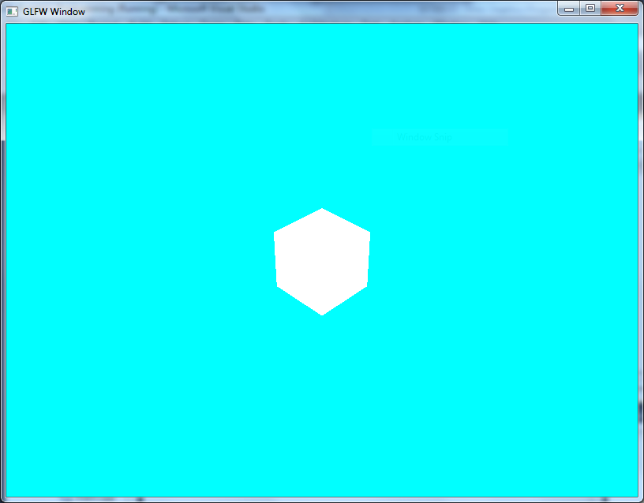

## Exercises

Again, try rendering multiple object with different transforms and colours using the same shader file. Also, try adding controls so you can move one of the objects around the scene.

# Doing OpenGL Properly: Working with Buffers

Now that we have our first two shader applications working, we are in a position to start utilising buffers in OpenGL. Up until now, we have essentially being assigning arrays of vec3 values to our geometry and then passing this to the graphics card for rendering. This is all well and good, but is actually not taking advantage of the fact that the graphics card has internal memory. What we are going to do is create a buffer object which allows us to assign our array of vertices on the graphics card (we will still have the array, or vector<glm::vec3>, in main memory). This will enable faster rendering overall.

## Defining a Vertex Array Object

We are just going to work with our previous transformation shader application. The first thing we are going to add is the following to the top of the main application file:

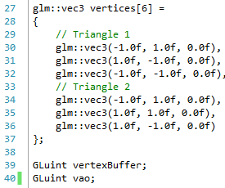

Lines 27 to 37 define a new set of triangles that we are using for our render (we will return to our procedurally generated geometry over the next couple of lessons). This should be fairly straight forward by now.

On lines 39 and 40 we declare two new GLuint values. The first is our vertexBuffer object, which will be used to store our vertices. The second is a Vertex Array Object (VAO). This object is used to store a collection of different buffers that make up a piece of geometry to send to the graphics card. At the moment we are only working with position, but we will soon be working with other values that make up a piece of geometry – such as normals.

Next, we need to initialise these values. This new code goes at the bottom of the initialise method:

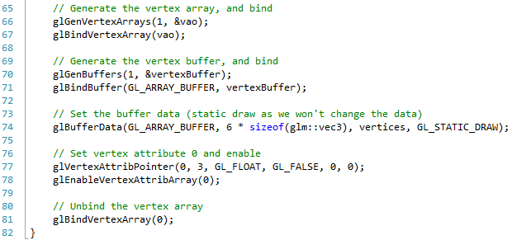

The comments help explain what is going on. We go through a number of steps:

1. Create the vertex array object (line 66). This call takes two values:
   * The number of vertex array objects to create
   * A pointer to an array of vertex array objects. In our case we are only creating one, so we just provide the pointer to our vao value.
2. We bind (use) the vertex array object (line 67)
3. We generate a buffer object (line 70). This is where our vertex position values will be going.
4. We bind the buffer as a GL_ARRAY_BUFFER (line 71). This is the standard buffer type we will be using.
5. We set the buffer data (line 74). This call takes four parameters:
   * The type of the buffer (GL_ARRAY_BUFFER)
   * The size of the buffer in bytes. We calculate this as the number of vertices (6) times the size of a glm::vec3
   * A pointer to the data to use. This is our vertices array
   * The buffer’s usage. At the moment we are using STATIC_DRAW. This means that the data will not be changing (the STATIC part), and we are using it to render (the DRAW part)
6. We set the vertex attribute pointer of the data within the vertex array object. This call is to do with how the data is sent to the GPU. It takes six values:
   * The index of the data when it is sent to the GPU. As we can have multiple streams of data sent to the GPU at once (we will be seeing this more as we go through the rest of our practical work), we need to tell the GPU where to send this data. For our position data, we are sending this to index 0
   * The number of components sent via this data type. Our positions are three dimensional vectors, so we have 3 components
   * The type of value for each component. Our glm::vec3 uses float values, so we use GL_FLOAT
   * Whether the data should be normalised. We will be looking at normals shortly. Our positions don’t need normalised, so we send GL_FALSE
   * The stride (space between each element) in the array we are using. It is possible to have many data types interleaved in our array data. However, we will be using buffers that contain only one type of data. Hence, we have a stride of 0
   * The pointer to the first element in the array. We don’t need to concern ourselves with this as we have buffers that store one data type, so we use 0
7. We enable index 0 of data being sent to the GPU (line 78)
8. We unbind the vertex array object (line 81)

Next, we need to do a slight change to our transform.vert file.

## Updated transform.vert

Our modification is only slight, but comes from our usage of buffers. Our new transfom.vert code is as follows:

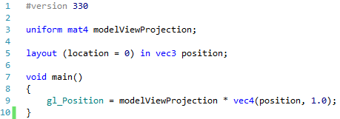

Our change is on line 5. We are now defining the layout of our incoming data. We state that the position value is coming in on location 0. Remember, when we created our vertex array object, we stated that the vertex positions were using index 0. This is a direct match. We will be adding more incoming data as we work through the rest of our material.

## Render

Our render is slightly different as well now. The following is our new render code:

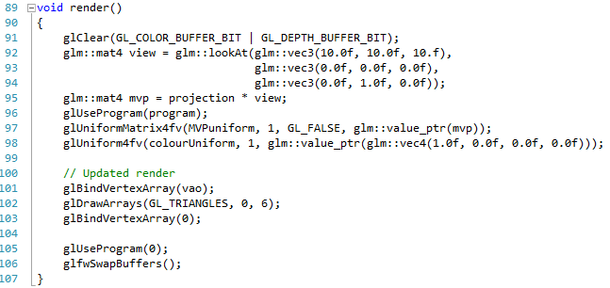

Our new code is lines 101 to 103. All we do is bind the vertex array object (line 101), call draw arrays as normal (line 102) and finally unbind the array (line 103). If you run this application, you will get the following:

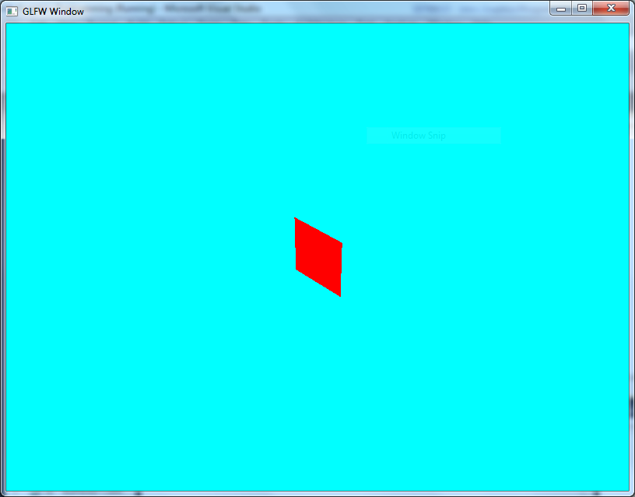

## Exercises

Again, experiment with drawing multiple instances of the square with different transforms just to make sure you fully understand the concepts introduced.

# Buffered Cube

We have now seen how we use buffers instead of standard arrays for rendering. Let us now expand this knowledge into our existing geometry code. We will start off with just the cube first and next practical we will look at how we extend this idea into the rest of our geometry. The first thing we need to do is update our definition in geometry.h.

## Updated Geometry Structure

Our updated geometry structure looks as follows (you will also have to include the GLEW header):

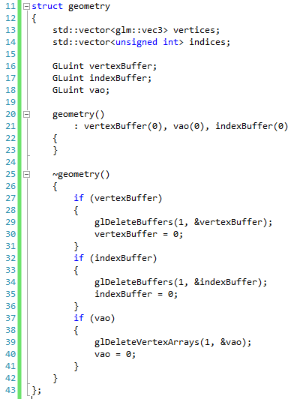

Notice that we have added a bit of new code here. Firstly, we have added three new attributes – a vertex buffer (to hold our positions), an index buffer (to hold our indices), and our vertex array object.

We also have a constructor, which simply initialises the three attributes to 0 (null). Also notice that we now have a destructor for the geometry struct. Its job is to clean up any resources by deleting the buffers accordingly, and setting the values to 0 (null).

We also need to update render_object as it will no longer be responsible for rendering itself (it will just be a collection of data. Our render_object code therefore becomes:

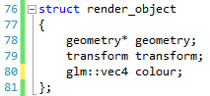

Finally, we need to do one minor change to our transform struct. This is just a minor change:

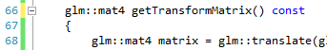

We make the getTransformMatrix operation const, meaning that we are stating it doesn’t change the state of the transform object (which it doesn’t). This allows us to write more rigorous code later.

Now we need to change how we create our cube.

## Updating Create Box

The main role of the box creation operation is to initialise the vectors accordingly. Now that we are using buffers, it also has a role in creating the necessary buffers for the geometry. Our new create box operation in geometry.cpp looks as follows:

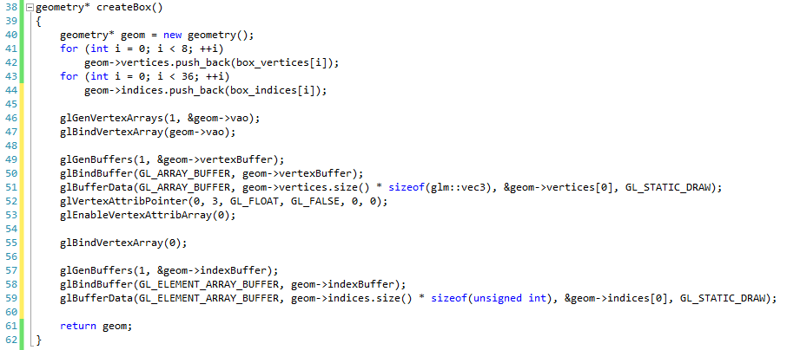

Lines 40 to 44 are the same as before. Now all we are doing is adding the code to initialise the buffers. We generate and bind the vertex array object (lines 46 and 47), and initialise the vertex buffer accordingly (lines 49 to 53). The new part is where we generate the index buffer. Notice this time we are generating an array of GL_ELEMENT_ARRAY_BUFFER. This is the type of an index buffer that we put on the GPU. Otherwise we just create the buffer as we did the vertex buffer.

## Rendering the Cube

Now we need to modify how we are rendering our objects. We will do this by adding a new render operation to our main application:

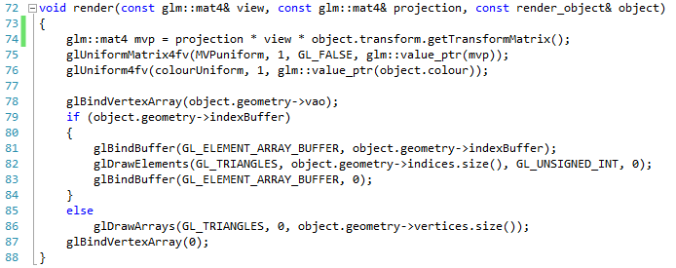

This operation essentially takes a view and projection matrix, as well as the object to render, and performs the render operation. Why we are doing this will become clear as we continue through the lessons, but we are essentially trying to treat our geometry and render_object structs as data only, and having the code to perform the render as a helper operation.

The core idea here is that we bind the vertex array object of the render_object, and then check if the render_object has an index buffer. If it does, we bind the index buffer and call draw elements. If it doesn’t have an index buffer we just call draw arrays.

With this new render operation in place, we can now return to our main render operation, which is now simplified:

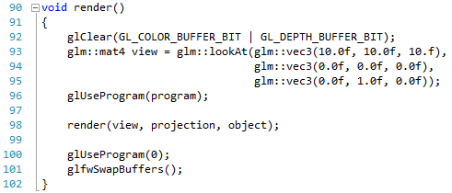

We use the program as before, and then call render with the view and projection matrices, and also the render_object. If you run this version, you will get the following:

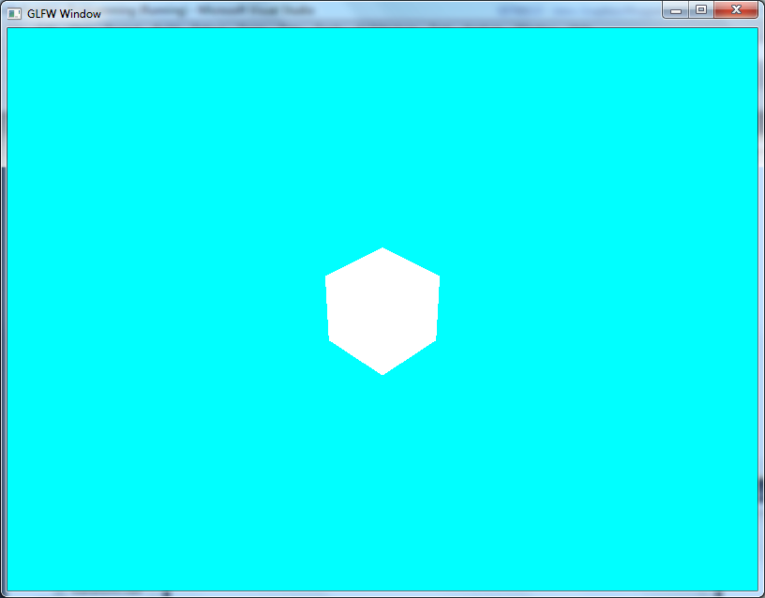

A lot of work for the same output we already had, but as we work through shaders you will see the advantage. Also, we are being more efficient by using buffers.

## Exercises

Again, try creating multiple boxes with different colours and positions just to make sure you know what is going on.

# Updated Geometry

We are now in a position to update all our procedurally generated geometry so that it uses our new geometry structure. These changes are very boilerplate (they are essentially the same for all the geometry), so we will look at a few, and then you can do the rest as an exercise.

## Updated Tetrahedron

Our new create tetrahedron code is as follows:

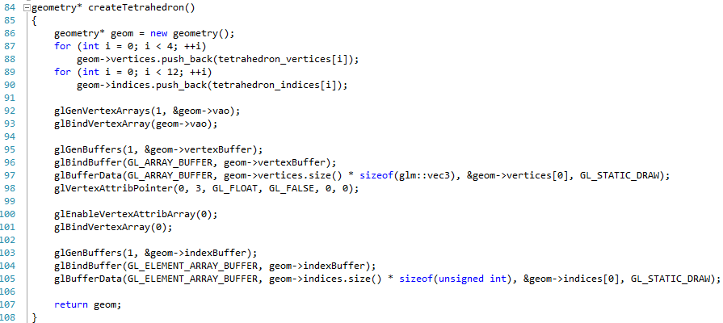

Notice that we are doing exactly the same changes as we did to the create box code. Modify your main application to use the tetrahedron just to confirm you have it done correctly.

## Updated Pyramid

The new create pyramid operation adds the same code as we did for box and tetrahedron:

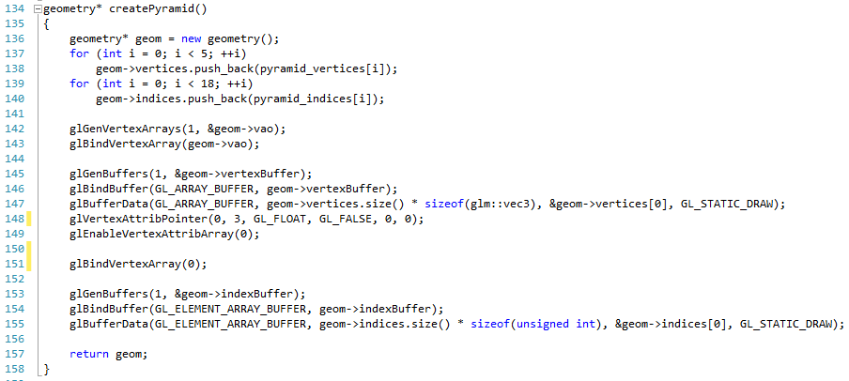

Again, modify your main application to make sure everything is OK.

## Updated Disk

The disk code doesn’t use any indices, and therefore is simpler than the previous pieces of geometry:

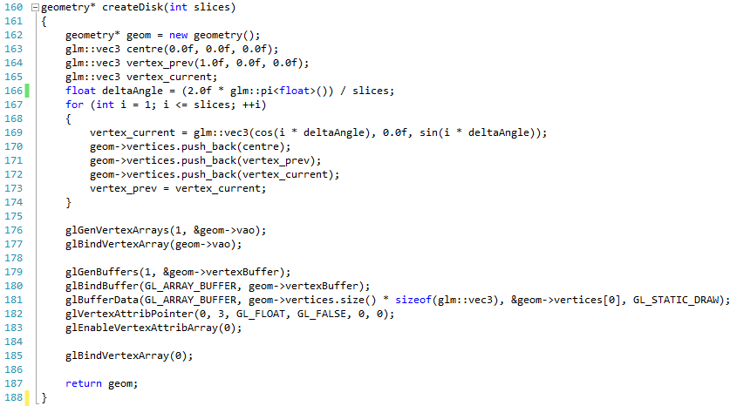

Again, test your code for accuracy. Now you should know enough to complete the others by yourself.

## Exercise

Modify the remaining geometry creation operations so that they now use buffers. Each time you create one, test it to make sure that it works. The ones you have to create are:

1. Cylinder
2. Sphere
3. Torus
4. Plane
5. Sierpinksi

# Lighting

We are not working with OpenGL far more effectively than we were originally, utilising GLEW, shaders, and buffers. We are now ready to start working on doing more useful effects. Over the next few lessons, we are going to focus on lighting, examining the different types, and implementing some lighting models in our shaders. We are building up current standard rendering techniques as we work now, and you will start to see your renders becoming more realistic as we work (when we introduce texturing much later, you will see some real differences when we combine light and textures to create realistic scenes).

## What is Lighting?

Lighting is actually a involves three pieces of physical information. These are:

1. Light emitters (for example, the Sun, a desk lamp, reflection from another surface)
2. Materials (describe how an object interacts with a light – what is absorbed, reflected)
3. Sensor (something to absorb the light – for example an eye, electronic sensor, film)

Over the next few lessons you will see that we use each of these pieces of physical information to create a lighting model for a particular rendered scene.

## Light Source

A light source is something that emits rather than absorbing or scattering light. There are a number of different potential light sources in a scene, and we will explore these different sources over the next few lessons. As a simplistic model of light, we can consider the following three types:

* Ambient light (light that is everywhere in a scene at equal measure)
* Diffuse light (light that has a direction and therefore reacts with an object’s surface differently based on this direction)
* Specular light (specular highlights – the shiny white reflection on a sphere for example. This requires knowing the position of the viewer and the direction of the light)

Our simplistic model utilises RGB colour values, each of which has intensity. We have already been using colour in RGB values, so you should be familiar enough with the concepts involved. However, although we typically consider RGB colour to range in values from 0.0 to 1.0, it is quite possible for light to go above 1.0 in any of the components.

## Materials

Materials describe the surfaces of objects. Up until now, we have considered our geometry as just that – a collection of geometric values that allow us to represent an object in 3D space. Materials are essentially a collection of colour values, textures, shaders and other information that allow us to describe what an object will look like, and how it will interact with the lighting of the scene.

Initially, we are just going to consider materials as a collection of colour values. These values will match our three lighting values defined in Section 34.2. That is, we have the following:

* Ambient material – describes how the ambient light of the scene interacts with the object
* Diffuse material – describes how the diffuse light of the scene interacts with the object
* Specular material – describes how the specular light of the scene interacts with the object

We have used the term interacts in these definitions. There are basically two properties we are concerned with when thinking about how light interacts with an object. These are scattering and absorption.

### Scattering

Scattering causes light to change direction, without reducing the amount of light involved. To put it simply, when light interacts with a mirror, you can consider the effect involved as a change in direction of the incoming light to the mirror. Essentially, a scattering effect causes the light to come in two different directions – light into the surface (called refraction) and light out of the surface (called reflection). This is an important concept when working with surfaces such as water. The following illustration, taken from *Real-Time Rendering* [3], should help illustrate reflection and refraction.

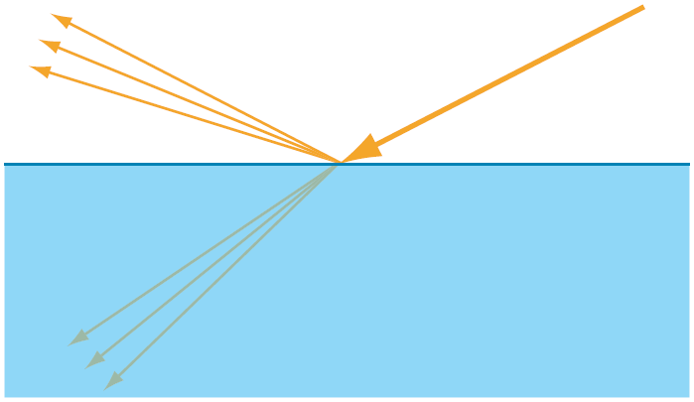

### Absorption

Absorption relates to the light that is captured by an object, converted into some form of energy, and therefore no longer affects the lighting of a scene. Absorbed light doesn’t change direction.

## Sensors

For an object to be visible, some of the light that has interacted with the object needs to be absorbed by a light sensor. A light sensor will actually be composed of numerous smaller sensors, each of which detect a light signal, and convert it into a colour value (we can take a simplistic view here, and consider each pixel we render to be an individual light sensor). There is much more to a light sensor than this (apertures, lens, etc.). The recommended reading will explain further.

## Recommended Reading

Chapter 5 of *Real-Time Rendering* [3] covers Visual Appearance, which includes lighting and other tehniques.

# Ambient Light

With our basic understanding of light, we can start working on the simplest form of lighting – ambient light. Ambient light is light that is considered uniform across the whole scene, and does not take into account concepts such as light direction.

## Examples

In Section 34.3, we described the idea of light being reflected from one object’s surface onto the rest of the scene. This is essentially how we are able to see objects in the first place (we see the reflected light from the object). Obviously, not all the light that interacts with an object is captured by a light sensor. Light that interacts with an object may be redirected, and interact with another object, etc. This is means that although there may only be one light source in a scene, light can interact with an object that is not in the same direction as the light source. This provides light that can be considered almost background to the scene. This is ambient light.

As an example, consider the desk you are likely sitting at. It will likely only have light shining directly down upon it. There will be areas under the desk that have no direct path to the light in the room, yet you can still see under the desk – that is there is still a light interacting with the surfaces under the desk. This is the ambient light of the room.

## Ambient Light Equation

Ambient lighting is the easiest lighting to model in our simple lighting model. Given an ambient light for the scene:

$$L_{amb}=〈L_{r},L_{g},L_{b},L_{a}〉$$

And how the object reacts with the ambient light (the ambient portion of the material):

$$M_{amb}=〈M_{r},M_{g},M_{b},M_{a}〉$$

The equation for working out the colour of the surface gained from the ambient light interacting with it is:

$$C_{amb}=L_{amb}⊗M_{amb}=〈L_{r}×M_{r},L_{g}×M_{g},L_{b}×M_{b}, L_{a}×M_{a}〉$$

That is, we just multiply each component of the light value by the equivalent component of the material value. For example, consider the following light and material values:

$$L_{amb}=〈0.97,1.0,0.4,1.0〉 \\ M_{amb}=〈0.2,0.2,0.2,1.0〉$$

Then the ambient colour of the object will be:

$$C_{amb}=〈0.97×0.2,1.0×0.2,0.4×0.2,1.0×1.0〉=〈0.194,0.2,0.08,1.0〉$$

Ambient light is the easiest to deal with in our simplistic lighting model, but ambient light itself is far more complex than we have discussed here.

# Your Third Shader Program – Ambient Light

Let us now take what we have just learnt about ambient light and implement our first lighting shader. We have a few things to change in our main application to get this working, but let us first look at our shader programs.

## Ambient Vertex Shader

The job of our vertex shader is typically to place objects in the world space. However, we will also be doing our lighting calculations here as well (when we do Phong shading, we will do this in the fragment shader). Our ambient.vert file looks as follows:

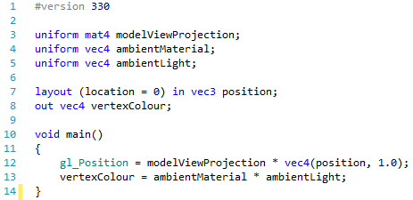

First of all, we define two new uniforms – the ambientMaterial and the ambientLight. These will be values sent in from the OpenGL application. Also notice that we now have an output from the shader in the form of a vertexColour. We calculate this value on line 13 by simply multiplying the material by the light.

## Ambient Fragment Shader

Our ambient fragment shader takes in the vertexColour value and applies it to our pixel colour. The code is as follows:

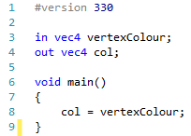

This code should be fairly straightforward. All we need to do now is use our new shader in our main application.

## Updating Main Application

We have a few things to update in our main application, so we will look at each section in turn. We have new attributes to define, an updated initialise, an updated update, and an updated render to implement. Let us start with our attributes.

### Main Application Variables

Our main application requires the following variables:

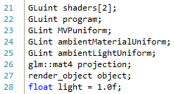

We have values for our two shaders and our program as before (lines 21 and 22). We also define our three uniforms for our shader – the model-view-projection matrix, the ambient material value, and the ambient light value. We have our projection matrix and render_object as before. One new value we have here is declared on line 28. This light value we will manipulate in our application providing a different level of light to our object.

### Initialisation

Our initialisation operation is defined as follows:

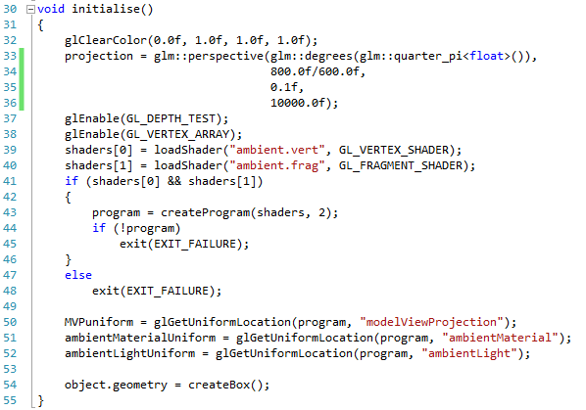

Notice that we are now loading ambient.vert and ambient.frag. We also get the location for our three uniforms. Notice as well that we use the box as our geometry.

### Update

Our update operation adds user controls for moving our object, and for adjusting the light value:

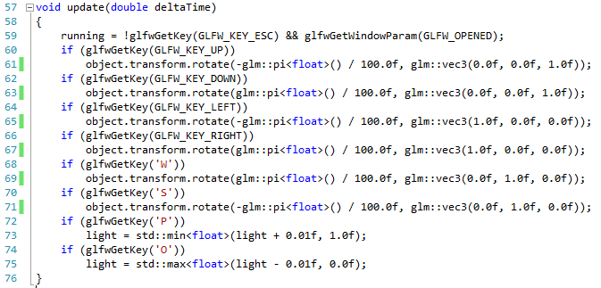

We use the min and max functions to ensure that our light value stays in the range [0, 1].

### Render Object

We also need to do some modification to our render object code so that the light values are set accordingly:

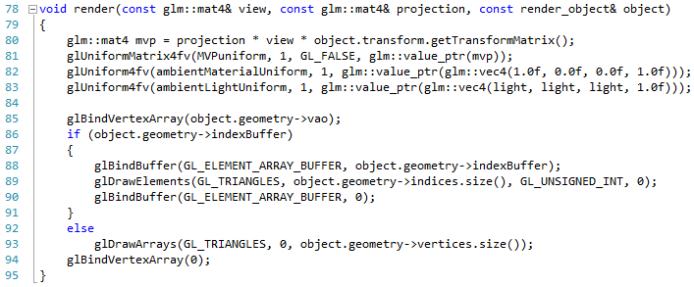

We set the ambient light on line 83 based on the current light value. If you run this application, you will get a red cube which you can adjust the light value of by using the o and p keys:

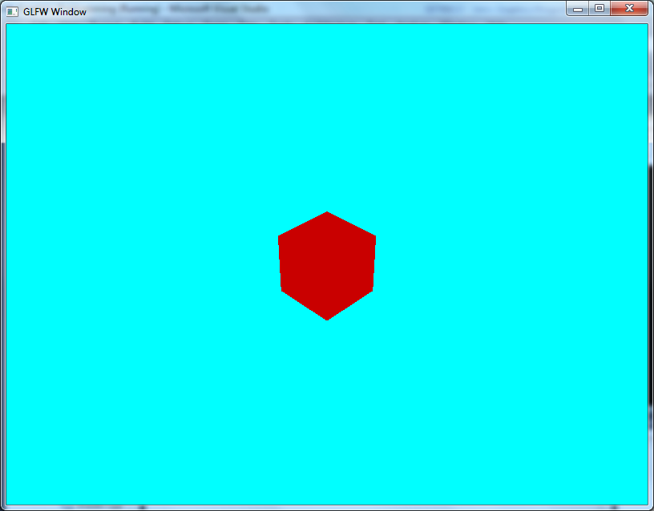

## Exercise

Try experimenting with different light and material values. In particular, see if you can find some light values for realistic environment lighting using Google.

# Diffuse Light

Diffuse light is a far more interesting light type than ambient, and when we actually implement diffuse light in a couple of lessons time, you will see actual 3D effects on our objects (in other words, they will look like they have depth, etc.). Diffuse light is a little bit more complex to deal with than ambient light as we must take into account the direction of the light, and how it interacts with the surface of the object.

## Examples

Diffuse light, from our point of view, is what gives an object a more realistic shape. Essentially, the adding of diffuse light to our render allows us to perceive the 3D look of an object without resorting to such approaches as colouring each side individually. With diffuse light, we can set a single colour for the object, and allow the light affecting the object to produce a 3D look. For example, compare the ambient effect (left) with the diffuse (right):

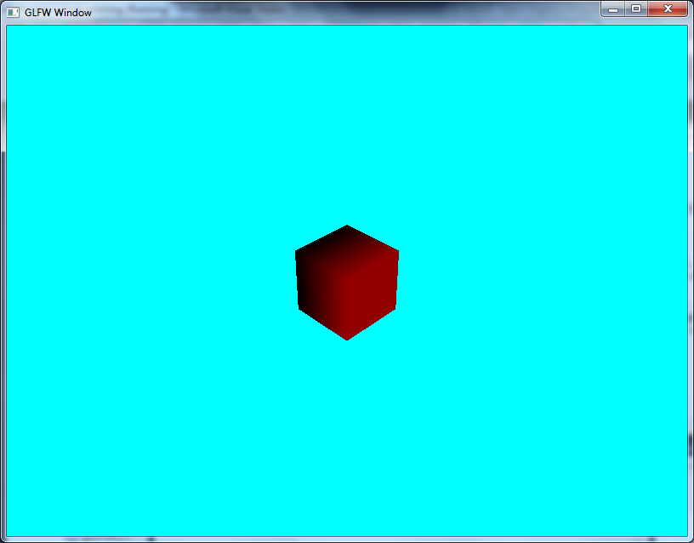

Notice that we have definite shape of the object when working with diffuse light, but not any when using just ambient light.

## Diffuse Lighting Equation

The diffuse lighting equation is slightly more complex than the ambient light equation. As before, we need to define the light and material values:

$$L_{diff}=〈L_{r},L_{g},L_{b},L_{a}〉$$

$$M_{diff}=〈M_{r},M_{g},M_{b},M_{a}〉$$

We also need to define the direction that the light is travelling in. This must be a normalized vector (i.e. unit length), and is just the direction to the light source:

$$\hat{LD}=〈LD_{x},LD_{y},LD_{z}〉$$

We also need the surface normal for the triangle we are working on. This is set on a per-vertex basis, as you will soon see. However, at the moment, just consider the normal to be a 3-dimensional vector of unit length.

$$\hat{n}=〈n_{x},n_{y},n_{z}〉$$

The diffuse light calculation works on the principle that the cosine of the angle between two vectors ranges from 1.0 (vectors facing the same direction) to 0.0 (vectors are perpendicular or at $\frac{π}{2}radians$). We can consider this to be 100% to 0% lit. We already know the relationship between the cosine of the angle between two vectors and the dot product of the two vectors. Therefore, we just use the fast dot product operation to calculate our light. The diffuse light equation is:

$$C_{diff}=\left(M_{diff}⨂L_{diff}\right)×\max\left(LD⋅n,0.0\right)$$

For example, let us consider the following values:

$$L_{diff}=〈0.97,1.0,0.4,1.0〉 \\ M_{diff}=〈0.2,0.2,0.2,1.0〉$$

This gives us the same calculated colour as before:

$$C_{diff}=〈0.97×0.2,1.0×0.2,0.4×0.2,1.0×1.0〉=〈0.194,0.2,0.08,1.0〉$$

Let us also consider the direction to the light to be as follows (that is, it is up to the right from the object):

$$LD=〈\frac{1}{\sqrt{2}},\frac{1}{\sqrt{2}},0〉$$

Now let us calculate the diffuse light for the six sides of a cube. The normal are therefore:

$$n_{1}=〈1,0,0〉 \\ n_{2}=〈-1,0,0〉 \\ n_{3}=〈0,1,0〉 \\ n_{4}=〈0,-1,0〉 \\ n_{5}=〈0,0,1〉 \\ n_{6}=〈0,0,-1〉$$

The dot products of each of these six normal with the light direction is as follows:

$$LD⋅n_{1}=\frac{1}{\sqrt{2}} \\ LD⋅n_{2}=-\frac{1}{\sqrt{2}} \\ LD⋅n_{3}=\frac{1}{\sqrt{2}} \\ LD⋅n_{4}=-\frac{1}{\sqrt{2}} \\ LD⋅n_{5}=0 \\ LD⋅n_{6}=0$$

Our equation uses the max function to ensure that the minimum value we use is zero. This means we are performing the following six calculations:

$$〈0.194,0.2,0.08,1.0〉×\frac{1}{\sqrt{2}}=〈0.137,0.141,0.057,0.707〉 \\ 〈0.194,0.2,0.08,1.0〉×0=〈0,0,0,0〉 \\ 〈0.194,0.2,0.08,1.0〉×\frac{1}{\sqrt{2}}=〈0.137,0.141,0.057,0.707〉 \\ 〈0.194,0.2,0.08,1.0〉×0=〈0.137,0.141,0.057,0.707〉 \\ 〈0.194,0.2,0.08,1.0〉×0=〈0,0,0,0〉 \\ 〈0.194,0.2,0.08,1.0〉×0=〈0,0,0,0〉$$

So only two faces (the faces pointing up and pointing left) are lit. In all instances, we will actually set the alpha component of the colour to 1 so that the objects rendered are opaque.

Diffuse light is actually quite easy to deal with. Really all we need to deal with is the calculation of the surface normals, and we do this during our geometry building at application start up. Let us look at normals next.

# Normals

We have mentioned a few times now the concept of surface normals. A surface normal simply lets us define which direction a surface is facing. There are actually simple calculations for this, but generally speaking we want to define the surface normal at the start of the application so we don’t have to calculate this value every frame.

## What is a Surface Normal?

The following diagram illustrates what we mean by a surface normal:

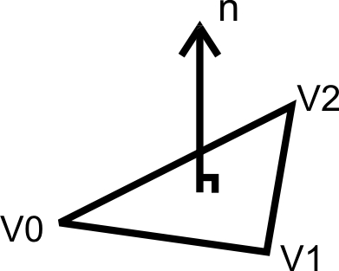

It is a vector that is perpendicular to the surface we are working on. The normal also has unit length (i.e. it has a length of 1). This allows us to use it in lighting calculations easily.

## Calculating Surface Normals

Surface normal calculation is actually very simple – we need to calculate the cross product between the two defining vectors. For example, for the figure above the surface normal can be defined as:

$$n=\left(V1-V0\right)×\left(V2-V0\right)$$

However, we will use some other techniques to generate the normal when required.

# Box Normals

Now that we have described what a normal is, and how we use it in lighting, we are ready to define our normal for our box. Because of the way we have created our box, using indexed values and shared vertices, we need to think a bit about how we implement our normals.

## Box Normals

The way to visualise our box normal is to look at the following image:

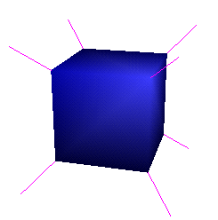

Each corner of the cube has a normal pointing away from the centre. This means that we don’t really have surface normal as such, but utilise a softer edged approach. You will see the outcome of this in the next practical.

## Updating Geometry Structure

The first thing we need to do is update our geometry.h file, and in particular the geometry struct, so that we have normal declared. Our new definition of the geometry struct is as follows:

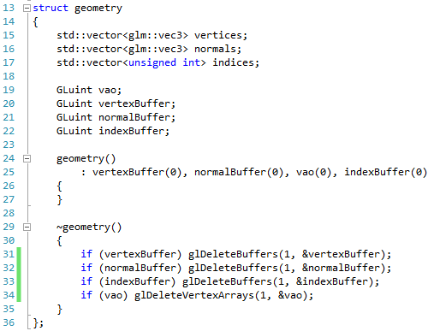

We have added a new vector to store our normal data (line 16), and also created a new normal buffer object (line 21). We also update the constructor and destructor to work with the new buffer objects.

## Updating Create Cube

Our create cube method currently only operates using vertex position data. We need to modify it to add normal data. First we need to define our normals. We do this by adding a new array of normals to our geometry.cpp file:

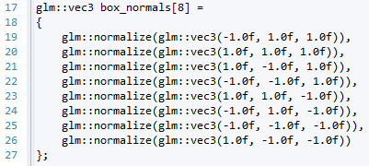

This declaration goes just below the box_vertices declaration. Notice that we call normalize on the vectors defined. This ensures that the vectors are of unit length (essential for our lighting calculations). Now all we need to do is modify the actual create box operation to create the buffer:

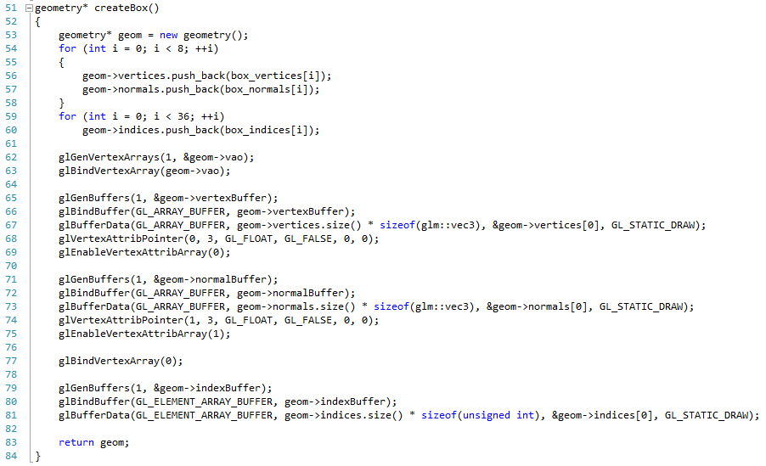

Everything up till line 69 is the same as before, except line 57 where we copy the box_normals values into the normals vector.

From line 71 to line 75 we initialise the normal buffer in the vertex array object. We go through the standard steps:

1. Generate the buffer object – line 71
2. Bind (use) the buffer – line 72
3. Set the buffer data – line 73
4. Set the vertex attribute pointer (index to send the data down). Notice that this time we are using 1 (the position was 0, the normal is 1) – line 74
5. We enable vertex attribute 1 – line 75

And that is all we need to do to set up the normal data. Run your application to make sure that it works, but you won’t see any difference yet. That is the next practical.

# Your Fourth Shader Program – Diffuse Light Attempt 1

Now that we have our normals set up for our box, we are ready to create our diffuse light shader. As before, we have the vertex and the fragment shader to implement. The vertex shader is where all the work is being done.

## Diffuse Vertex Shader

Our diffuse.vert file is defined as follows:

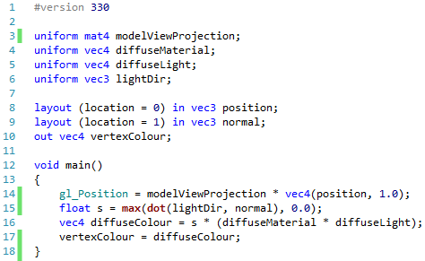

We now have four uniform values:

* Model-view-projection matrix as before
* The diffuse material
* The diffuse light
* The direction that the light is coming in from

Line 9 declares that we also have a normal value coming in on location 1.

The main shader operation sets the position as before (line 14). We also calculate the intensity of the diffuse colour based for the particular vertex. This is done using the following equation:

$$s=max⁡(\hat{l}⋅\hat{n}, 0)$$

The notation of a vector with a hat (e.g. $\hat{a}$) indicates that the vector in question is of unit length. The other point to note is that we use the fact that the dot product between two vectors provides the cosine of the angle between them. If the vectors are in parallel, then we have $\cos{0}=1$. When the vectors are orthogonal (at right angles), then we have $\cos{\frac{π}{2}}=0$. If the angle is greater than a right angle, then the cosine of the angle becomes negative. However, we take the max between the cosine and the 0.

Once we have calculated $s$, we multiply the output diffuse colour by this value to scale according to the surface’s angle in relation to the light.

## Diffuse Fragment Shader

The diffuse fragment shader, diffuse.frag, is just the same as the ambient fragment shader:

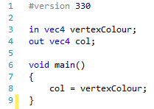

## Updating the Main Application

Our main application needs to be updated to now work with our diffuse light shader. Again, we need to set our variables, our initialisation, our update, and our render object operations.

### Variables

Our application variables are as follows:

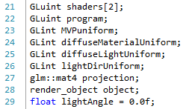

All of these should be expected, except line 29. This value represents the angle the light is making with the Y axis. We will use this value to calculate the light direction for the shader.

### Initialisation

Our initialisation code looks as follows:

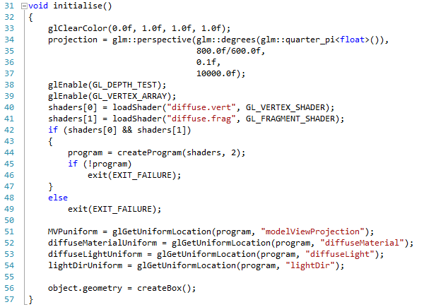

Again, there should be nothing unexpected here – we are just loading the shader and getting the uniform locations as before.

### Update

Our update will now allow us to manipulate the light direction. The code is as follows:

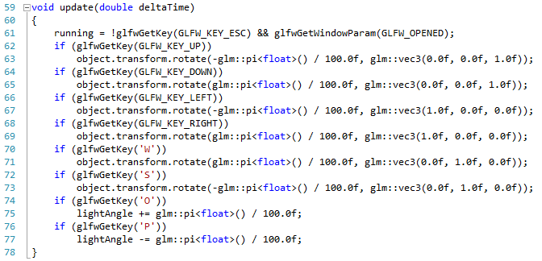

The main difference now is that we use O and P to manipulate the light angle value.

### Render Object

Our render object operation now must set our new uniform values. It takes the following form:

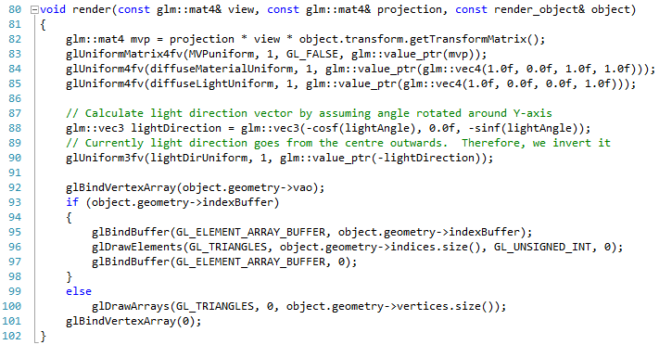

The new interesting parts are lines 87 to 90 where we calculate the light direction. We simply use the light angle and some trigonometry to figure out the light direction, and then set the uniform. If you now run this application, you will get the following:



Finally we can start seeing the three dimensional shape of the object. However, our shader has a problem. Try rotating the object, and you will see that it is as if the light rotates with it:

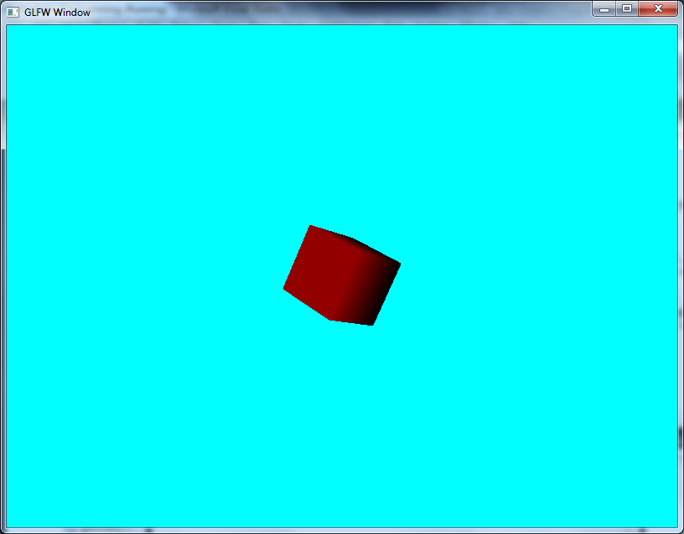

This is obviously not what we want. We will see how to fix it in the next practical.

## Exercise

Again, experiment with having multiple boxes with different transforms in the scene. Watch what happens as you rotate the light around these objects.

# Diffuse Light Attempt 2

Now we need to fix what went wrong in our diffuse shader. The problem actually comes from the fact that we are not transforming our normals to match the fact that we have transformed our geometry. This isn’t a case of just applying the same transformation matrix (model-view-projection) as before, but using a new matrix. The matrix we have to use is called the model-inverse-transpose, which is the inverse of the transpose of the model matrix. Sounds complicated, but GLM has the necessary functions for us to do this simply.

## Updated Vertex Shader

Our updated diffuse.vert file is as follows:

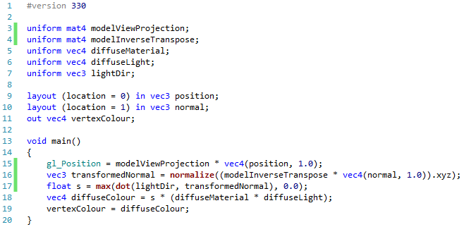

We have declared a new uniform called modelInverseTranspose (line 4), and we use this to transform the normal on line 16 (notice that we only use the xyz components of the vec4, and that we normalize the vector to ensure it is unit length). We then use this transformed normal instead of the incoming normal on line 17 to calculate $s$.

## Updated Main

Our main application needs to set this model-inverse-transpose matrix. To do this, we need to create a new variable, get its location, and then use it in our render. First the variable:

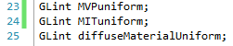

The new line is line 24. Now we also need to get its location in the initialise operation:



Line 53 is our new line. Now we just need to set this in our render object operation:

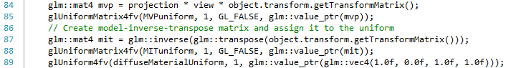

Lines 87 and 88 are our new ones this time. Notice on line 84 we just use the glm::inverse and glm::transpose operations on the object’s transform matrix. This makes our job relatively easy. If you run this version of the diffuse shader, you will get the following when you rotate the object now:

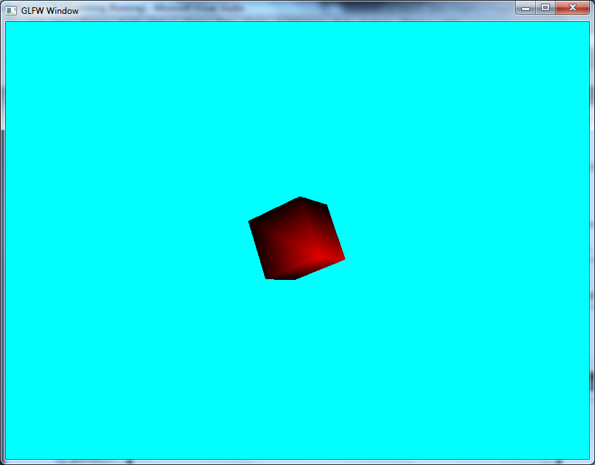

Which is the outcome we expected.

## Exercises

Now that we have a working diffuse shader, return to the previous exercise and add multiple cubes with different transforms and material colours. Does the output look better this time?

# Calculating Normals for All

So we now have a cube that can be lit in a more realistic manner. Our next stage is to allow us to do realistic lighting on all the geometry we have generated thus far. We will do this for each of our pieces of geometry in turn.

## Tetrahedron

Our tetrahedron is another shape that utilises a fixed set of vertices, and therefore will have a fixed set of normals. The first code you will need to add to geometry.cpp is the following:

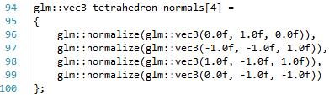

All we need to do now is update our tetrahedron creation operation as follows:

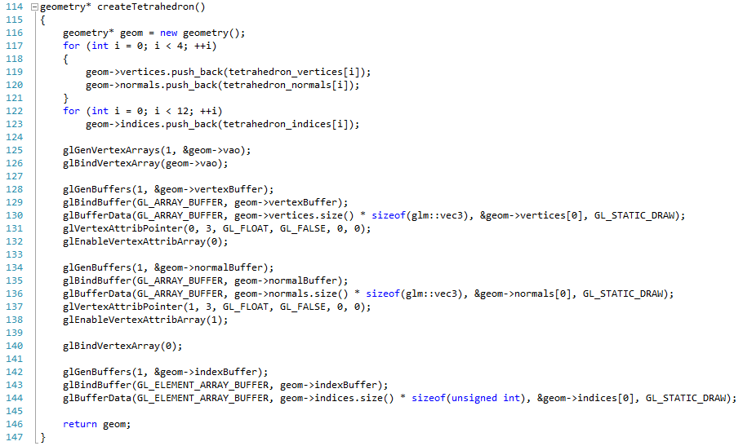

Our first new line is 120, where we just add our normals to the vector. Then we have our block of code from 134 to 138 that allocates our normal buffer. And that is all we need to do to add normals to our tetrahedron. We are just doing the same changes as we did for the cube. If you modify the main program to use a tetrahedron as geometry, you will get the following:

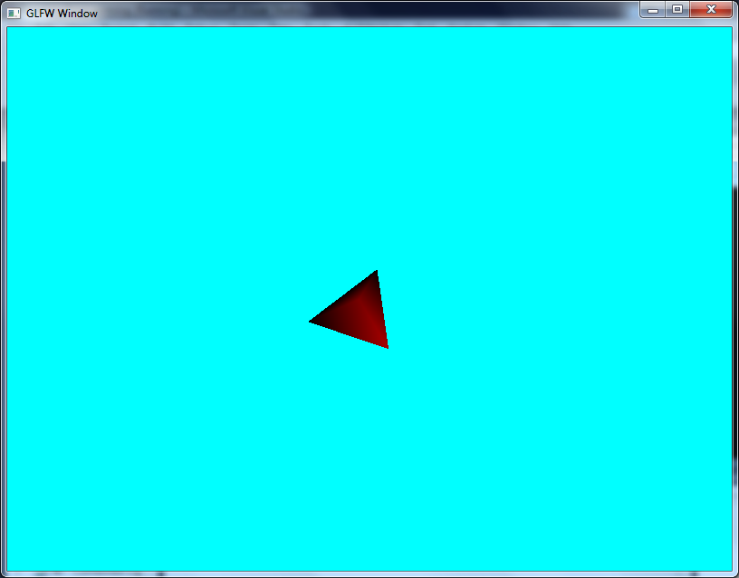

## Pyramid

The pyramid code is essentially the same modifications as we did to the tetrahedron. First we need a set of normals:

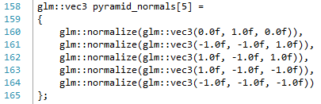

And then we need to update our creation operation:

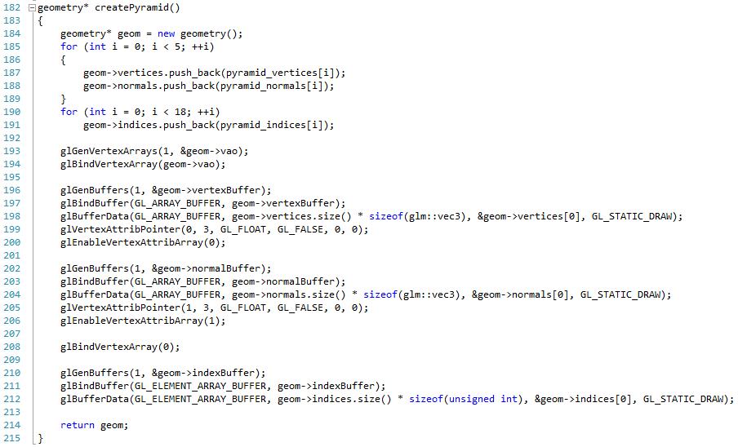

This will result in the following output:

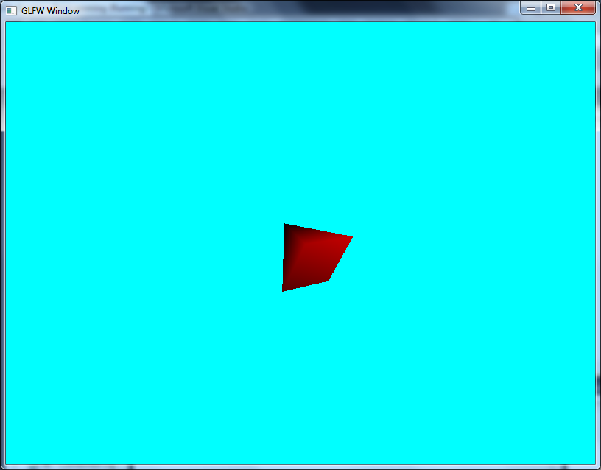

## Disk

The disk was our first piece of geometry that utilised a purely procedural method to create the vertices. As such, we also need to produce our normals procedurally. This is actually simple for the disk, as we will just make all our normal face upwards:

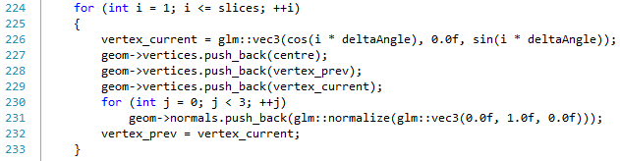

The new code is lines 230 and 231. You will also need to add the code to add the normal buffer (we have done this enough times that you should be able to add this code yourself now). If you run this version, you will get the following output:

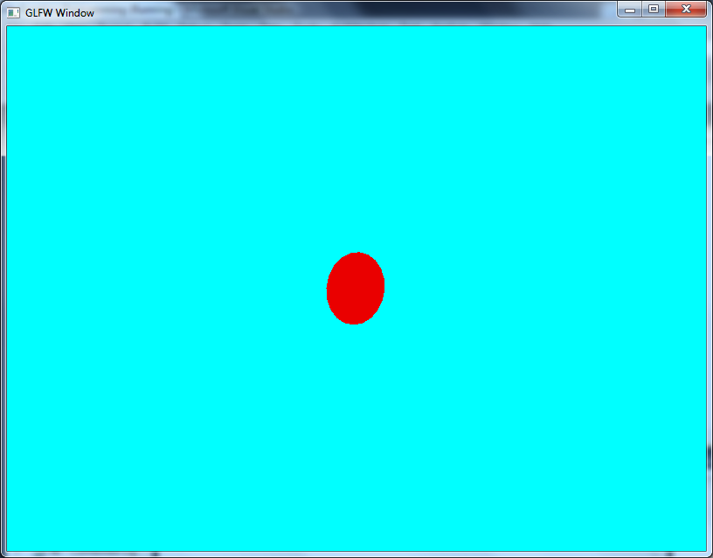

The trick here is to realise that only one face has normals (the side that faces up). You will have to manoeuvre the disk to get the light to shine on it correctly. If you want to have both sides lit, you will need two disks.

## Cylinder

The cylinder is also procedural, and requires the addition of normals to the top, the bottom, and the sides. The top and bottom follow the same principles as the disk:

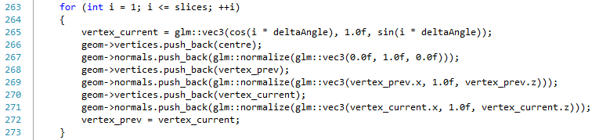

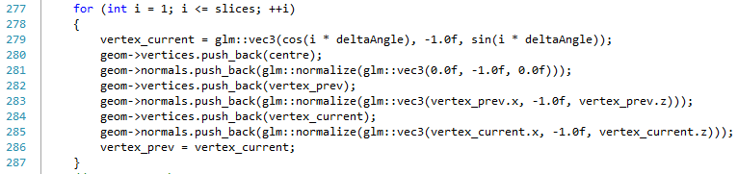

The new lines are 267, 269, and 271, and 281, 283 and 285 respectively. The code to add normals for the side of the cylinder is a bit trickier in principle, until we realise that we want our normals to point directly outwards from the centre, with no y-component. The normal then just become the normalised vertices with the y-component set to 0:

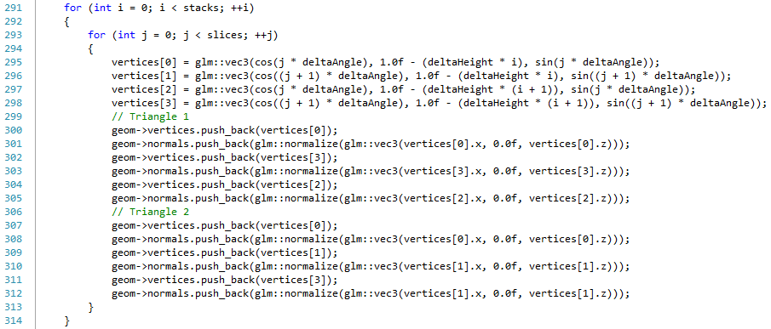

The new lines are 301, 303, 305, 308, 310, and 312. Again you will need to add the code to set the normal buffer. If modify the main to create a cylinder, you will get the following:

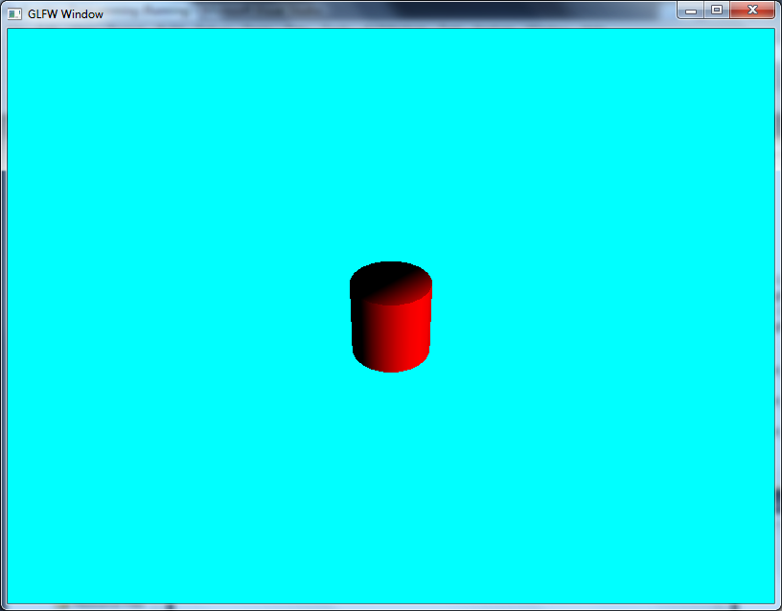

Which is probably the most realistic looking piece of geometry we have created thus far.

## Sphere

The sphere would also appear to be a complex piece of geometry to create the normal for. However, again if we think about the idea that each vertex is just an offset from the centre, then the normal for each vertex is just the normalized version of this vector. The code to add is as follows:

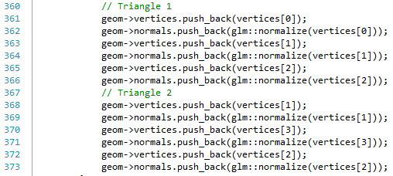

The new lines are 362, 364, 366, 369, 371 and 373. Again, you will need to update the code to add the normal buffer. If you run the main application with a sphere, you will get the following:

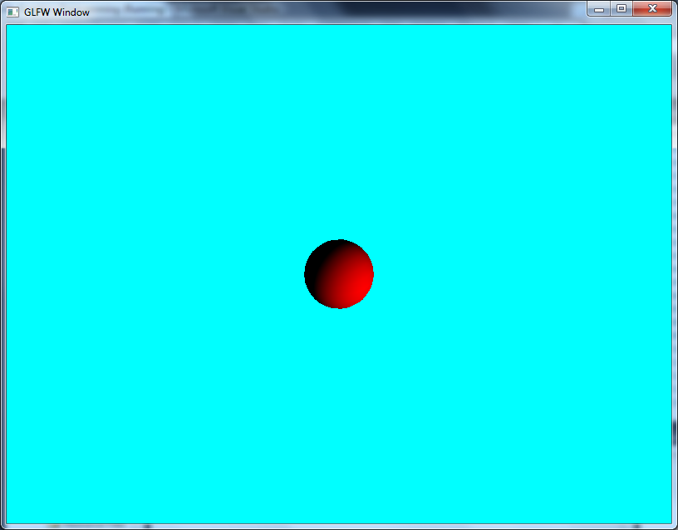

## Torus

The torus is possibly the most complicated piece of geometry we need to add normals to, as the geometry is both procedural, and has normals pointing in all directions relative to the centre. There is a bit more code to add here, as shown below:

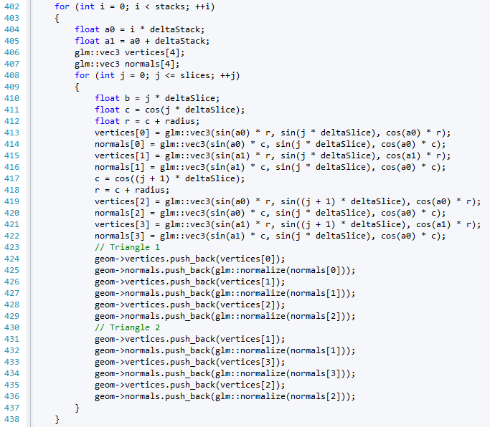

First we need to declare an array of vectors to allow the storage of the normal data (line 407). Then during the position data generation we also need to generate the normal, as seen on lines 414, 416, 420, and 422. We then store the normals in the normals vector in lines 424 to 436. You will also have to add the code to create the normal buffer. With that done, you should be able to run the main application and produce the following:

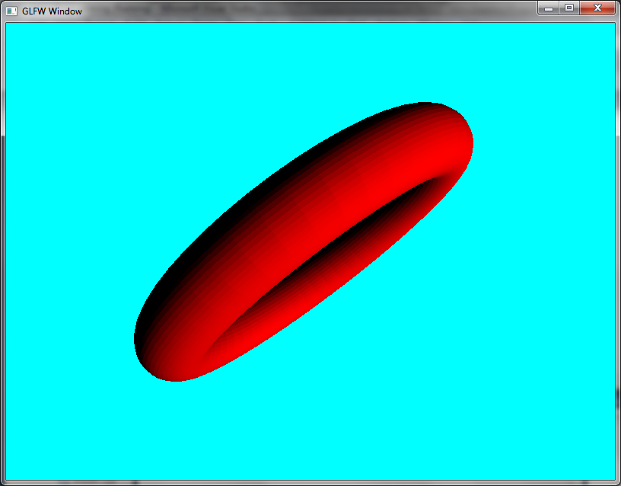

## Exercises

1. The final piece of geometry to create normal data for is the plane. This just requires you to use the same technique as you did for the disk. Try and get the plane to operate with the diffuse shader as well.
2. Try and recreate the scene from the exercise in Section 24.3. Your scene should look a bit more realistic with correct lighting. We will come back to this when we look at texturing.

# Challenge – Lit Sierpinski Gasket

This is a rather short challenge, and will let you have the final piece of geometry created with normal data. The Sierpinski Gasket is essentially a collection of tetrahedrons, and therefore it is actually very easy for us to create the normal data. In fact, apart from the code to create the normal buffer, you only require one more line of code to create a lit Sierpinski Gasket. Give it a try. Your output should look something like this:

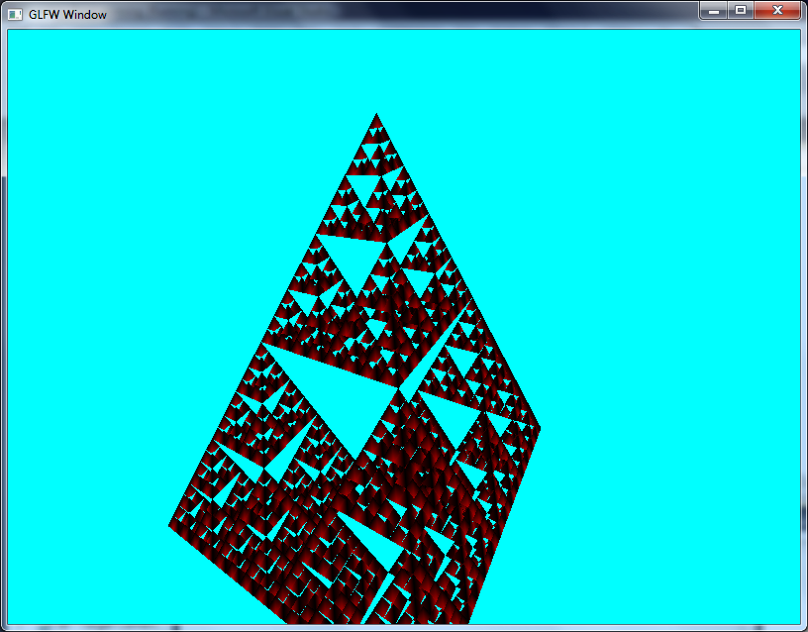

# Specular Light

Our final form of basic lighting is specular lighting. Specular lighting follows many of the characteristics of diffuse lighting – it is based on the direction that the light is travelling in. However, unlike diffuse light, we are also interested in the position of the viewer. This is because we are creating an effect that provides highlights to an object. For example, if we examine the following image:

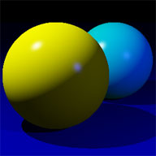

You will see a couple of points on the rendered spheres where it looks like the light is reflecting from the surface of them. This is what is known as a specular highlight. It is determined by determining the direction of the light, the position of the eye, and using the surface normal to determine where the highlight appears on the object.

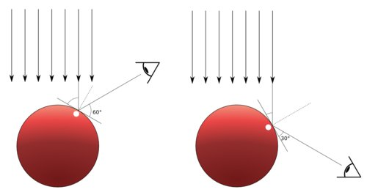

## Specular Lighting Equation

The specular lighting equation is again more complex than the diffuse equation, although it does build upon it. As before, we need to define the light and material values:

$$L_{spec}=〈L_{r},L_{g},L_{b},L_{a}〉$$

$$M_{spec}=〈M_{r},M_{g},M_{b},M_{a}〉$$

We also need to define the direction that the light is travelling in:

$$\hat{LD}=〈LD_{x},LD_{y},LD_{z}〉$$

We also need the eye position. This is just a 3-dimensional vector defined as follows:

$$e=〈e_{x},e_{y},e_{z}〉$$

Unlike the diffuse shader, we will work with the position of the vertex as well:

$$p=〈p_{x},p_{y},p_{z}〉$$

We also need the surface normal for the triangle we are working on:

$$\hat{n}=〈n_{x},n_{y},n_{z}〉$$

One final value we need is the shininess of the object. This is just a scalar value:

$$s$$

The specular lighting calculation is defined as follows:

$$C_{spec}=\left(M_{spec}⨂L_{spec}\right)×{\max\left(reflect\left(-LD,n\right)⋅normalize\left(e-p\right)\right)}^{s}$$

The reflect function creates the reflection vector from the light direction and the normal. The normalize function normalizes (creates a unit length) the vector from the eye position and the eye position.

We won’t calculate an example here as there is too much data for this page. However, we will cover an example in the lecture. Now let us look at how we implement a specular shader.

# Your Fifth Shader Program – Specular Light

We don’t need any new information in our geometry for a specular light shader; we are just working with our normal data again. Therefore, all we really need to worry about is developing our shader, and setting up the necessary information. Let us look at the vertex shader first.

## Specular Vertex Shader

The code for specular.vert is as follows:

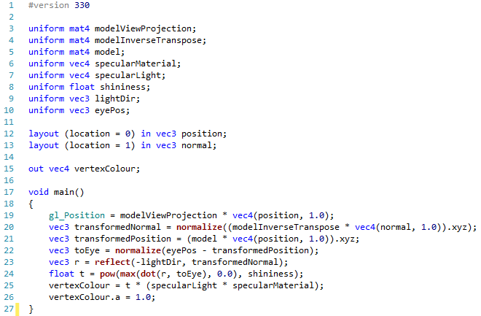

We now have quite a few uniforms in our vertex shader. Let us look at each of these in turn:

* *modelViewProjection* – is the combined model, view and projection matrices
* *modelInverseTranspose* – is the matrix we use to manipulate our normal
* *model* – is our model matrix. We will be using this to work out the vector between our eye position and the position of the vertex we are operating on by transforming the incoming position into world space.
* *specularMaterial –* the colour of the specular material of the object
* *specularLight –* the colour of the specular light
* *shininess –* the shininess of the object
* *lightDir –* the direction that the light is pointed
* *eyePos –* the position of the viewer

To work out our specular colour for a vertex, we need a value to multiply the specular material and light by. This is the value $t$ above, and is calculated as follows:

$$t={\left(max\left(\hat{r}⋅\hat{v},0\right)\right)}^{s}$$

Where $r$ is the reflection vector between the light direction and the normal, $v$ is the vector between the position of the vertex and the eye, and $s$ is the shininess value.

## Specular Fragment Shader

The fragment shader follows the same idea as the previous fragment shaders, and only applies the colour received by the vertex shader. It looks as follows:

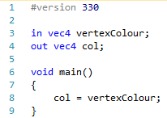

## Updating Main

As before, we need to get the uniforms from the shader, set these, and then render the object. First of all we need some new attributes. The ones we need for this application are as follows:

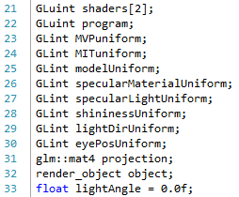

We also need to acquire their locations in the main initialise operation:

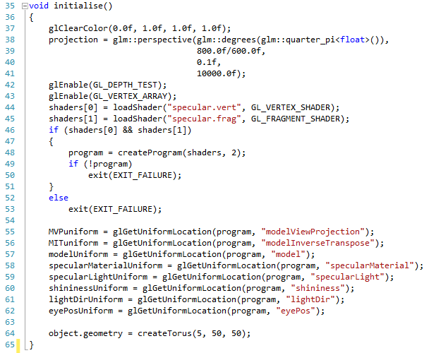

We are going to use a torus in this instance. Finally, we need to set the uniforms in our render operation:

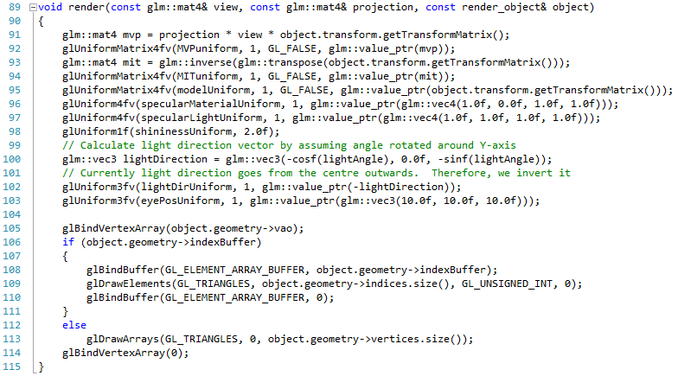

Notice that our material is magenta (line 96) and our specular light is white (line 97). We can now run this application and get the following result:

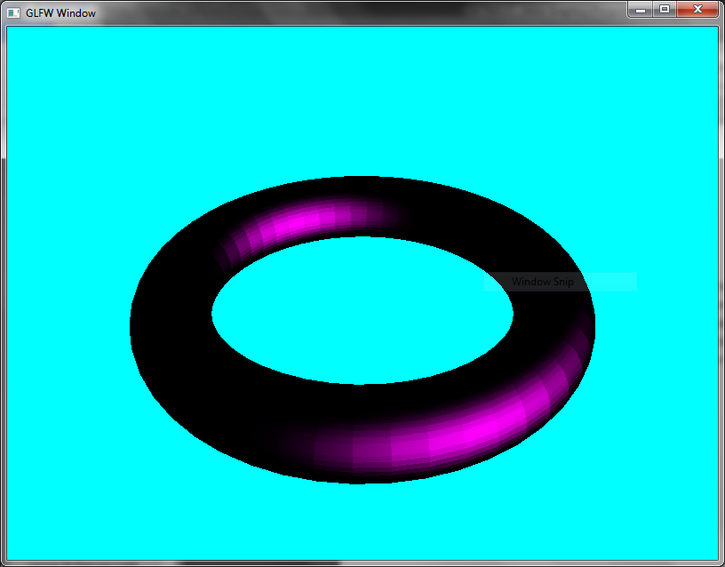

And we now have geometry with specular light.

## Exercises

1. Try manipulating the shininess value and see what results you achieve. Try and determine the relationship between the shininess value, and what you see on the screen.
2. Try different types of geometry with the specular shader. Can you see the relationship between the eye position and where the reflection appears?
3. Try manipulating the light direction, and further understand how the light direction and eye position effects the specular light you see.

# Combined Lighting

With our three types of lighting in place, we can now combine the effects to try and create a more realistically lit object. In this practical, only the shader code is given, and it is up to you to add the necessary updates to the main application to allow the object to be lit in the way you want. First we will look at the vertex shader.

## Vertex Shader

The vertex shader will combine all three lighting approaches, creating a final colour that can be sent to the fragment shader. The file lighting.vert is as follows:

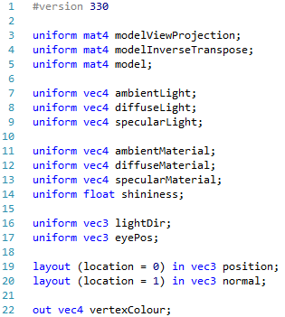

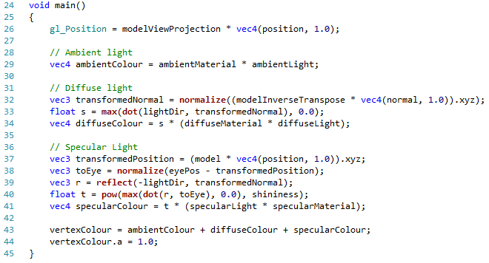

You should have enough of a grasp of what is going on at this stage to understand the code presented. It is just a combination of all three shaders.

## Fragment Shader

As you can probably guess, the combined fragment shader is the same shader we have used in all occurrences. The file lighting.frag is as follows:

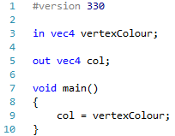

Update the main file accordingly, and then run the application. For a cylinder, you should have something similar to the following:

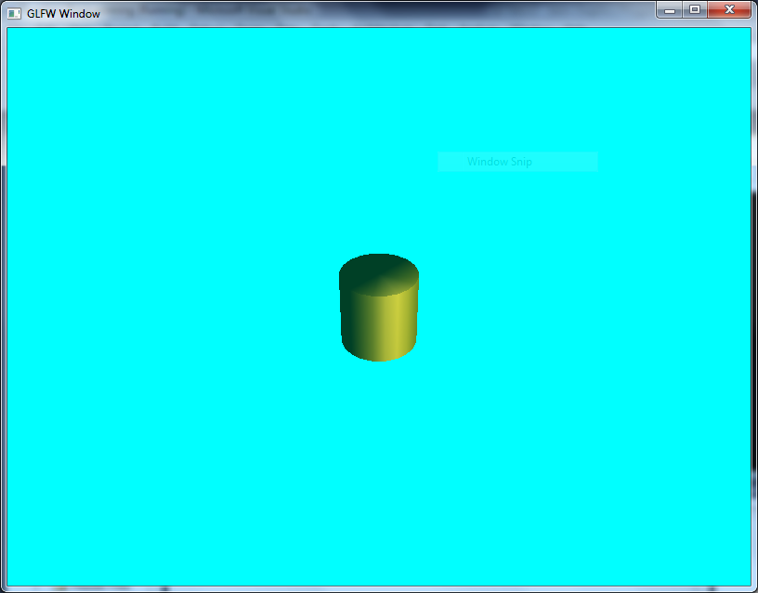

## Exercises

1. Try different types of geometry again and see how objects look. Is there anything unexpected?
2. Recreate the scene from Sections 24.3 and 42.7. Your scene should look much better with a combined lighting model.

# Phong Shading

Our last main form of lighting, and the type we will actually use from now on, is Phong Shading. Phong Shading adds little from the point of view of how we calculate the light colour. However, rather than calculate light on the vertex shader – a per-vertex lighting solution – we will calculate the light on the fragment shader – a per-pixel lighting solution. The following image illustrates the difference between flat (per-quad or per-triangle), Gouraud (per-vertex – what we have been doing up till now), and Phong (per-pixel) shading. You should be able to notice the difference between these three implementations.

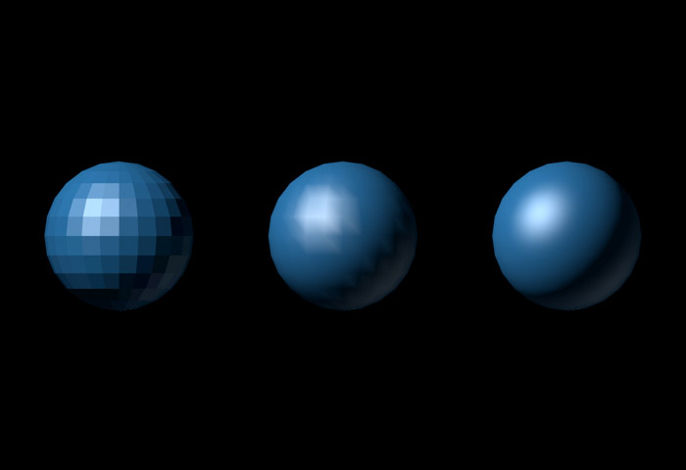

Phong shading tends to be the approach taken in modern graphics applications, as although expensive in comparison to Gouraud shading, it is still relatively cheap to process. There are no new equations here, as the previous equations work as before. However, we will be reprogramming our vertex shader and fragment shader to suit.

# Your Sixth Shader Program – Phong Shading

As with our previous combined lighting shader, we will only present the shader code. It is up to you to modify the main application to utilise the new shader.

You will find that our Phong shader has the same uniforms, so there is little work to do in comparison to your previous example. The main difference is that we are doing most of our work in the fragment shader rather than the vertex shader. Let us look at the vertex shader first.

## Phong Vertex Shader

The code for the phong.vert is as follows:

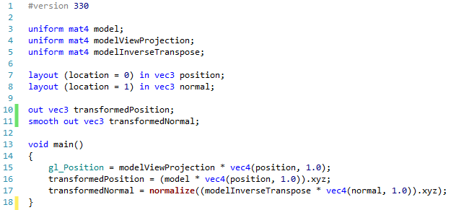

Notice that now our vertex shader really only has three tasks to achieve:

1. Calculate the position of the vertex for rendering (line 15)
2. Calculate the position of the vertex to world coordinates to pass to the fragment shader (line 16)
3. Calculate the transformed normal for the fragment shader (line 17)

The real work for working out the colours is now done in the fragment shader. We use the keyword smooth on the output normal to indicate that interpolation should occur between the normal.

## Phong Fragment Shader

The Phong fragment shader looks as follows:

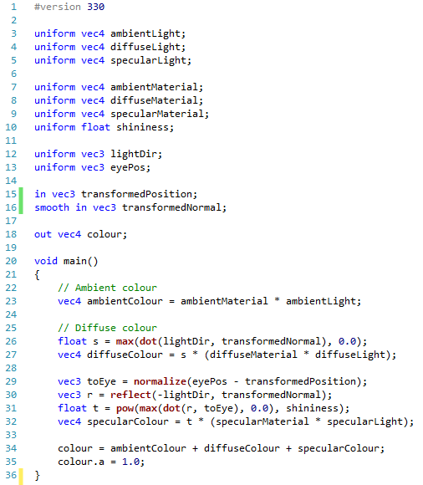

All we are now doing is performing the same calculations as before, but this time using the fragment shader. Because there is some interpolation performed in the fragment shader, we get a much more realistic looking lighting effect with fewer hard edges on the vertices:

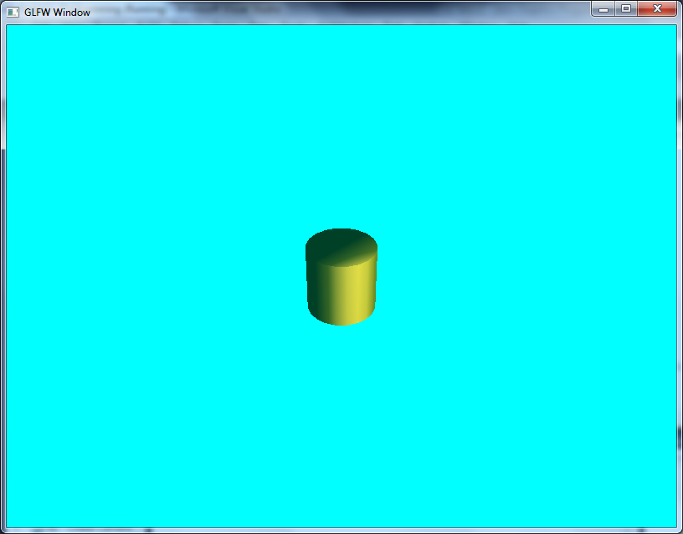

## Exercises

Repeat the exercise from Practical 46 using the Phong shading model.

# Materials and Lights

We have now covered quite a number of basics in doing lighting and shading, and you may have noticed that we have quite a bit of information that we can pass to a shader to get the lighting that we want. However, this does mean that we have quite a bit of code in our main operation (which isn’t the best situation). To rectify this, we are going to add some useful data structures to allow support of our rendering system.

## Adding a Material Structure

The first thing we can do is realise that our objects have something called a material associated with an object. This material makes up the colour of the object, and has four values:

* The ambient material
* The diffuse material
* The specular material
* The shininess

As we want to associate a material with an object, it makes sense to attach these values to our render_object structure. We do this in geometry.h:

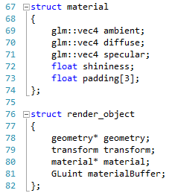

We have a pointer to a material value in the render_object so that we can reuse the material if we wish. Next, let us consider our lighting.

## Adding a Lighting Structure

As with our materials, we can also see that lighting can be constructed into a structure of four values (this code goes into shader.h):

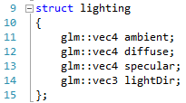

We have the ambient, diffuse and specular light values, plus the direction of the light. Having both the material and lighting structures makes our job a little easier. Another addition we can do is adding a shader class.

## Shader Class

At the moment, we are generally just loading shaders and storing necessary variables for them (such as uniforms) in the main operation. A simpler method would be to allow setting of these values in a shader object. First we need to create a shader class, which we add to shader.h:

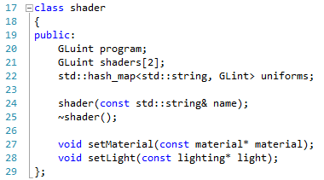

Notice that we have our program and two shader values declared, and we also have a hash map of uniforms. We are going to populate that hash map with all the available uniforms in our shader, making our job easier. We also add a setMaterial and setLight method to allow us to set these values accordingly. All we need to do now is add the code for these operations to our shader.cpp file.

### Shader Constructor

The shader constructor looks as follows:

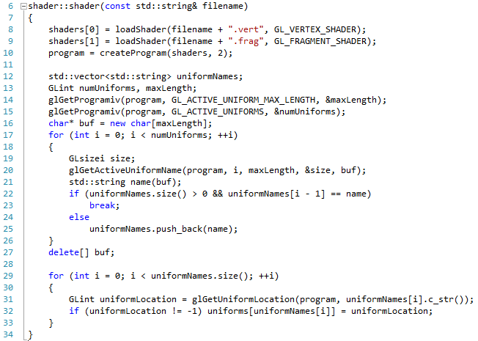

It takes the name of the file, and assumes that this means that there is a file called <filename>.vert and <filename>.frag. It then creates the program object using this code (lines 8 – 10).

Next the shader interrogates the shader to discover the names of all the uniforms (lines 12 to 27). It does this by getting the maximum name length of the uniforms (line 14), and the number of active uniforms in the shader (line 15). We then use these values to iterate over the uniform names, and store them in a vector (lines 19 to 25). This will give us a vector of all the uniform names. We then use this to get all the uniform locations, storing the location against the name in the hash_map. We also ensure that the location is not -1. If a location is -1, then the uniform does not have a location (this can happen when dealing with uniform blocks, which is the next practical). If the uniform has no location, there is no point adding it.

### Shader Destructor

The shader destructor has the responsibility of cleaning up any resources used by the shader. The code is as follows:

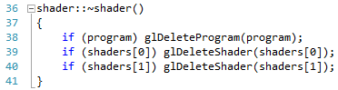

All it really does is check that the program and shader objects are still valid (not 0 / null), and if they are deleting them accordingly.

## Set Material and Lighting

As our hash_map contains all the locations for our uniforms, we can use this to set our material and lighting values. This is actually very trivial:

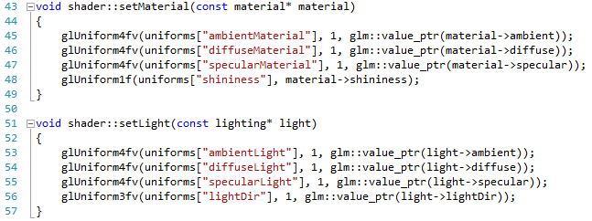

In each case, we get the location of the uniform from the hash map (for example, the location of the ambient light uniform is uniforms[“ambientLight”]), passing in the relevant value from either the material or lighting structure.

With the new shader class in place, we can simplify our main application again.

## Updating Main Application

Firstly, we have a reduced set of attributes to worry about:

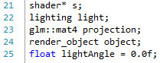

We now only have the shader object, a lighting object, a projection matrix, a render_object and our light angle value. Our initialise is also simplified:

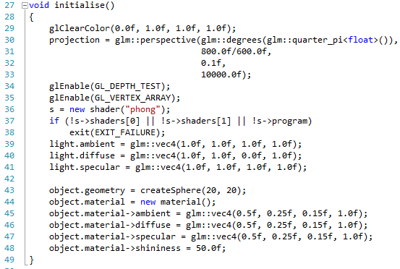

We load our shader on line 36, check that it loaded OK on lines 37 and 38, and then set up our light (39 to 41) and the material of the render_object (lines 43 to 48). All we need to worry about now is our render.

### Updating Render

Our updated render operation looks as follows:

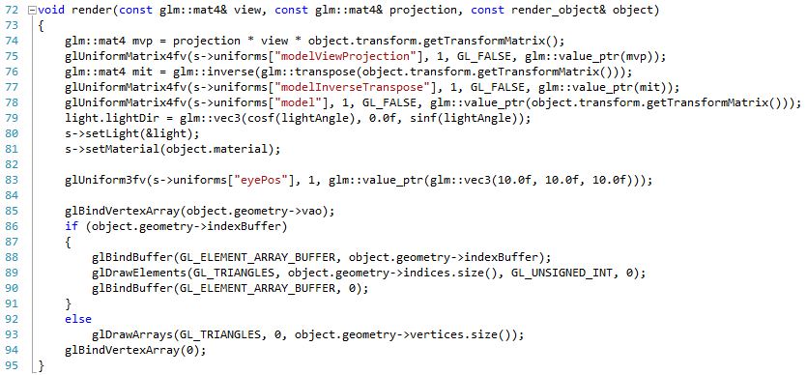

We have quite a change here. Firstly, on line 75 we now use the shader to get the location of the modelViewProjection uniform. We also do this on lines 77 and 78 respectively. We also now use the lighting structure to store the light direction (line 79), and call the set material and set light methods of the shader object accordingly (lines 80 and 81).

On line 83, we again use the shader object to get the uniform location of the eye position value. We then finish the render accordingly. The only other minor change is to the main render operation:

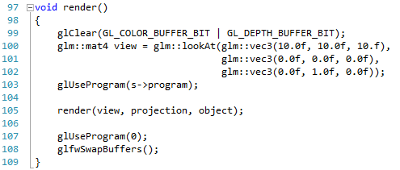

On line 103 we use the program value stored in the shader object. You should now be able to run your application, and get the same result as before:

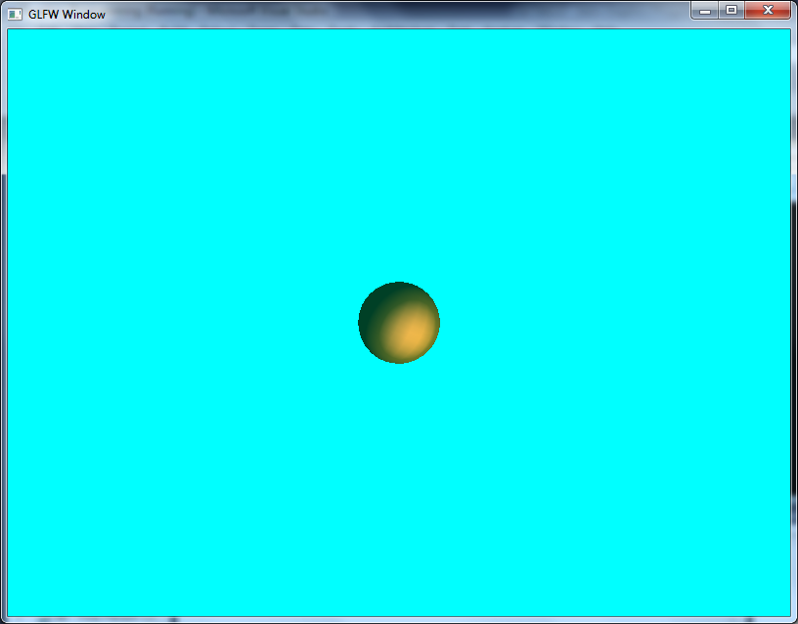

This represents the sphere rendered with the Phong shader. There are no exercises this time, as we have really only done some clean-up of the code base.

# Uniform Blocks

The last practical was really about some refactoring of our existing code (we will be doing a large refactor very soon). However, there is another advantage of us doing this work – we can now start utilising uniform blocks.

## What are Uniform Blocks?

Up until now, we have been sending uniforms to our shader every frame. This involves us copying data from the main memory of the computer to the memory of the GPU. Performing this sort of memory transfer operation is actually quite expensive relative to the other operations that we are doing (main memory to GPU memory copies take time). A far more efficient mechanism is for us to store the values on the GPU in the first place, and only update them whenever they change.

A big problem with this approach is the number of uniforms that we might have in our shader, with each requiring us to tell the shader which values in the GPU memory to use. Doing this negates the advantage of using the GPU memory (we still need to send some data to the GPU to tell it what values to use in its own memory). What we can do instead is utilise the concept of uniform blocks instead to minimise the overhead.

A uniform block is essentially a collection of uniforms bundled together to create a single uniform value. For example, we may have the following in our shader:

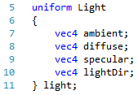

As you will notice, this is just the collection of light values that we need to set. Now instead of setting each value individually, we can set this entire block of memory in one operation, which is far more efficient.

As we are also going to be using GPU memory rather than main memory, we are going to be working with buffers. This means that for us to set the values for the lighting above, all we need to do is bind the buffer using OpenGL:



Here we are binding a uniform buffer, using the ID of the light uniform in the shader (parameter 2), the ID of the light buffer we are using (parameter 3), a starting offset (0 in this case) and the size of the data to set. We have gone from four lines of code to set the lighting values to one (and decreased the memory transfer). There is more setup code to create the buffer, but this is done before we consider rendering anything.

## New Phong Fragment Shader

Let us now start using uniform blocks by first modifying our Phong fragment shader so that it uses uniforms blocks rather than uniforms. Our new fragment shader code is as follows:

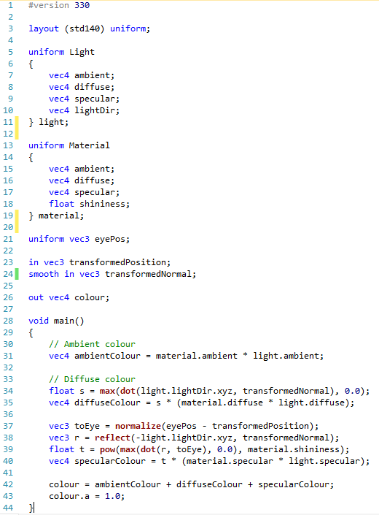

There are a few changes here. Firstly notice that we have a completely new line in line 3:



This line declares the layout in GPU memory of any uniform blocks. This is actually quite important. As we are essentially setting a chunk of memory to a set of values, we need to ensure that the values are set accordingly. The line above is generally the best type of layout, as it follows a standard across all architectures and systems. Other methods may be more memory efficient, but we are more worried with portability.

Lines 5 to 11 define our Light uniform and 13 to 19 our Material uniform. All other uniform and input definitions remain the same. All we then need to do is modify our main fragment operation to use the new uniform definitions. This is done using the standard . notation.

## Updating the Main Application

We now need to do some work updating our main application. There are a few changes to make to reflect the change to our shader operation. First of all, we have a slight change to our material declaration in geometry.h:

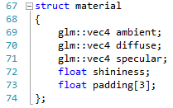

On line 73 we have added a 3 value array of float as padding. For our buffers, each value has to be aligned to 16 bytes of memory (a vec4 is 4 * sizeof(float) = 4 * 4 bytes = 16 bytes). This is how GPU memory operates – with vec4 values. As our float is only 4 bytes in size (a vec1 if you like), then we need to provide some padding to the buffer.

We need a couple of helper operations to allow the creation of a material structure, and its relevant buffer. First, we declare these in geometry.h:



And then we implement them in geometry.cpp:

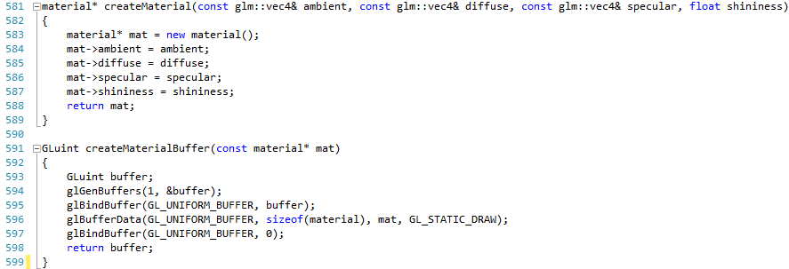

The first operation should be fairly straightforward to understand. The second is where we actually create our first uniform block buffer. The process is generally the same as any other buffer creation process – we generate the buffer (line 594), we bind it so we can use it (line 595) and then set the data (line 596) and then unbind the buffer (line 597). On line 596 we use the parameter GL_STATIC_DRAW. This parameter basically tells OpenGL that we will be using the buffer to draw with (the DRAW part) and that the data in the buffer will not change (the STATIC part). We will utilise some other buffer types soon.

We also have to make a minor change to our render_object (geometry.h):

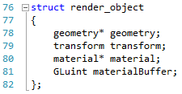

Our render_object now contains the ID of a material buffer, as well as a pointer to a material. We will use this value when setting the uniform block later.

### Updating Shader

Our shader.h and shader.cpp code also needs updated so that we can work with uniform blocks instead of uniforms. Firstly, shader.h requires updating as follows:

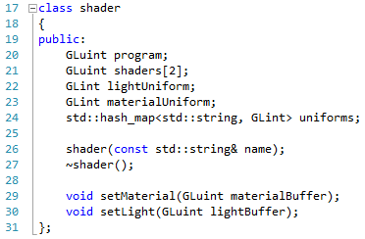

Our class definition now includes the ID for our light uniform and material uniform (lines 22 and 23). The set methods of these values is also changed to accept the ID of the buffers to be used. Now we need to modify our constructor in shader.cpp to set the two uniform IDs:

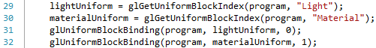

These lines get the index of the index of the light and material uniforms (29 and 30) and then bind them so we can use them later (31 and 32).

Our set methods now only need to utilise the buffer ID passed into the methods:

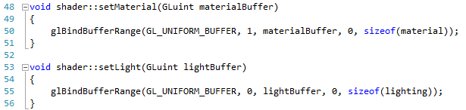

Notice that we use the bound IDs from lines 31 and 32 to bind the relative buffers (line 31 binds the light uniform to 0 for example, which is the value used as parameter 2 in line 55). All we need to do now is modify the main code file to utilise the new approach.

### Updating Main

First, we need to update our main variables again:

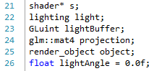

We now have a lightBuffer value (line 23) which will store the ID of the created light buffer. We create our new uniform buffers in the initialise operation:

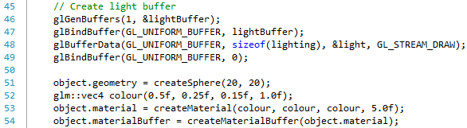

We create a buffer as we did for the material (lines 46 to 49). Notice that we use GL_STREAM_DRAW now. STREAM means that the data in the buffer will change, but that it will not change too often. This means that the GPU will not be constantly copying memory across, but there will be some changes. The reason we need GL_STREAM_DRAW for the light data is because we change it whenever we update the light position.

All we need to do now is modify the render method so that we modify the light buffer, and also so that we use buffers for setting uniforms instead of actually setting values. The new code in render is as follows:

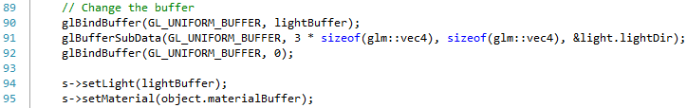

Lines 90 to 92 show how we modify the buffer. We bind the buffer (line 90) then tell OpenGL to modify the buffer memory, starting at memory offset 3 * sizeof(float) (remember that the light direction value is the fourth vec4 value in the lighting structure – so has an offset of 3 vec4 values). The size of the memory to change is vec4, and we pass in the address of the light direction value in the local data. We then unbind the buffer (line 92).

Finally, we set the light and material buffers in the shader. If you run this version, you should get the same output as before:

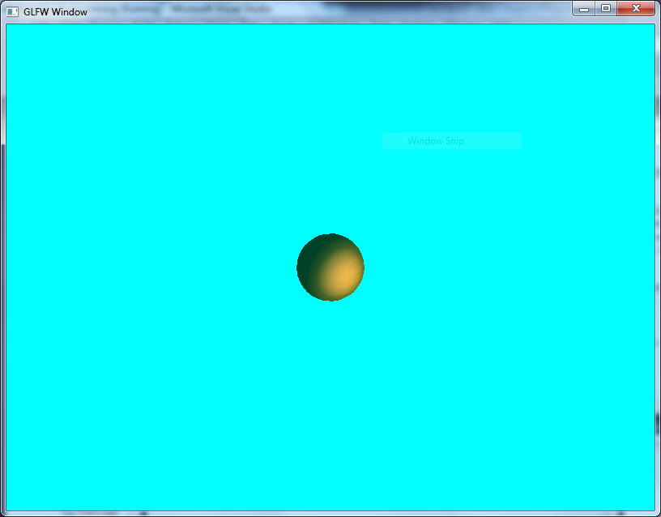

## Exercise

This is a little challenging, as you will have to create multiple buffers for materials, but equally try and reuse existing buffers when possible. Recreate the green pillar, red floor scene using the uniform buffer approach.

# Challenge – Sphere by Subdivision

We are going to take a break from working on lighting for a bit to allow us to try and develop another approach to generating a sphere by using a sub-division technique.

## Technique

The simple way to show how we are going to achieve a sphere using sub-division techniques is by looking at the example of a circle. We start initially with a triangle that fits inside a unit circle:



As the circle is unit size, each vertex of the triangle is exactly one unit away from the centre. We then find the midpoint in all the lines of the triangle:



And then use these points to subdivide the individual lines, and then push the midpoints out so they are unit length from the centre:



We continue this approach until we gain a rough approximation of a sphere.

## Getting Started

The first thing we need to do is declare our new operation in geometry.h:



In geometry.cpp you will also need a helper operation to create a triangle and add it to some geometry:

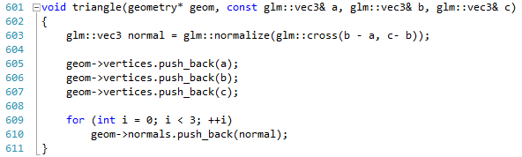

On line 603 we use the cross product to calculate the surface normal for the triangle, and then store our three vertices, and three copies of our surface normal. With this helper operation, you are ready to get started.

## Implementation

The operation you will need to create is called divide_triangle, and it has the following definition:



The createSphere operation calls this operation to create a sphere based on a number of subdivisions. The createSphere operation is provided below:

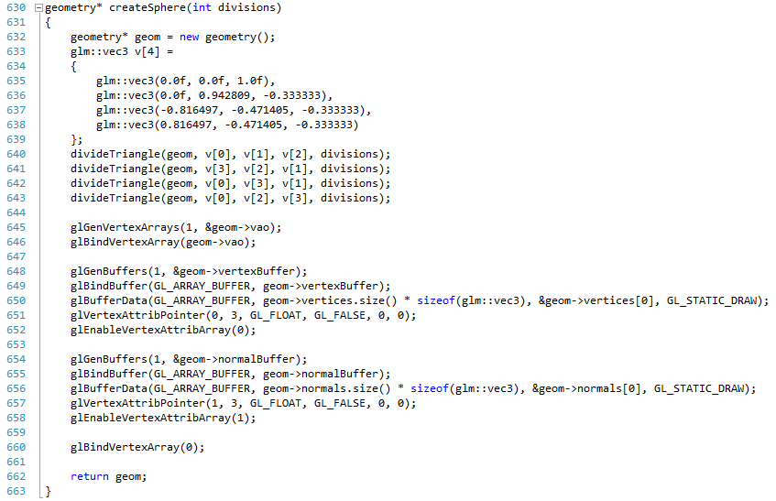

Your task is to develop the divide_triangle operation. Remember how we approached things in the Sierpinski Gasket, and consider trying to do 0 sub-divisions, then 1, and then finally the general case.

## Exercise

You will find that the subdivision and the other create sphere operation creates a different render style:

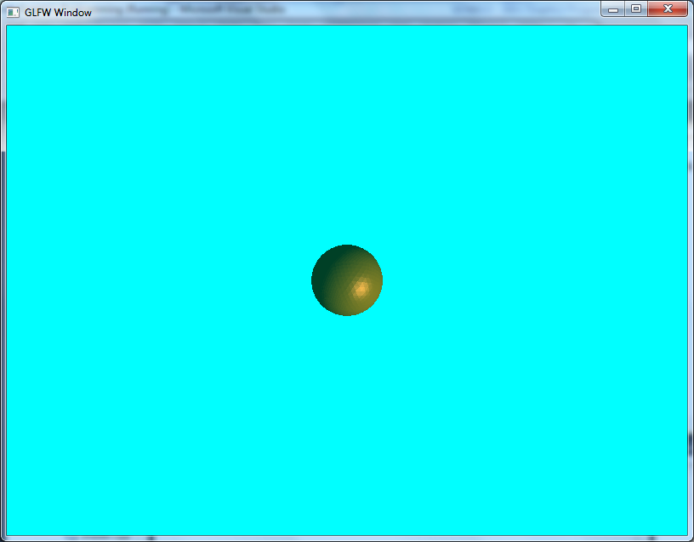 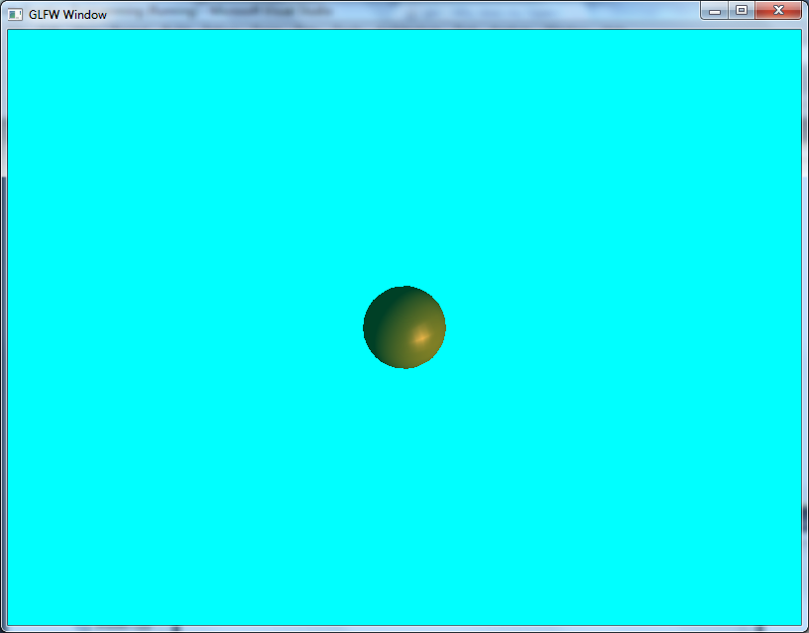

On the left is the sphere by subdivision, where you can see the triangles, whereas on the left you cannot. Why are their appearances different, and can you fix them? (hint – think about how we calculate the normals for the other sphere).

# Point Light

Let us now try and add some other lighting types to our scene. The first lighting type we will examine is a point light.

## What is a Point Light?

Point light works in many regards to normal lighting. However, now our light source has a position and it has a distance which it lights:

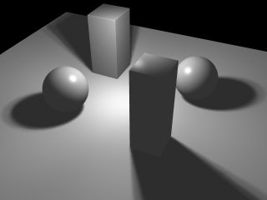

To determine our light vector now, we must take into account the position of the vertex in question in comparison to the position of the point light. This can be determined as follows:

$$LD=normalize(LightPos-position)$$

Notice also that objects closer to the light source are lit more intensely. We achieve this effect within the point light equation.

## Point Light Equation

The point light equation is as follows:

$$C=\frac{1}{k_{c}+k_{l}d+k_{q}d^{2}}C_{0}$$

Where $C_{0}$ is the colour of the light, $d$ is the distance to the light source from the vertex, and the constant values $k_{c}, k_{l}$ and $k_{q}$ are the attenuation values. We will see how we calculate this colour in our shader code.

## Point Light Vertex Shader

Our point.vert file contains the following code:

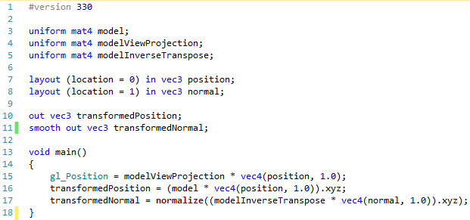

Note that this is just the same as our previous vertex shader code for Phong shading. You can therefore copy it if you wish.

## Point Light Fragment Shader

The fragment shader code is where there are some differences:

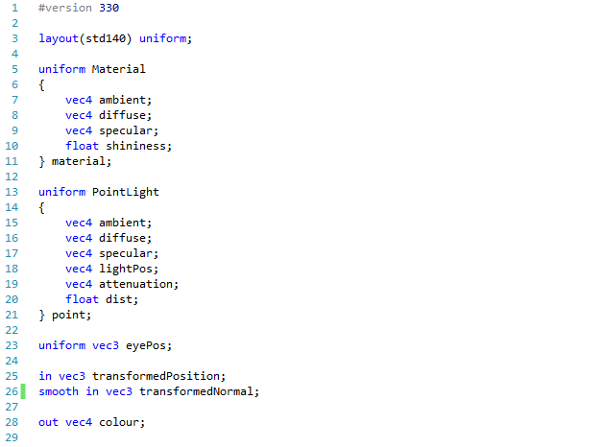

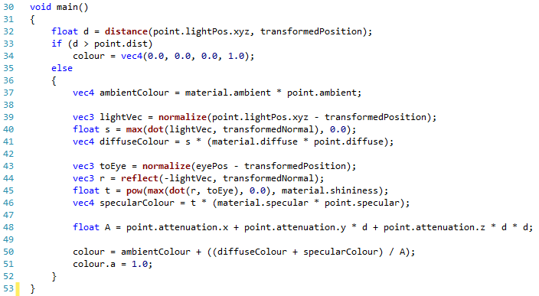

Notice first that we now have out point light uniform (lines 13 to 21). We will be using the same material buffer technique from Lesson 50. Otherwise, our uniforms are similar to the Phong shading model.

Our main shader code is a little different. The first thing we do (line 32) is calculate the distance from the transformed position to the light position. If the distance is greater than the point light distance (line 33) then we perform no further calculation (line 34), outputting black as a colour.

If the vertex is within the distance of the light, then we start calculating as normal Phong shading (lines 37 to 46). On line 48, we calculate our attenuation value. We then use this value to divide the diffuse and specular values (line 50).

## Updating the Main Code Base

We are going to build an application that allows you to see a point light at work by allowing you to move the light source around the scene. This is actually quite trivial with the framework we have been building. There are a few files we need to change however.

### Updating Shader

Our shader.h file requires a definition of our point light:

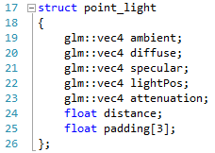

These values just match our point.frag struct values, with some padding to make it be of the correct size. We also need to add an attribute and a method to our shader class to allow this point light to be set:

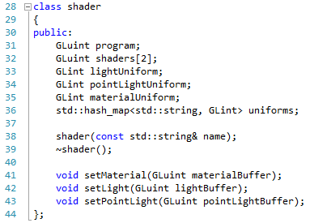

The new lines are line 35 (the point light uniform) and line 43 (the set point light method). Now we need to update our shader constructor in shader.cpp to allow us to get the point light uniform location:

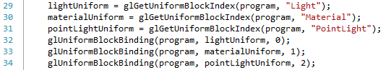

The new lines are 31 – where we get the uniform block location for PointLight – and line 34 – where we associate this uniform block with binding location 2. All we now need to add is the set point light method:

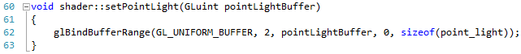

This should be familiar from the other buffer binding methods. Now all we need to do is update main to allow us to use the point light shader.

### Updating Main

First of all, we need to update our main application variables. These are as follows:

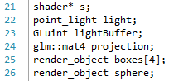

We now have a point light structure in our application (line 22). Also, we are going to have four box render objects (line 25) and a sphere (line 26). Next, we need to update our initialise method to allow us to create these objects:

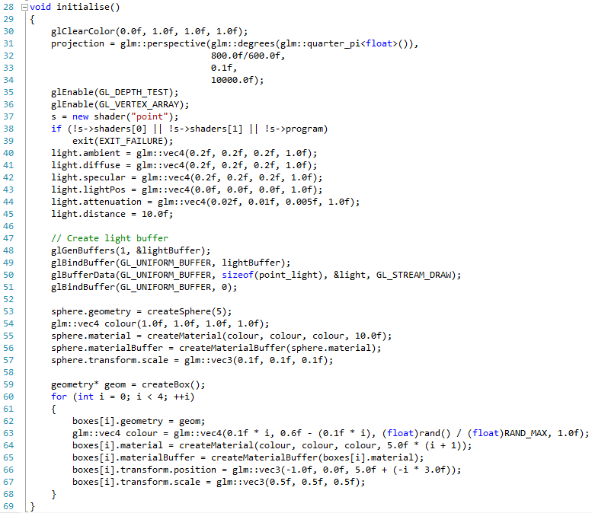

Notice that we are now loading in the point shader (line 37). We set the point light values accordingly (lines 40 to 45). We create the point light buffer (lines 48 to 51), and then generate a sphere (lines 53 to 57). This sphere will represent our point light in the scene. Next we create some box geometry (line 59) and use this to create the four cube objects (lines 60 to 68). Each cube is given a different colour (lines 63 to 64) and position (line 66).

We also need to modify our update to allow us to move our point light around:

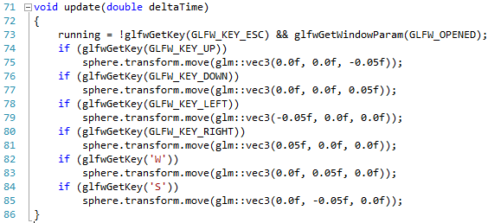

The final pieces of the main application we need to update are in the rendering stage. First, we need to update our object render operation:

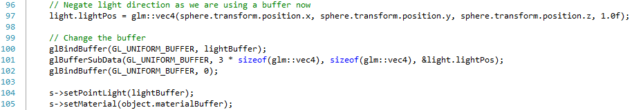

We now use the position of the sphere as our light position (line 97), and then modify the point light buffer accordingly (lines 100 to 102). We also now add the set point light method (line 104).

Finally, we update our main render function so that all the objects are rendered:

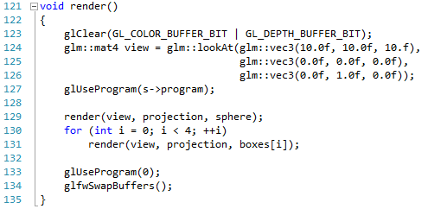

Line 129 renders the sphere, and lines 130 to 131 render the boxes. If you run your application you will get something similar to the following:

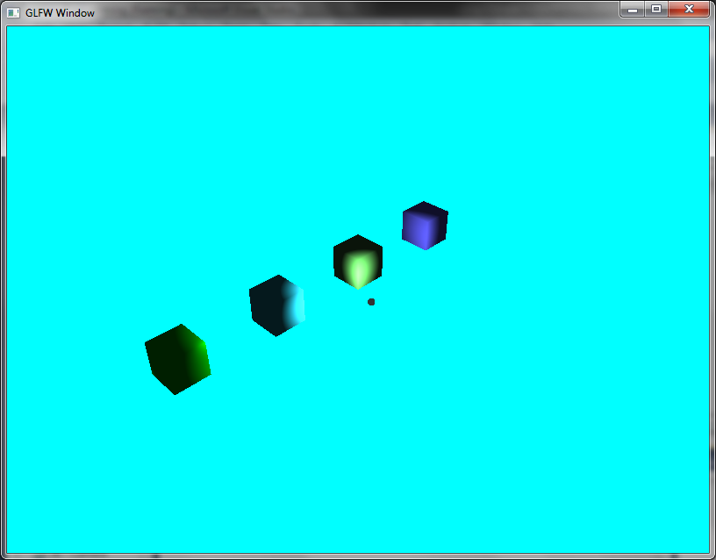

You can move the sphere around, thus influencing where the light is emanating from.

## Exercises

1. Can you make a Gouraud shading (i.e. vertex shading) version of the Point light shader? This shouldn’t prove too difficult.
2. Also, experiment with values as before to see the different effects you can achieve.

# Spot Light

Our next form of light is a spot light. A spot light shares many similar properties to the point light, but now we have to consider the direction that the light is facing in.

## What is a Spot Light?

A spot light shares the properties of a point light (it has position and distance), but now we have a direction to consider as well:

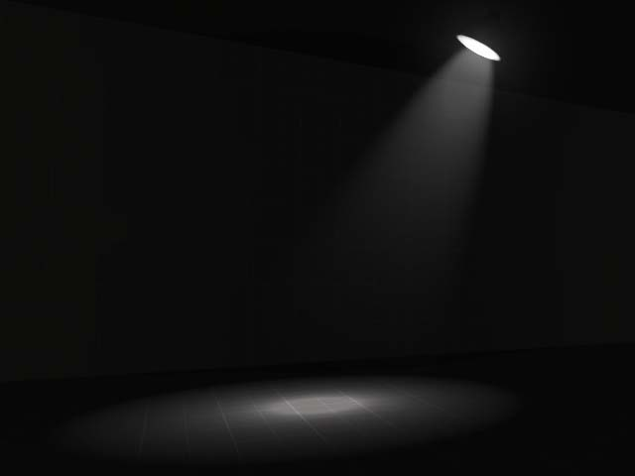

Apart from that, we are still dealing with the same concepts as our other lighting calculations.

## Spot Light Equation

The spot light equation is similar to the point light one, although now we are concerned with the direction of the light in comparison to the light vector:

$$C=\frac{{\max\left(-R⋅L,0\right)}^{p}}{k_{c}+k_{l}d+k_{q}d^{2}}C_{0}$$

Where $R$ is the direction of the spot light, and $L$ is the light vector (direction to the spot light). The value $p$ is the spotlight power. The other values are the same as the point light equation.

## Spot Light Vertex Shader

The spot light vertex shader is the same as our previous two shaders:

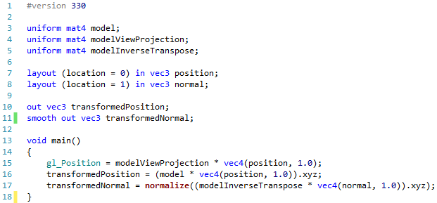

## Spot Light Fragment Shader

The fragment shader is again where we see some differences:

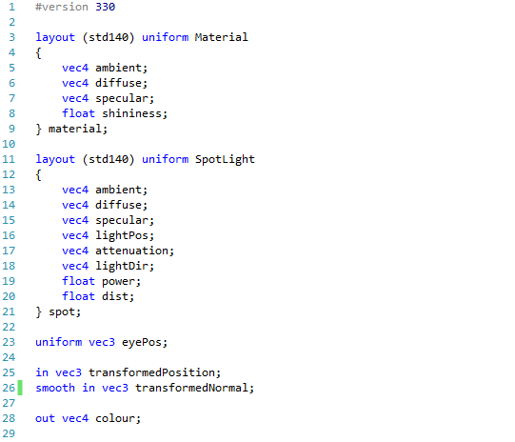

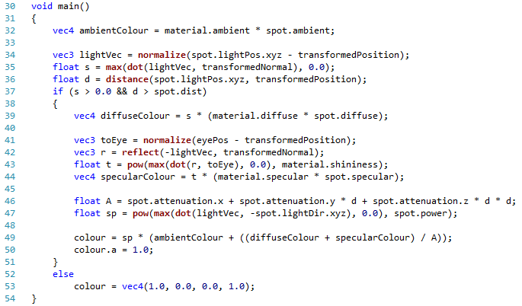

We now define a spot light structure (lines 11 to 21). The values are as before with the addition of a light direction (line 18) and a power (line 19).

Our main shader function shares much of the same calculations as our point light, but with a few subtle differences. First of all, once we calculate the light vector (line 34) we get the angle between it and the transformed normal. We then use this to check if the spot light is even in affect (line 37). If it is, then we use this value to calculate the diffuse component of the light (line 39). We get the reflection vector (line 42), and use this to work out the specular value $t$. We then get the spot light value (line 47) and multiply our existing light calculation by this value.

## Updating the Main Code Base

Again, we have a few pieces of code to update. First, shader.h requires a new structure:

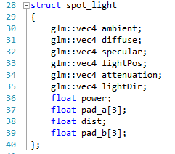

Notice this time that we have two padding values to fill out the power and distance. We also need to update our shader class:

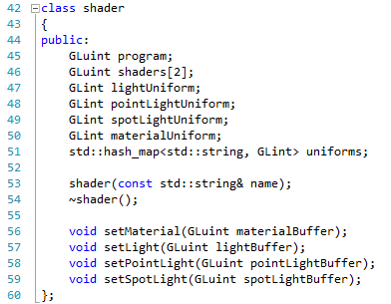

We now have a spot light uniform (line 49) and a method to set this value (line 59). We now need to update shader.cpp to use these values. First, the shader constructor needs updating:

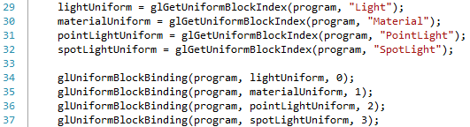

Line 32 gets the location of the spot light uniform block, and line 37 sets the binding location. We also need the set spot light method:

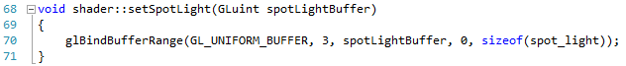

### Updating Main

The main code file needs a few updates as well. First, we are going to change our main variables to the following:

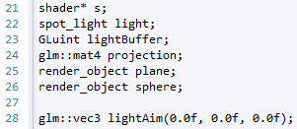

We now have a spot light value (line 22), a plan (line 25) and a sphere (line 26). The sphere is again going to indicate the position of our light. However, we are now going to move the aim (line 28) around. This will give the impression of the spot light target moving across the plane. This is the effect we are going for.

Our initialise operation now requires a bit of updating:

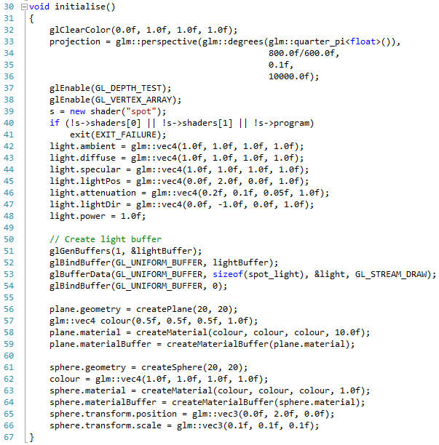

We now load the spot light shader (line 39), then set up our lighting values (lines 42 to 48), and create our light buffer (lines 51 to 54). We create our plane (lines 56 to 59) and also our sphere (lines 61 to 66). Notice that our sphere position is the same as our light position (lines 45 and 65).

Our update operation is also updated:

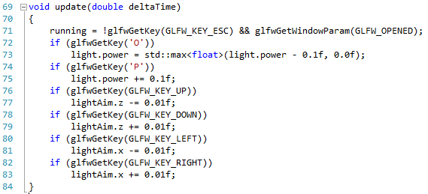

We now use the keys to manipulate the light aim, and the power of the light (O and P). We also need to update our object render:

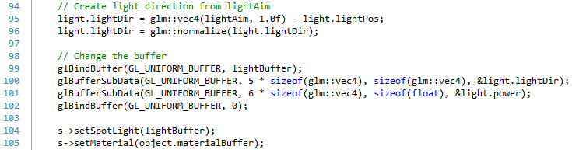

We generate our light direction from our light aim (lines 95 to 96), modify our buffer (lines 99 to 102), changing the light direction (line 100) and light power (line 101) values. We then set our spot light (line 104). Finally, a small change to our main method and we are done:

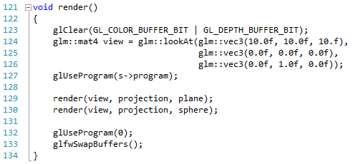

Line 129 renders the plane, and line 130 renders the sphere. We are now ready to run the application. You should see something as follows:

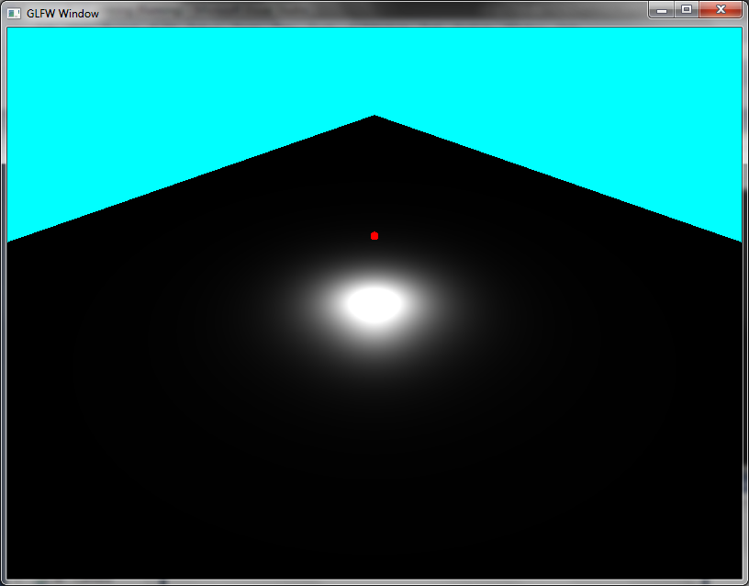

## Exercises

1. Again, try and implement a Gouraud shading approach to this shader.
2. Also, experiment with the values used to see the different effects you can generate.

# Emissive Light

So far, we have been treating objects simply as light absorbers and reflectors in our scene. However, objects can also emit light as well. Let us add one other component to our scene – using emissive light.

## What is Emissive Light?

Emissive light is light that emits from a rendered object in our scene.

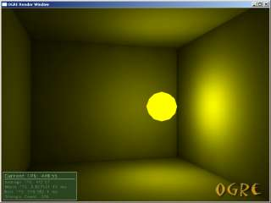

However, we will not be dealing with emissive light quite in this manner. We will consider emissive material to be the colour that a surface has, without taking into account the different lighting values. If we also want to emit a light from the object, we can use a point light for this.

## Updated Shaders

We only need to make a small change to our spot.frag file. First, we need to update the material definition:

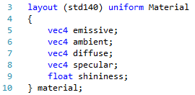

We have now added an emissive component (line 5). All we need to do now is update how we calculate the pixel colour:



Notice now that we just add the emissive value to the existing colour calculation. It is that easy. Now all we need to do is update the code base.

## Updated Code Base

First of all, we need to update our definition of material in geometry.h:

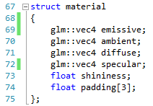

Notice that the new emissive value on line 69. We also need to update our create material operation. First in geometry.h:



And then in geometry.cpp:

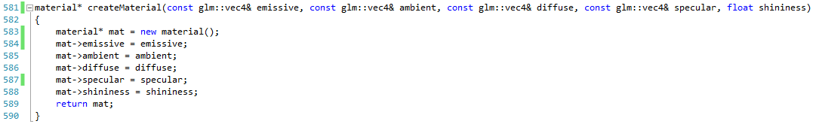

In our main file, we need to update our attributes:

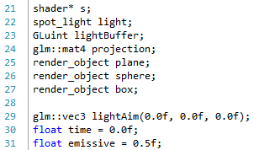

Notice that we now have a plane, a sphere and a box (lines 25 to 27). We are going to make our box flick between a green emissive light, and a black emissive light. This is down using the time value (line 30).

Our initialise operation is also updated. These lines go after the creation of the light buffer:

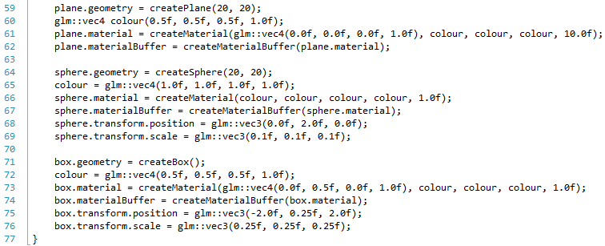

We create our plane (line 59), and set its colour to grey (line 60) but with an emissive black value (line 61). For our sphere (lines 64 to 69) we set our colour including emissive to white. Finally, our box (lines 71 to 76) is grey (line 72) but with an initial emissive colour of green.

Our update will modify the emissive colour:

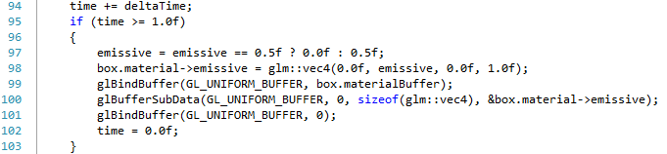

These lines go at the end of update. We add the time since the last update to the current accumulated time (line 94), then when we have 1 second (line 95), we change the emissive light (lines 97 to 98). We also update the buffer accordingly (lines 99 to 101).

The only other change we require is to our main render method:

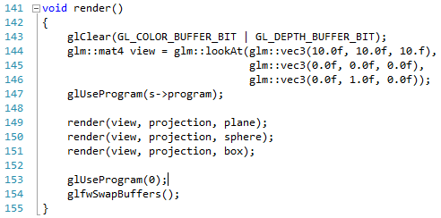

We just render the plane, the sphere and the box (lines 149 to 151). When you run this application you will get the following:

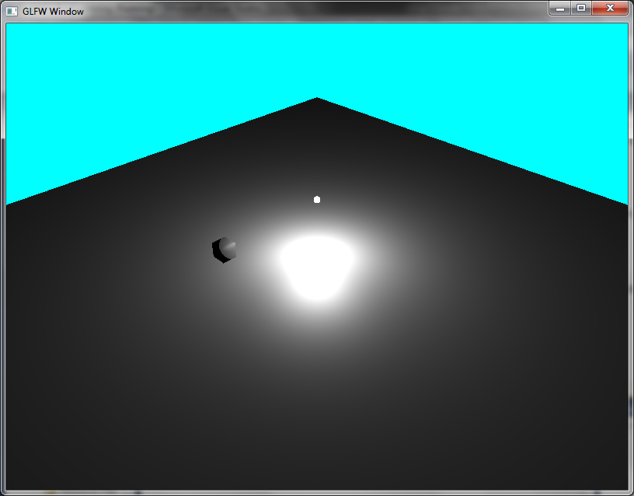

The box will flash green every second. And that is us with our main lighting setup. There are no exercises, as the next lesson is a major refactor of our code base. This will take time.

# Refactor Time

We have now quite an impressive collection of code (if you count the lines, we have approximately 1000 discounting the main code file). That is quite a bit, but we have quite a bit still to do. The next lesson will make our job much easier still, but requires us to do some refactoring first. This is probably the best time for it as well.

## Components

We are going to try and build a reasonable architecture for our rendering framework. To do this, we need to take a look at the components we have built, and the components we need to build. Let us first take a look at the components we have put together so far. The classes and structures we have are:

* Geometry – stores geometry information for our objects
* Transform – describes an object’s transform
* Material – describes and object’s material
* Render Object – an object that we can render. Contains a transform, geometry, and a material
* Lighting – stores lighting information for a scene
* Point Light – describes a point light for a scene
* Spot Light – describes a spot light for a scene
* Shader – describes a shader that we can use to provide an effect for an object or scene

So we have quite a lot of really useful components / classes / structures already. We also have a number of helper operations. What we need to do now is to plan out how our framework is going to operate a bit better. Let us draw a class diagram for this.

## Architecture

Hopefully you are familiar with class diagrams. If not, I suggest that you do some reading! A class diagram is a simple method for us to explore our architecture without looking at the code. From our point of view, we have a few different major component types in our system. These are:

* Render object – objects that can be rendered to the screen. This includes the transform, geometry, and material of the object.
* Lighting – holds lighting details, including point and spot lights
* Effect – holds information about a particular group of shaders used for a particular effect.

We have already developed the code for these three main components. We are just going to do some major refactoring to make the code more useful. Let us start by looking at the render object.

### Render Object

The class diagram for the render object is given below. It is the most complex grouping of components in our system, but still relatively simple to understand.



We have five structures in place here (I use the term structure as these are all essentially data that we can use). Looking at the diagram, we have:

* Render object – contains all the information that is required to render an object to the scene. The render object itself contains 3 sub-parts:
  + Transform – the information required to create the model matrix for the render object.
  + Geometry – contains the geometric information for the object, including positions and normals.
  + Material – contains the material information for the render object. Notice that the material itself contains a buffer object, and reference to a material_data structure:
    - Material data – contains the raw information for an object’s material. This information can be created as a buffer and stored on the GPU.

Notice that we use two different relationship types – one with a filled in diamond, and one with an empty diamond. The former indicates a component relationship. This means that the related to object is owned by the other object to the point where it is destroyed when the parent object is destroyed. Notice that we have the relationship between the render object and the transform like this. We won’t reuse the transform for a second object.

The second type of relationship (the empty diamond) is known as an aggregate relationship. This means that although the object has one of these objects as part of their structure, they do not own it exclusively, and other objects may also contain the related object. Notice that the render object has an aggregate relationship to the geometry structure. This means that we are stating that geometry may be used by multiple render objects (which it can be).

### Lighting

Let us now look at the lighting component. There are actually two parts to this – the static lighting for the scene, and the dynamic lighting (the point lights and spot lights). Let us look at the static lighting first.



The lighting component is similar to the material one, in that it is just a buffer object and a reference to some data (lighting data) that we can store in this buffer. The dynamic light component is similar, but allows multiple point and spot lights:



We have a dynamic light structure, which is just a buffer and a reference to a data structure. The data structure is just two arrays of point light and spot light data. Each of these data structures contain the necessary information for our point and spot lights.

### Effect

Our final component is the effect. This is actually the only class we are creating (the others are just data so therefore we treat them as structures). The effect class is actually central in many regards to our architecture:



The relation types here are dependencies. These means that lighting depends on the effect, the material depends on the effect, and dynamic lights depend on the effect. This is because they all use effect in their bind operation. This operation simply registers the various components with the shader, setting the uniform blocks accordingly. This will make our work quite simple.

Notice as well that the effect has a vector of shader objects. This is because we are just going to add the shaders to an effect, then link the entire effect. This will actually make our job much easier later on.

### Overall Architecture

The overall architecture of the system looks as follows. We won’t analyse this any further, but you should be able to understand the total architecture from the parts we just examined.



### Overall Operation

It is also worth taking a look at the overall operation of the system. The sequence diagram below should help. In effect, what we do is:

1. Call begin on the effect. This will cause the shader to be set as active on the GPU.
2. Call bind on the light. This will cause the relative buffer to be bound to the relative block on the shader.
3. Call bind on the dynamic lights. This will cause the relative buffer to be bound to the relative block on the shader.
4. Call bind on the material. This will cause the relative buffer to be bound to the relative block on the shader.
5. Draw the geometry
6. Call end on the effect. This will cause the shader to be set as inactive on the GPU.



We are now ready to build our updated rendering framework. As the effect class is at the centre of everything, we will start there. You will definitely want to start a new project for this.

## Effect

The class diagram for the effect class was as follows:



The effect.h file is as follows:

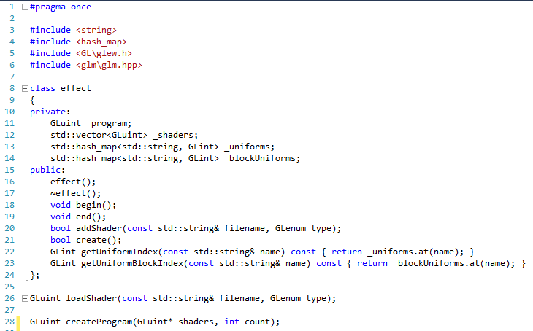

Notice the similarity between the class file definition above and the effect class definition in effect.h. This is intentional. We also keep our loadShader (line 26) and create program (line 28) operations from before (code reuse is good, and means we can be lazy). If we look at the actual implementation of effect.h in effect.cpp, we have for the constructor, destructor, etc.:

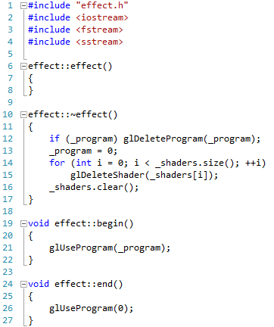

None of this should be unfamiliar. Next let us look at the addShader code:

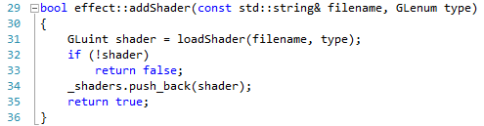

Here, we just use loadShader (line 31) with the given filename and shader type to load in the shader. If we hit a problem, we return false. Otherwise we place the shader in the vector of shader objects. Now let us look at create, where the shader program is actually linked.

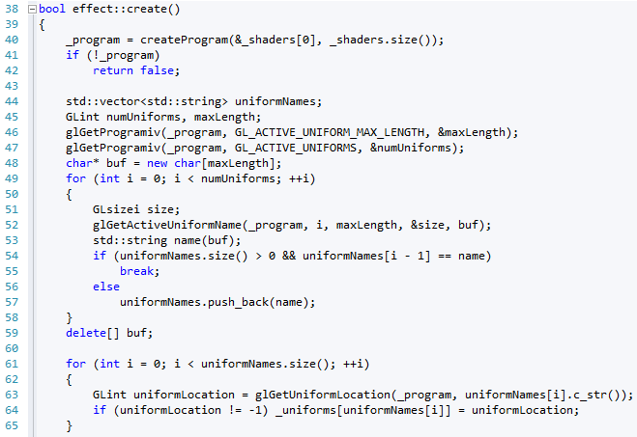

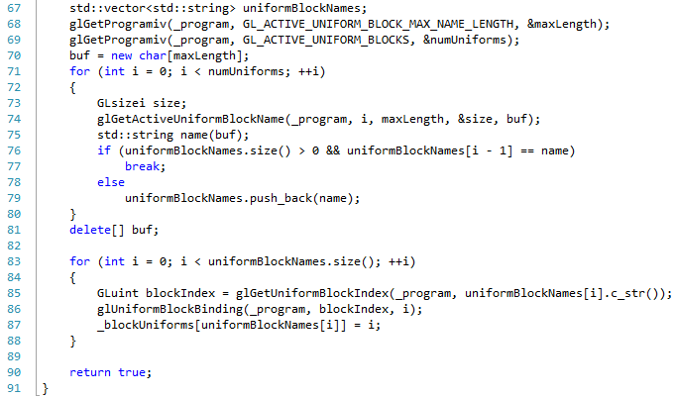

This code is generally the same as our previous shader program linking step. However, we now also retrieve the uniform block names from the linked program (lines 67 to 88). This will make our life even easier than before.

We also need read file from before:

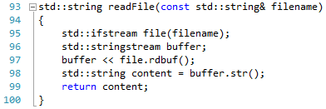

Load shader:

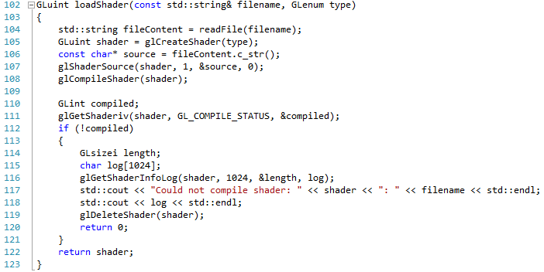

And createProgram:

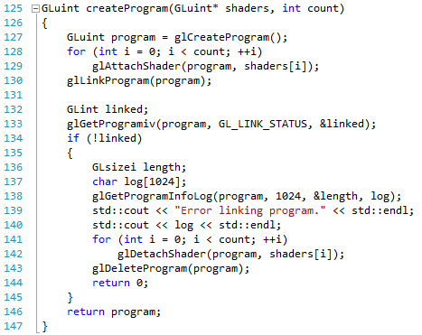

And that is effect.cpp completed. Effect is probably the most complicated change we have to make. The rest are very similar to our original files.

## Transform

For transform, we just need a header file. Transform.h is as follows:

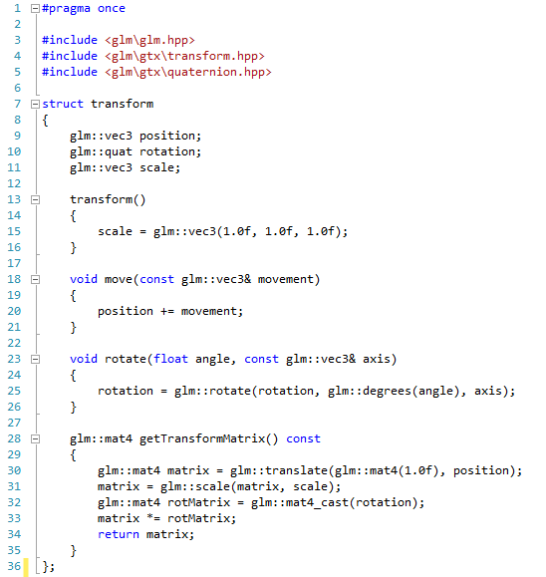

This is identical to the previous transform code. Next, let us look at geometry.

## Geometry

The geometry.cpp file had by far the most code for our application. This hasn’t changed, but most of the code is the same. Our header file, geometry.h, is as follows:

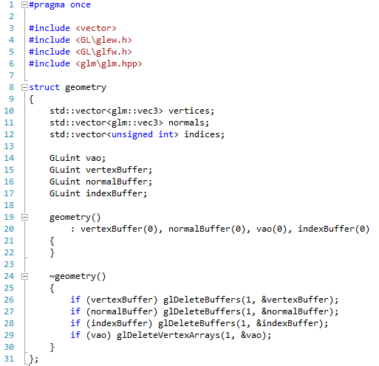

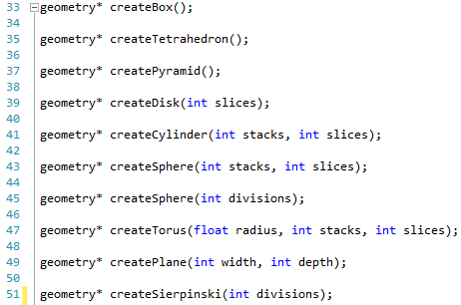

This is just a cut down version of the existing geometry file. You can easily create geometry.cpp as a copy of the original file, so I won’t repeat the code here.

## Material

The material file is new, but is based on the old material structure we had in the old geometry.h file. The header material.h is as follows:

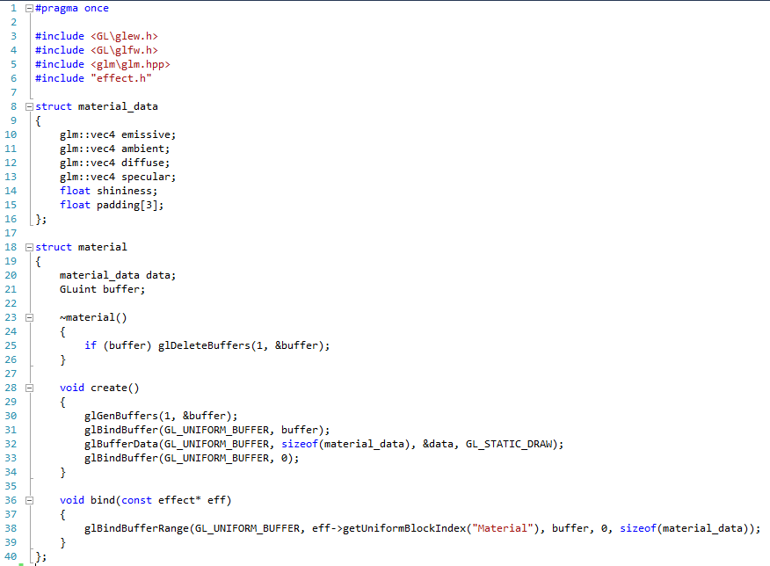

Most of this is taken from the previous work. The difference now is that the material_data structure is used as the data stored on the GPU, with the material containing a link to this data, and a reference to the created buffer.

## Render Object

Render object is the simplest construct, and just requires render_object.h:

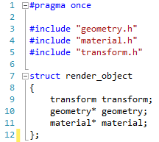

Now that the render object and effect components are done, all we need is our lighting.

## Light

The lighting approach has changed a little, although the concepts are the same. The file light.h can be thought of as two parts. First the lighting:

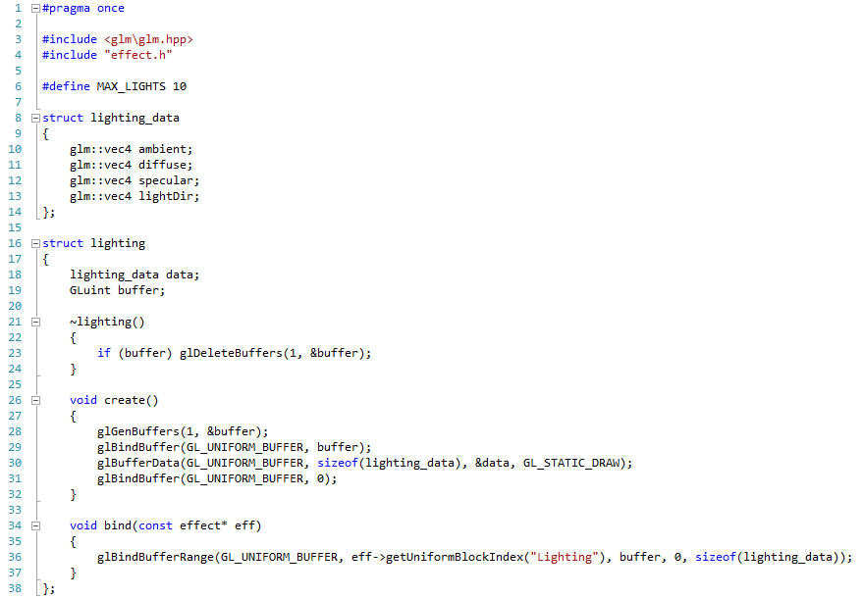

This is similar to before, but uses the same technique we did for material. Our other part is the dynamic lighting code. This has some more differences as we are going to be dealing with multiple spot lights:

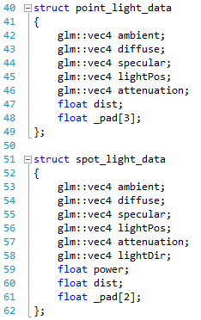

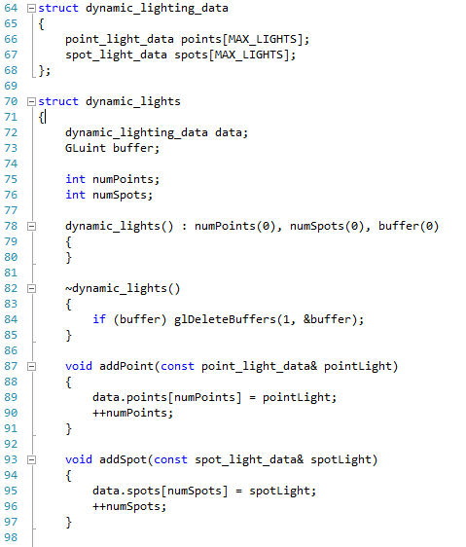

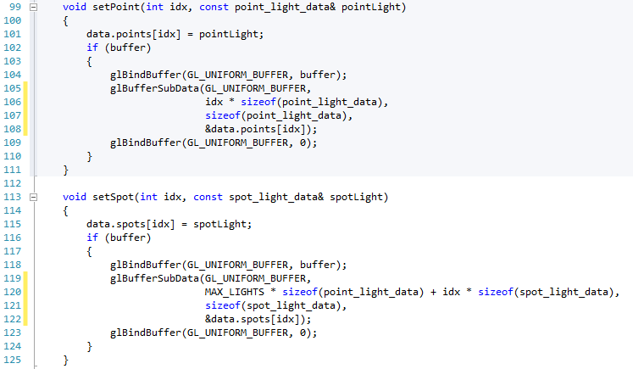

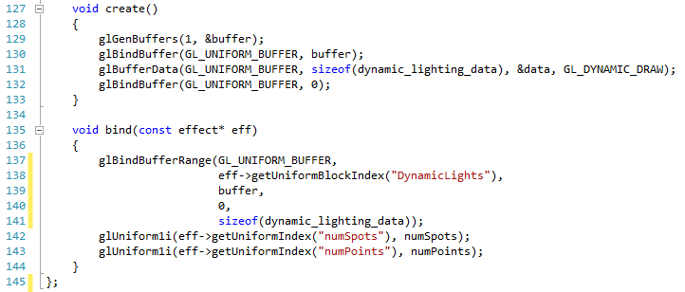

Most of this should make sense, so we won’t explain it here. However, if you are struggling, ask for some help. Let us now look at an updated shader and main application to support our new code base.

## Multi-Light Shader

We are going to update our shader so that we are using multiple point and spot lights. This is actually a relatively simple change to perform. However, we are also going to take this opportunity to break our code down into a collection of operations instead of one main one.

### Multi-Light Vertex Shader

The multi_light.vert file is defined as follows:

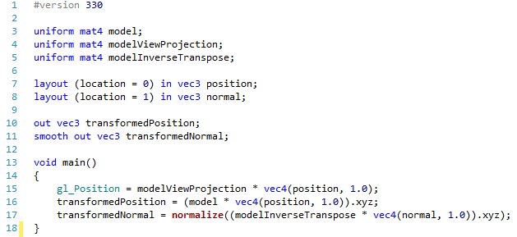

This is just the same as our current vertex shader.

### Multi-Light Fragment Shader

The multi_light.frag file is a bit more involved. Let us first look at the material and light uniforms:

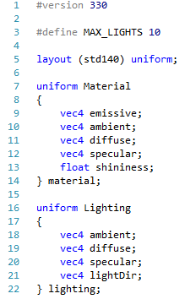

These should be familiar from before. Notice however the MAX_LIGHTS definition at the top. This is important. Next, let us look at the point and spot light uniforms:

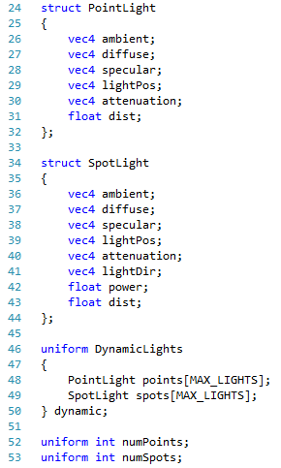

We have created structs in our shader now, that match the ones we have in our main code base. We then use these structs to define a uniform block for dynamic. Notice we have two arrays now. Also notice that the size of these arrays are fixed (by the MAX_LIGHTS value). You cannot allocate memory in a shader, so you have to declare the amount of memory that you are using. We also introduce two new values, numPoints (line 52) and numSpots (line 53). These will store the actual number of points and spots in a scene.

We only have one more uniform, and the incoming and outgoing data to define. This is as follows:

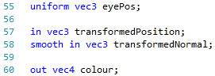

These are the same as before. We are now going to divide our shader into a collection of operations, like so:

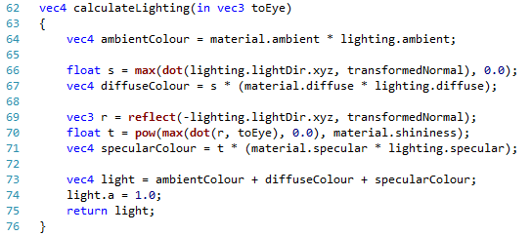

Our first operation calculates the standard Phong light model. Notice we return a vec4 (the colour for the light) and take in a vec3 for the toEye value. The in part of the parameter is important.

Next we have calculate point and calculate spot:

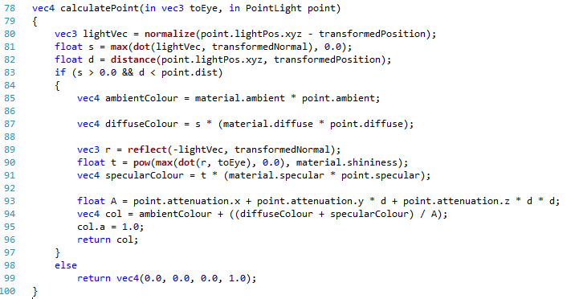

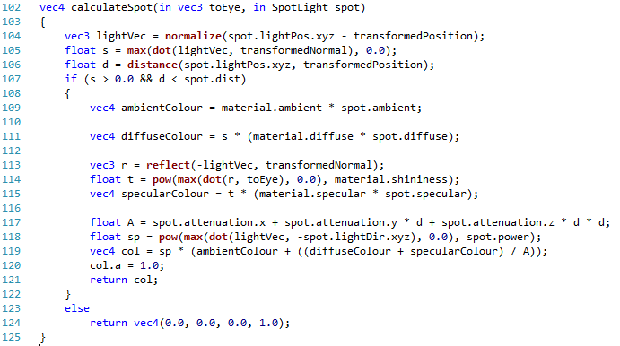

Again, we are just reusing code from before. Notice that we take in spot light or point light data as a parameter. This means that we can reuse this code in a loop in our main operation for each of the point and spot lights. The main operation is as follows:

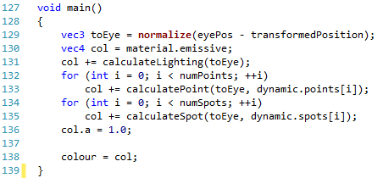

We first calculate the toEye value (line 129) and start with the emissive colour as our base colour (line 130). We then add the static lighting (line 131), and then loop round each of the point and spot lights, adding their generated colour (lines 132 to 135). We then set the alpha component of the colour to 1.0 (line 136) and output the colour (line 138). And that is our shader implemented. Now to test our new framework and shader by updating our main application code.

## Main

We are going to start from scratch again with our main file, although in truth it is almost identical. This will give you the chance to start from this point onwards with a particular main file. First of all, we have the following compiler pre-processors.

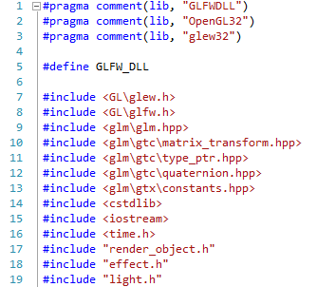

We won’t explain these in detail – they should make sense by now. The variables we will be working with are defined as follows:

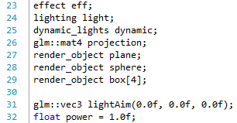

We have an effect object (line 23) which will contain the effect we will use for the scene. We also have a lighting structure (line 24) and a dynamic lighting structure (line 25). We have our projection matrix as before (line 26) and a collection of render objects we will create (lines 27 to 29). We will be having a spot light in the scene, so we also create a light aim and a power value.

Our initialise method is quite long now because we have a lot of geometry to set up. However, none of this should be unfamiliar by now. We will be fixing our large initialise method in the next lesson:

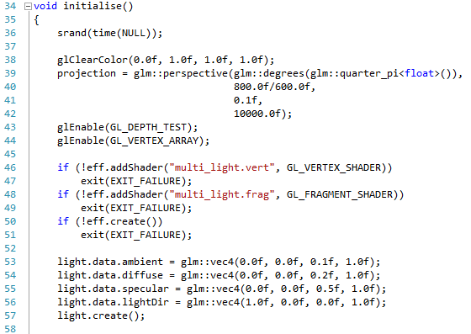

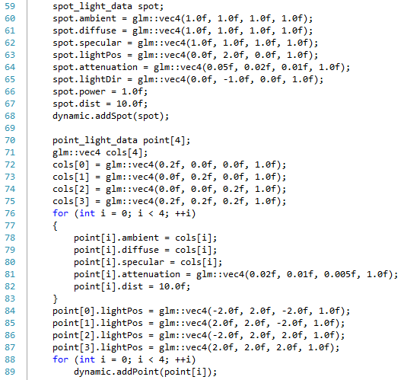

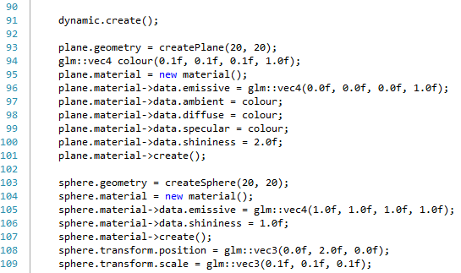

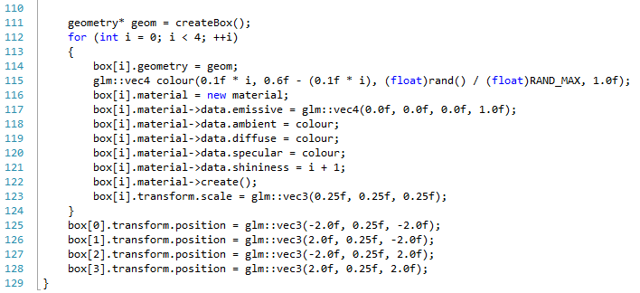

As mentioned, there is a lot of code here, but it is all just lighting and geometry setup. Our update method allows us to manipulate our spot light:

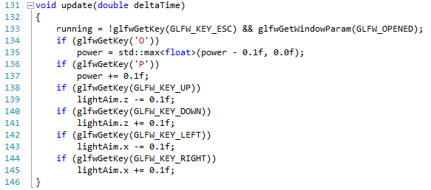

We allow the spot light aim position to be manipulated by the arrow keys, and O and P to manipulate the power.

Our operation to render an object is as follows:

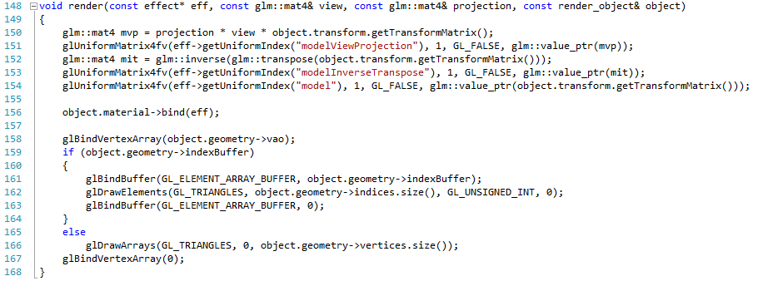

Again, this should be familiar from before. Our main scene render operation is as follows:

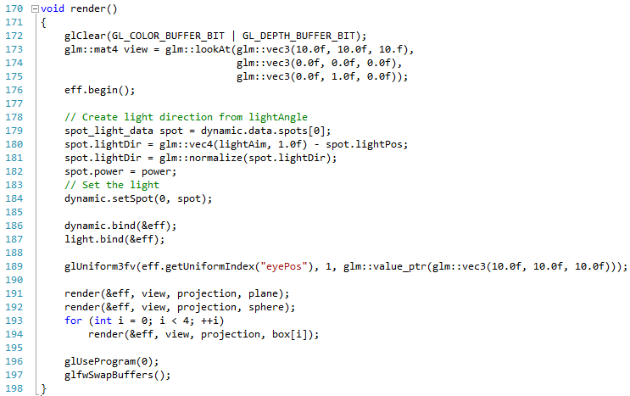

Notice we use the effect begin method on line 176, and use the lighting data structure to manipulate the light in lines 179 to 184. We then bind the lights (lines 186 and 187) and then render our objects (lines 191 to 194).

Our cleanup operation is also simple:

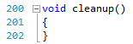

Finally, we make some changes to our main operation. This will let you print out some details of OpenGL, which you may find useful later on.

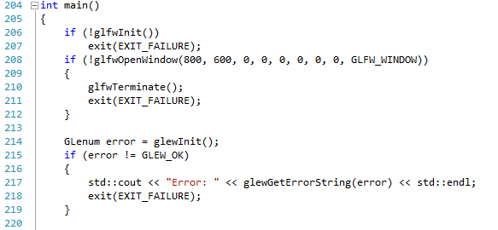

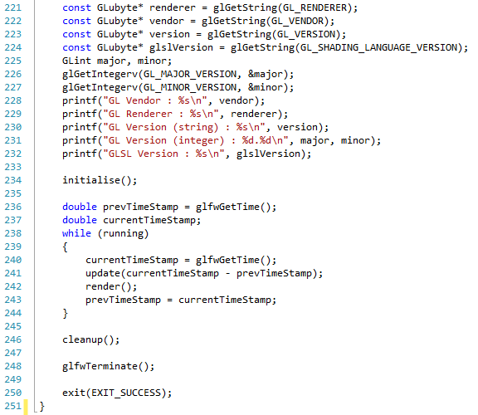

Lines 221 to 232 are the new ones. These print out the OpenGL renderer, the OpenGL vendor, the OpenGL version, and the OpenGL shading language version for your system. We also get the version number of OpenGL in number form (lines 226 to 227). We then print all this information out. You will be able to see it on your console window. If you run your application, you should get the following:

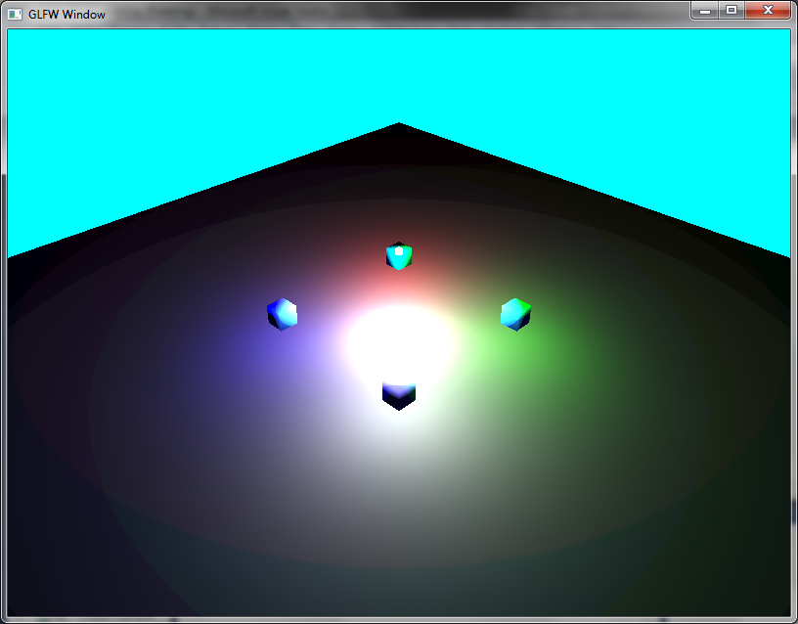

## Exercises

No exercises again this time, as this was a large lesson. However, you can change some of the values to see the results.

# Using Config Files

You may have noticed that we now have a quite large initialise method. This isn’t great, as we want to create more complicated scenes, but do so easily. What we will do is create a method to allow us to read in a definition file, and use this to generate our scene. We are going to use JSON (JavaScript Object Notation) to define our scenes, and we will use the set of Boost libraries to provide JSON reader capabilities.

This is quite a large new part of our library, but has nothing really to do with the rendering aspect. Therefore, the two code files are provided on Moodle. I recommend you at least go through the lesson to understand what we have done, and you will definitely need to get Boost (Section 56.1). You will also have to update your main code file (Section 56.4).

## Getting Boost

Boost is sometimes referred to as the extra C++ API. It provides more functionality than the standard C++ API, reaching into areas that we see the .NET and Java API cover. Parts of Boost are often integrated into the standard C++ API (quite a few of the extra features in the new C++11 standard originated in Boost).

To get Boost, you need to visit <http://www.boost.org/>. However, you may prefer getting the pre-built libraries for Windows from <http://www.boostpro.com/download/>. We shouldn’t actually be using any code that requires built libraries, and therefore the headers in the main source download should be enough. You should be able to work out how to set up your property sheet accordingly, but if you are unsure, ask for help.

## Scene Code

We are going to create a new data structure which is going to contain all the information required in a scene. We first need a new header file called scene.h:

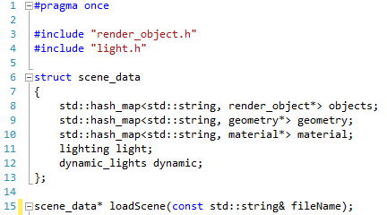

We define a scene_data structure (lines 6 to 13) which contains all the information required for representing a scene. We have a hash_map of render objects against names (line 8), a hash_map of geometry against names (line 9), and a hash_map of materials against names (line 10). We also have a light structure and a dynamic light structure. These are all the elements we require to define a scene at this time. We also create a new operation – loadScene (line 15), which takes a file name and produces a scene data structure.

Let us think of what we have to do in our loadScene operation. First of all, we need to be able to load geometry. We need to be able to load materials. From these two, we can then read in render objects made up of these two items, and a transform. Next we need to read in lighting, and then dynamic lighting. The dynamic lighting also needs us to be able to read in point light and spot light data. We therefore have the following operations:

* Load Geometry
* Load Materials
* Load Render Objects, which includes:
  + Load Transform
* Load Lighting
* Load Dynamic Lighting, which requires:
  + Load Point Light
  + Load Spot Light

The following Use Case diagram should help:



Now we need to build these operations. Let us first define a few helper methods.

### Helper Methods

You will need to create a new code file called scene.cpp. First of all we need the following files included:

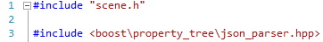

We have the scene header file as expected, and also the Boost header file for a JSON parser. We will discuss JSON files shortly, but let us explain the structure which the parser gives us. The JSON parser will read in the document and create a tree data structure as follows:



Obviously each of the main branches will have items within then (mat_1, mat_2 for material, etc.). This tree data structure allows us to access data very easily. We will look at how we do this shortly.

First, we need to define a couple of helper methods. The JSON parser only understands how to read primitive types (strings, numbers, etc.). Therefore, we need to be clever about how we store vectors. The simple solution is that we store then as an array. This means that the JSON parser will create a tree structure as follows:



This means we need a few helper functions to read a 3-dimension and a 4-dimensional vector. These are defined as follows:

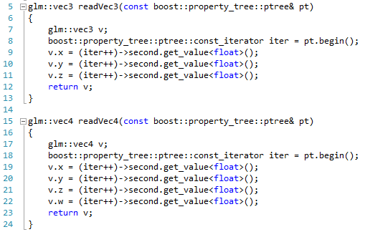

This code may look very complicated, so let us step through it. You should hopefully be familiar with the idea of an iterator (where we can iterate through a data collection, accessing each member exactly once, in some order defined by the iterator implementation). On lines 8 and 18, we create such an object from the incoming branch of the scene tree we read in (the pt value passed in as a parameter). We then iterate across the values, assigning them to a value in the vector accordingly (lines 9 to 11 for a vec3, and lines 19 to 22 for a vec4). With each value in the tree, we call the get_value<float> to read a floating point value. Hopefully this makes sense. If not, you can read up on property trees in the Boost documentation, or just accept that this works.

### Load Geometry

Let us now create our geometry loading operation. This involves us reading in information regarding the type of geometry we want to create. The code is as follows:

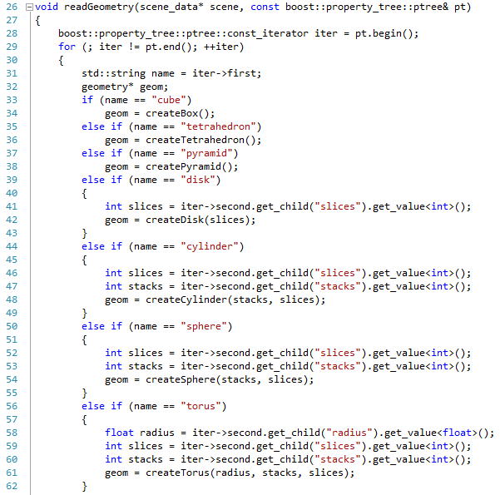

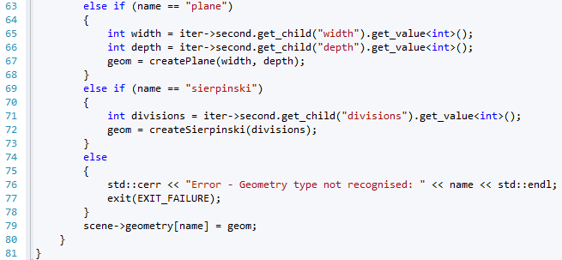

We create an iterator as we did for the vector loading (line 28). Then, we iterate across the iterator as long as it has values (line 29), reading in the name of the geometry first (line 31). We then use this name to create the relevant geometry type, reading in any extra values we may require. So for example, if the name is “plane” (line 63), we read in the width value (line 65) and the height value (line 66) and use these to create a plane as geometry (line 67). This will allow us to store one type of each geometry at present (which we store in the geometry data of the scene – line 79). We will fix our code in a later refactor to allow us to load multiple instances of the same geometry type – this is lesson 78. However, this is all we need at present.

### Load Materials

Next we need to load in our materials. This is handled by the following operation:

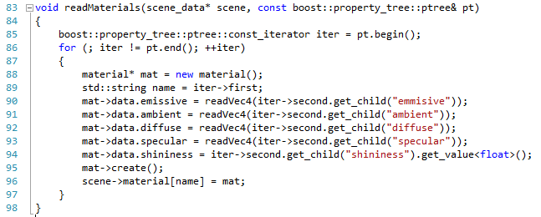

We create an iterator (line 85) and iterate across it (line 86). We read in the name for the material on line 89 (we will use this to match our render objects shortly) and then read in the relevant values for the material (lines 90 to 94), before creating the material (line 95) and adding it to our scene data (line 96).

### Load Transform

Next we need to load our transforms information. This operation is also simple:

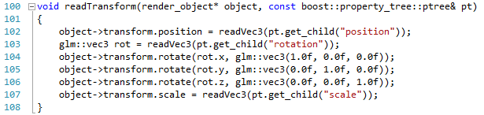

We read in the position from the branch of the property tree we are on (line 102). We then read in the rotation (line 103), and then use this value to rotate the object accordingly on lines 104 to 106 (remember we have a quaternion underneath). Finally, we read in the scale (line 107).

### Load Object

Now we can write our load object operation. This is defined as follows:

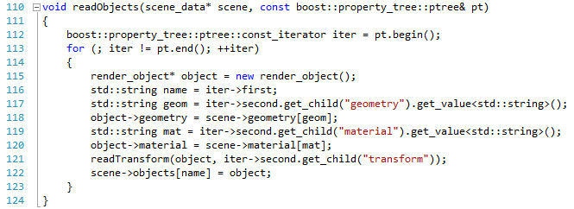

We create an iterator for the branch of the tree we are on (line 112). We then iterate through our render objects (line 113), first reading in the name of the render object (line 116) and the name of the geometry we want to use (line 117). We use this name to get the relevant piece of geometry from the scene, and associate it with this render object (line 118). We do the same for the material (lines 119 to 120). Finally we read in the transform (line 121) and then store the render object in the scene data (line 122). At that is our render objects read in.

### Load Lighting

To load lighting, we just need the following simple operation:

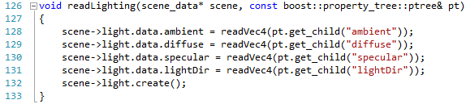

For the particular branch of the tree, we just get the various values we are interested in (lines 128 to 132).

### Loading Dynamic Lighting

First, we need our helper operations to read in our point and spot lights:

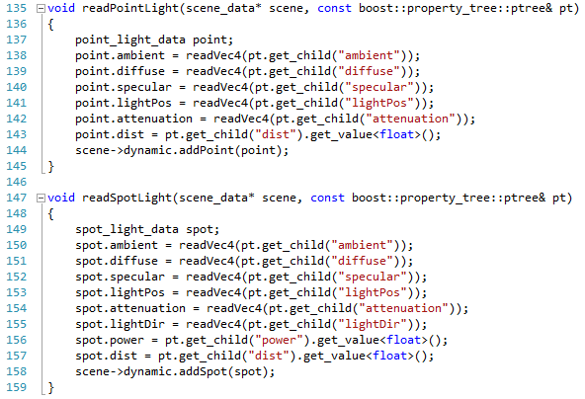

These operations are similar to the read lighting operation, so you should be able to understand what is going on. Now we need to write our operation to load the dynamic lighting:

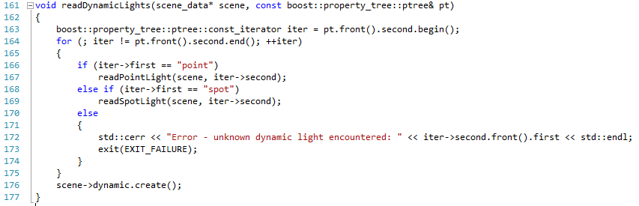

We iterate across the branch of the tree we are on (lines 163 to 164). We then either read a point (lines 166 to 167) or a spot (lines 168 to 169) and act accordingly.

### Load Scene

Finally, we are ready to define our load scene operation. Now that we have all the parts, this is actually quite easy.

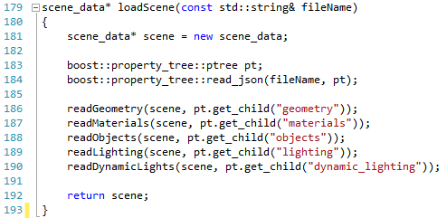

We create a new scene data structure (line 181). We then create a new property tree (line 183) and read in the given file into this tree (line 184). We then get the geometry branch and use it to read the geometry (line 186), and likewise for materials (line 187), objects (line 188), lighting (line 189) and dynamic lighting (line 190). Finally, we return the scene data (line 192). We are now ready to look at JSON files.

## JSON Files

JavaScript Object Notation (JSON) files are a common method of exchanging data between applications. It is useful as it is simple in its rules.

### Structure of JSON Files

JSON files work on a simple premise. Objects are defined within curly brackets:

We can also name our objects using a string before the definition:

$$\text{"object"}:\left\{\right\}$$

For example, we can define a sphere as follows:

"sphere":

{

"shape": "sphere",

"slices": 20,

"stacks": 20

}

We have an object called sphere, which has a sphere shape, 20 slices, and 20 stacks. We can build a hierarchy of objects quite easily.

### Checking JSON Files

One thing you will need to do is check JSON files. We haven’t built any checking into the scene code, so we should validate our JSON files before using them. This can be done using the JSONlint website, found at <http://jsonlint.com/>.

### JSON File for the Scene

The JSON file for our scene is available on Moodle. However, we will also put it here for you to analyse. You should be able to comprehend what is displayed. Try and see how the file relates to the scene code we developed. The filename is scene.json.

{

"geometry":

{

"sphere":

{

"shape": "sphere",

"slices": 20,

"stacks": 20

},

"cube":

{

"shape": "cube"

},

"plane":

{

"shape": "plane",

"width": 20,

"depth": 20

}

},

"materials":

{

"mat_001":

{

"emmisive": [0.0, 0.0, 0.0, 1.0],

"ambient": [0.1, 0.1, 0.1, 1.0],

"diffuse": [0.1, 0.1, 0.1, 1.0],

"specular": [0.1, 0.1, 0.1, 1.0],

"shininess": 2.0

},

"mat_002":

{

"emmisive": [1.0, 1.0, 1.0, 1.0],

"ambient": [0.0, 0.0, 0.0, 1.0],

"diffuse": [0.0, 0.0, 0.0, 1.0],

"specular": [0.0, 0.0, 0.0, 1.0],

"shininess": 1.0

},

"mat_003":

{

"emmisive": [0.0, 0.0, 0.0, 1.0],

"ambient": [0.0, 0.6, 0.3, 1.0],

"diffuse": [0.0, 0.6, 0.3, 1.0],

"specular": [0.0, 0.6, 0.3, 1.0],

"shininess": 1.0

},

"mat_004":

{

"emmisive": [0.0, 0.0, 0.0, 1.0],

"ambient": [0.1, 0.5, 0.5, 1.0],

"diffuse": [0.1, 0.5, 0.5, 1.0],

"specular": [0.1, 0.5, 0.5, 1.0],

"shininess": 2.0

},

"mat_005":

{

"emmisive": [0.0, 0.0, 0.0, 1.0],

"ambient": [0.2, 0.4, 0.3, 1.0],

"diffuse": [0.2, 0.4, 0.3, 1.0],

"specular": [0.2, 0.4, 0.3, 1.0],

"shininess": 3.0

},

"mat_006":

{

"emmisive": [0.0, 0.0, 0.0, 1.0],

"ambient": [0.3, 0.3, 0.1, 1.0],

"diffuse": [0.3, 0.3, 0.1, 1.0],

"specular": [0.3, 0.3, 0.1, 1.0],

"shininess": 4.0

}

},

"objects":

{

"plane":

{

"geometry": "plane",

"material": "mat_001",

"transform":

{

"position": [0.0, 0.0, 0.0],

"rotation": [0.0, 0.0, 0.0],

"scale": [1.0, 1.0, 1.0]

}

},

"sphere":

{

"geometry": "sphere",

"material": "mat_002",

"transform":

{

"position": [0.0, 2.0, 0.0],

"rotation": [0.0, 0.0, 0.0],

"scale": [0.1, 0.1, 0.1]

}

},

"cube_001":

{

"geometry": "cube",

"material": "mat_003",

"transform":

{

"position": [-2.0, 0.25, -2.0],

"rotation": [0.0, 0.0, 0.0],

"scale": [0.25, 0.25, 0.25]

}

},

"cube_002":

{

"geometry": "cube",

"material": "mat_004",

"transform":

{

"position": [2.0, 0.25, -2.0],

"rotation": [0.0, 0.0, 0.0],

"scale": [0.25, 0.25, 0.25]

}

},

"cube_003":

{

"geometry": "cube",

"material": "mat_005",

"transform":

{

"position": [-2.0, 0.25, 2.0],

"rotation": [0.0, 0.0, 0.0],

"scale": [0.25, 0.25, 0.25]

}

},

"cube_004":

{

"geometry": "cube",

"material": "mat_006",

"transform":

{

"position": [2.0, 0.25, 2.0],

"rotation": [0.0, 0.0, 0.0],

"scale": [0.25, 0.25, 0.25]

}

}

},

"lighting":

{

"ambient" : [0.0, 0.0, 0.1, 1.0],

"diffuse" : [0.0, 0.0, 0.2, 1.0],

"specular" : [0.0, 0.0, 0.5, 1.0],

"lightDir" : [1.0, 0.0, 0.0, 1.0]

},

"dynamic_lighting":

[

{

"spot":

{

"ambient": [0.2, 0.2, 0.2, 1.0],

"diffuse": [0.5, 0.5, 0.5, 1.0],

"specular": [1.0, 1.0, 1.0, 1.0],

"lightPos": [0.0, 2.0, 0.0, 1.0],

"attenuation": [0.05, 0.001, 0.001, 1.0],

"lightDir": [0.0, -1.0, 0.0, 1.0],

"power": 0.5,

"dist": 10.0

},

"point":

{

"ambient": [0.2, 0.0, 0.0, 1.0],

"diffuse": [0.2, 0.0, 0.0, 1.0],

"specular": [0.2, 0.0, 0.0, 1.0],

"lightPos": [-2.0, 2.0, -2.0, 1.0],

"attenuation": [0.01, 0.02, 0.0005, 1.0],

"dist": 10.0

},

"point":

{

"ambient": [0.0, 0.2, 0.0, 1.0],

"diffuse": [0.0, 0.2, 0.0, 1.0],

"specular": [0.0, 0.2, 0.0, 1.0],

"lightPos": [2.0, 2.0, -2.0, 1.0],

"attenuation": [0.01, 0.02, 0.0005, 1.0],

"dist": 10.0

},

"point":

{

"ambient": [0.0, 0.0, 0.2, 1.0],

"diffuse": [0.0, 0.0, 0.2, 1.0],

"specular": [0.0, 0.0, 0.2, 1.0],

"lightPos": [-2.0, 2.0, 2.0, 1.0],

"attenuation": [0.01, 0.02, 0.0005, 1.0],

"dist": 10.0

},

"point":

{

"ambient": [0.2, 0.2, 0.2, 1.0],

"diffuse": [0.2, 0.2, 0.2, 1.0],

"specular": [0.2, 0.2, 0.2, 1.0],

"lightPos": [2.0, 2.0, 2.0, 1.0],

"attenuation": [0.01, 0.02, 0.0005, 1.0],

"dist": 10.0

}

}

]

}

## Updated Main Application

Now all we need to do is update our main application. First, we need to update our variables:

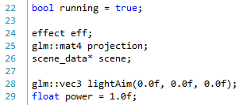

We have our effect as before, and our projection. However, now all we have is our scene data instead of all the lighting and render objects. We still have the light aim and power from before. Our initialise method is now much simpler:

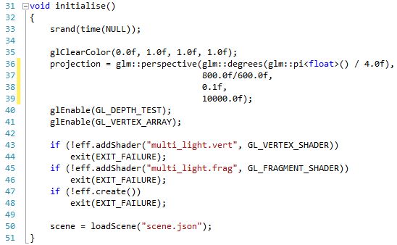

Line 50 is where we load the scene. This replaces all the previous initialise code, and makes things much easier. We need to do a quick update to our render object operation:

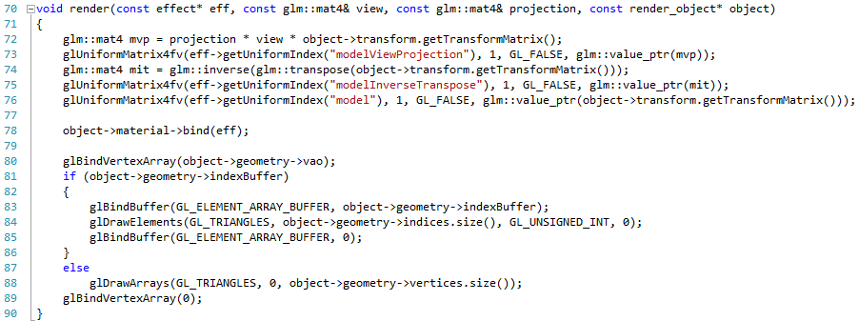

All we are doing now is working with a pointer to the render object (*) rather than a reference (&). Now, we just need to change our main render function:

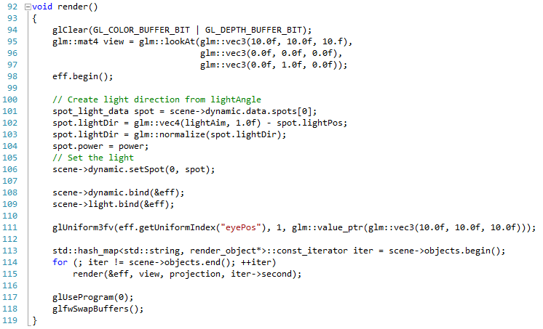

The main difference here is that we create an iterator for our render objects (line 113), iterate through it (line 114), and render each object (line 115). If you run this version of the application, you will get the following:

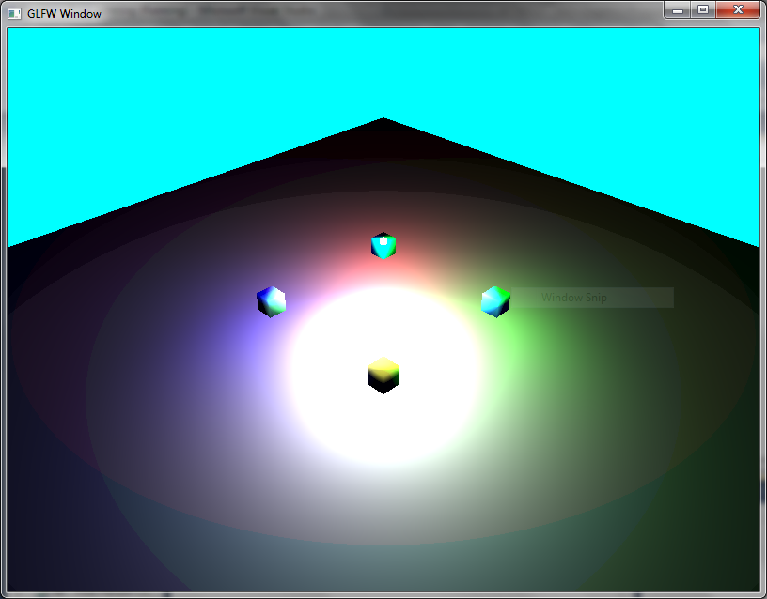

Which is the same as last time.

## Exercises

Try changing some values in the JSON file, or introducing new objects. Try and be comfortable with the file layout (although we will be updating our structure in a couple of weeks). At this point, you are now ready to build a prototype for your coursework just by manipulating the existing JSON file.

# Cameras

We now have ourselves a very simple method of loading in scenes, which makes our work far easier from now on. We are going to digress from our work on shader development for a while, and do some work with cameras.

## What Do We Mean by Cameras?

A camera is just a convenient method for us to discuss the concept of the viewer for a scene. We have been working with these concepts for a long time – we set up a view matrix using eye position, view angle, etc. What we want do is have an approach that lets us have some standard cameras that we can reuse to explore our scenes. Over the next few lessons, we will build a set of standard cameras. We will use methods to move the eye position, rotate our angle of view, and other more specific methods.

The following two images, taken from Real Time Rendering [3], should help you see what we are essentially doing:

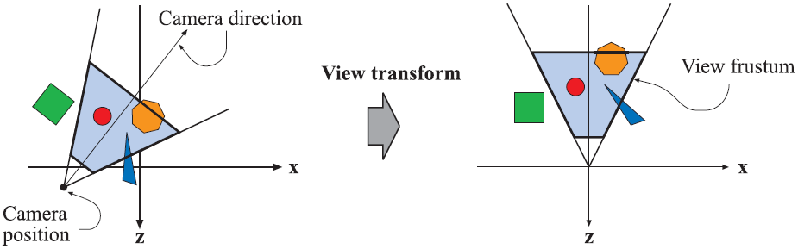

This image shows how we can view a camera. We have the position and the direction (or camera target). This helps define what is known as a view frustum, which can be considered the camera space or view point.

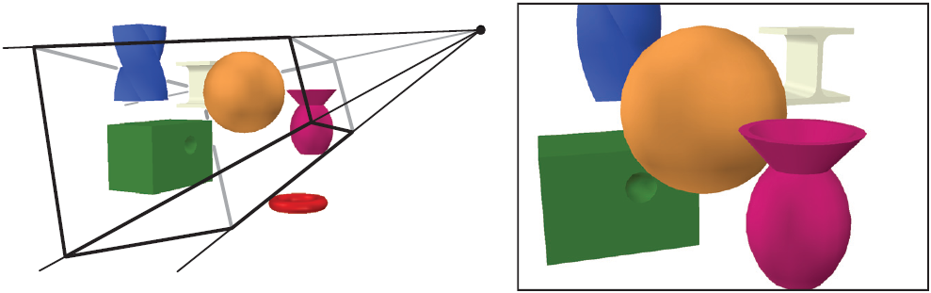

This second image shows how the view from the camera is transformed into a 2D image. There are items that can be seen and not seen. The final render is based on what is in the viewpoint of the camera.

## Why Do We Need Cameras?

The big reason we are building cameras is to allow us to generate our view and projection matrices easily, and use them in our shaders. This will make our life much easier.

# Camera Class

Let us look at our basic camera class. This goes in camera.h:

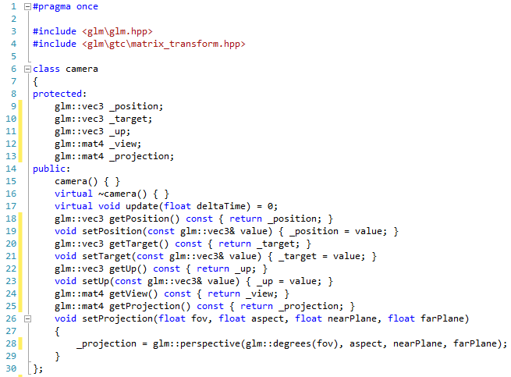

We have that standard properties we have been using to create our view matrix. We have the position, target and up vectors. We can get and set these properties appropriately. We also define a virtual update method (line 17). This is a method we will define in each camera, which will have the responsibility of building the view matrix. Everyone else is straight forward. We will look at implementing some cameras over the next few lessons.

## Exercises

No exercises just yet, as we can’t do anything. We will do some work over the next few exercises.

# Target Camera

The first camera we are creating is the simplest – a target camera. A target camera is just a simple camera that points at a particular target. We can adjust the position and target, but really the point is that it is a static camera.

## Target Camera Definition

The class definition for our target camera in camera.h is as follows:

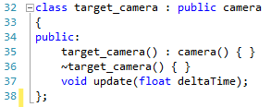

So we aren’t really adding anything. All we need to do is implement the update method.

## Target Camera Implementation

You will need to add a camera.cpp file. It has the following initial code:

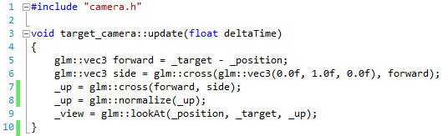

There is only one operation we need to do – that is calculating the up vector (or the way the camera is oriented). We do this by calculating the forward vector (line 5), which is just the target minus the position. We then calculate the side vector from this vector and the standard up direction (line 6). We do this doing the cross product, which means the side vector is perpendicular to the forward and up vector. We then use the cross product to calculate the actual up vector from the forward and side vectors. This up vector will be perpendicular to the forward vector and side vector. Finally we normalise the vector (line 8) and use it to generate the view matrix (line 9).

## Updating Main

Let us now update our main application to use our target camera. First, we need to change the variables for the main application:

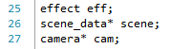

We now have a camera object. We will set up our camera object in the initialise method:

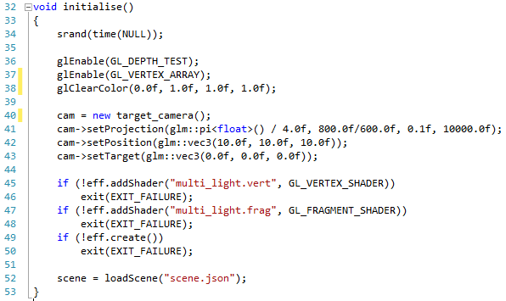

The new code is on lines 40 to 43. All we do is create the camera object (line 40), create the projection matrix (line 41), set the position (line 42) and the target (line 43).

We need to change our update method to the following:

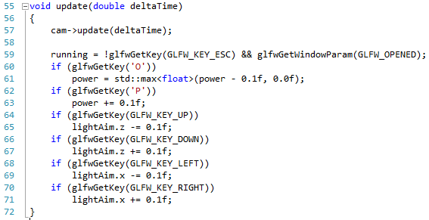

The new line is really just line 57, where we call update on the camera. The only other change we need is to our main render operation:

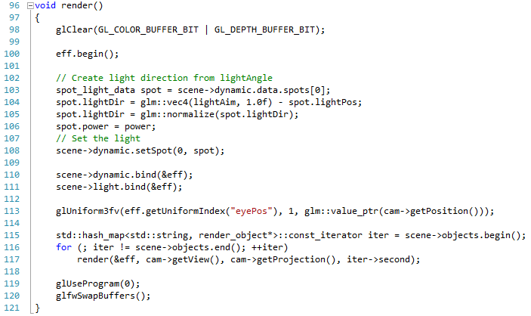

The only change is line 117, where we use the camera to get the view and the projection matrices. If you run the application, you will see the following:

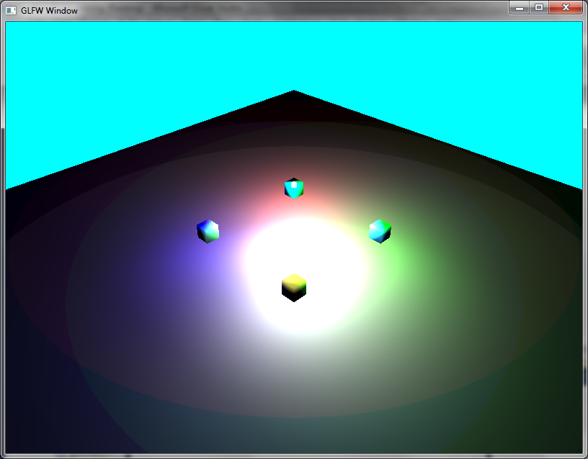

Which is no real difference than before – we are just using our camera object now.

## Exercise

Try and change the position and target of the camera to get different views of the scene, and so that you understand the operation of the camera.

# First Person Camera

Our next camera is a bit more interesting – a first person camera. This camera type allows free movement by allowing us to rotate around and move forward in the direction we are facing. This is the standard camera used in first-person shooter type games. The code for this is actually quite trivial.

## First Person Camera Definition

The first person camera definition in camera.h is as follows:

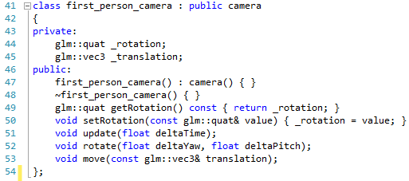

Our first person camera has a rotation (to create the orientation it is facing), and a translation (how much it has moved since the last update). We provide a method to get and set the rotation (lines 49 and 59), as well as methods to rotate the camera (line 53) and move the camera (line 53).

## First Person Camera Implementation

We have three methods to implement for our first person camera, the update, the rotate and the move. We will look at the update first:

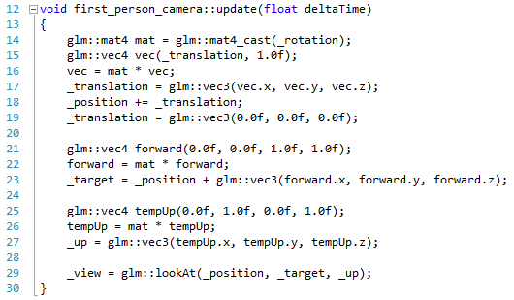

First, we create our transformation matrix from our rotation quaternion (line 14). We then create a 4-dimensional vector from the translation (line 15) and then multiply this by our transform matrix (line 16). This converts our translation vector so that it moves in the direction we are facing. We then use this newly calculated value to modify our position (lines 17 to 18). We do the same idea of transforming for the forward vector (lines 21 to 22), which we use to calculate the target (line 23). We also do the same translation approach for up (lines 25 to 27). Finally we can generate the view matrix (line 29).

Our rotate and move methods are as follows:

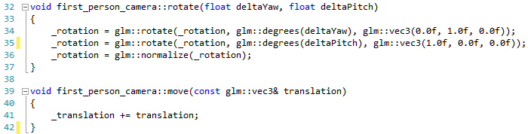

The rotate method simply takes the delta values for the yaw (rotation around the Y-axis) and the pitch (rotation around the X-axis) and modifies the rotation quaternion accordingly. The move method simply adds the incoming translation to the existing translation.

## Updating Main

First, we need to modify our camera variable at the top of the file:



We then need to initialise this in the initialise method:



Finally, we need to modify our update method so we can move the camera:

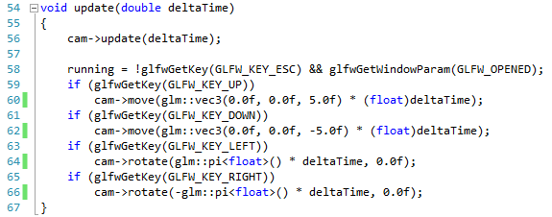

We use up and down to move forward and back, and left and right to rotate the camera. If you run the application, you will see that you can move around the scene.

## Exercise

Can you update the controls so you can rotate around both axes, and also move in four directions (forward, back, left and right)?

# Arc Ball Camera

Our next camera is an arc-ball camera. This is a camera that faces a particular target, but allows us to rotate around it as well as zooming in and out. Therefore, it operates as a target camera, but with some extra controls.

## Arc Ball Camera Definition

The definition for the arc ball camera class in camera.h is as follows:

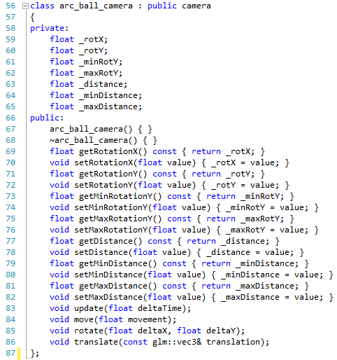

We maintain seven attributes:

1. rotX – the amount of rotation around the x-axis the current camera has
2. rotY – the amount of rotation around the y-axis the current camera has
3. minRotY – the minimum amount of rotation around the y-axis the camera can have
4. maxRotY – the maximum amount of rotation around the y-axis the camera can have. These two values essentially clamp the amount of rotation around the y-axis the camera can make
5. distance – the current distance of the camera from the target
6. minDistance – the minimum distance the camera can have from the target
7. maxDistance – the maximum distance the camera can have from the target. These two values essentially clamp the distance the camera can be from the target

The majority of the methods of the class allow the manipulation of these values, apart from the usual update, move, rotate and translate. We will look at these operations in the implementation.

## Arc Ball Camera Implementation

The implementation of the arc ball camera is as follows:

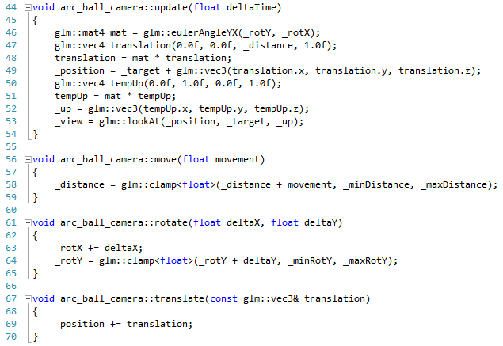

The only real method worth analysing is the update. However, we can see that this follows the same pattern as previous update methods.

## Updating Main

Our main needs just a few changes. First, we need to modify the camera attribute we are using:

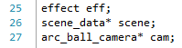

The updated line is line 27. We also need to create this camera in the initialise operation:

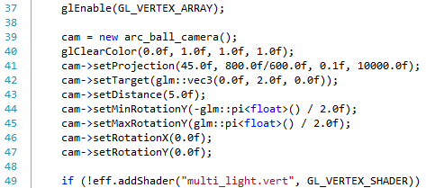

Lines 39 to 47 are the new ones. Notice that we set the target to the same position of the sphere. All we need to do now is modify the update method:

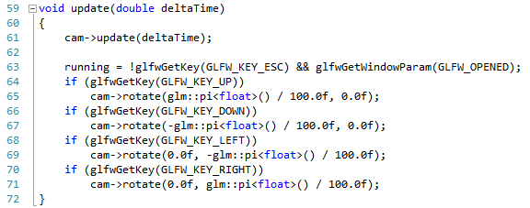

We use the cursor keys to rotate the camera (you could add controls to modify distance as well if you like). If you run the application, you will get something like the following:

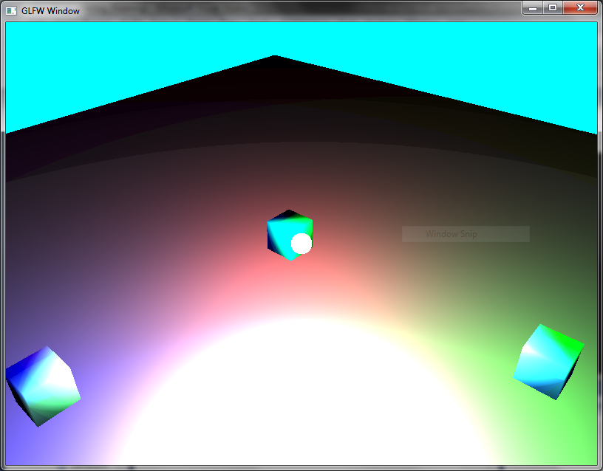

## Exercise

Can you add controls to move the sphere around (for example, using WSAD) but with the arc ball camera remaining targeted on the sphere. You should also update the spot light position (since it is related to the sphere).

# Chase Camera

The final camera we will implement is a chase camera. The chase camera is what is sometimes referred to as a third person camera. It shares similarities to the arc ball camera, but implements some extra functionality to provide a spring like feel to the camera as it moves.

## Chase Camera Definition

The definition of the chase camera in camera.h is as follows:

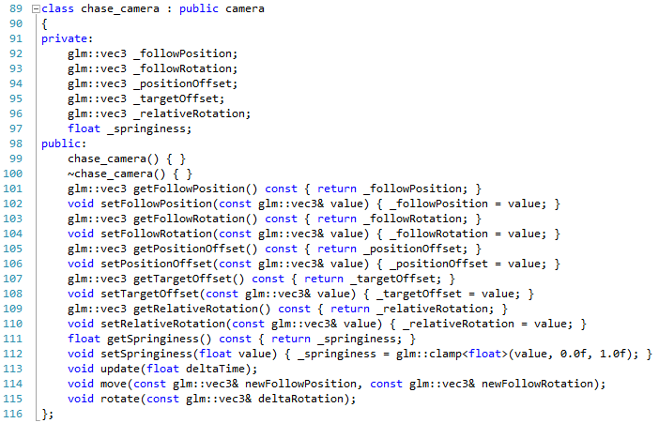

The chase camera has six attributes:

1. The position of the target being followed
2. The rotation of the target being followed
3. The offset of the camera’s position to the target’s position
4. The offset of the camera’s actual target view to the follow target’s position
5. The rotation of the camera in relation to the target being followed
6. The springiness effect of the camera as it moves

The operations allow the getting and setting of these values, with update, move and rotate operations.

## Chase Camera Implementation

The implementation of the chase camera in camera.cpp is as follows:

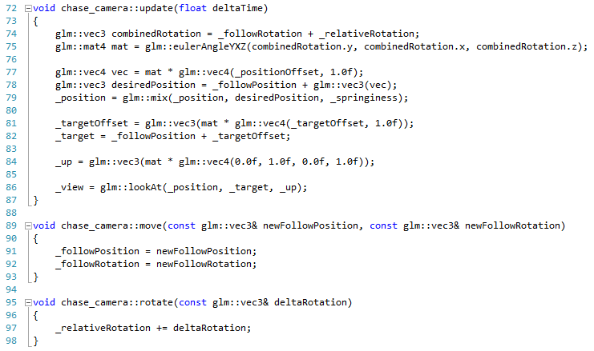

The update method is the only one we need to look at. First, we combine the rotations (line 74) and use this value to generate a rotation matrix (line 75). We then use this to transform the position offset (line 77), and use this value added to the follow position to determine the desired position of the camera (line 78). Finally, we use the mix operation between position and the desired position to determine the new position. Mix is a linear interpolation operation, thus a value between position and desired position is chosen based on the value of springiness – 0.0 being position, 1.0 being desired position, and the values between defined linearly.

To determine the target, we transform the target offset by the rotation matrix (line 81), and then add this to the follow position (line 82). Finally, we generate the up vector by transforming the standard up vector (line 84) and then finally generate the view matrix (line 86).

## Updating Main

To update main, we first need to change the attributes:

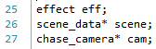

The updated line is line 27. Then we need to update the initialise method:

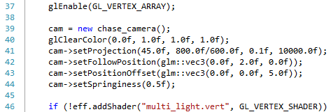

Lines 39 to 44 are the new ones. Finally, we update the update operation:

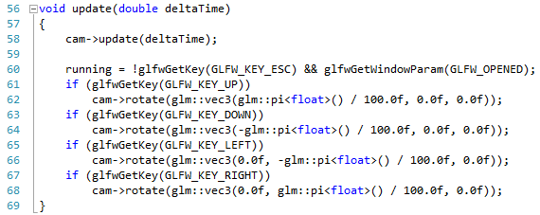

If you run the application you will get the following:

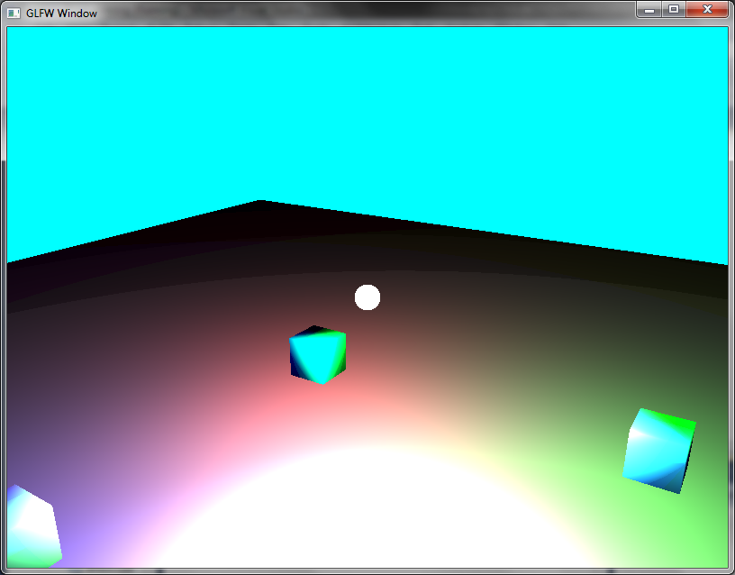

## Exercise

Repeat the exercise from lesson 61 for the chase camera. You will have to think a bit differently for this one.

# Challenge – 3D Sierpinski Gasket 2

This challenge should be relatively easy. You should create a scene using the Sierpinski Gasket (you will have to modify the JSON file). Your scene should use the four cameras we have just defined. You can use the number keys 1 to 4 to switch camera. You will also have to modify the update to allow the different cameras to be used. Explore the scene accordingly using your four cameras.

# Texturing

We have come a long way and developed quite a substantial rendering framework. The one element we are missing in our system is the use of textures to give our objects more detail. Before moving onto how we implement texturing, we will first look at how texturing works.

## What is Texturing?

Texturing is the process by which we apply some form of image data to our surfaces to provide more detail. For example, we can consider a wall as just a simple geometric plane. If we attach a brick texture to the wall, all of a sudden the wall looks far more realistic. If we change the texture to that of a wooden wall, we completely change the look of the wall, but at no extra cost.

Texturing is basically the third part of what can be considered core 3D rendering requirements. The three are:

* Geometry
* Lighting
* Texturing

## How Do We Texture?

Texturing a piece of geometry requires more data to be sent to the GPU. What we need to do is send texture coordinates along with our texture data. But what are texture coordinates? Let us take a look at a typical 3D model and the texture used on it.

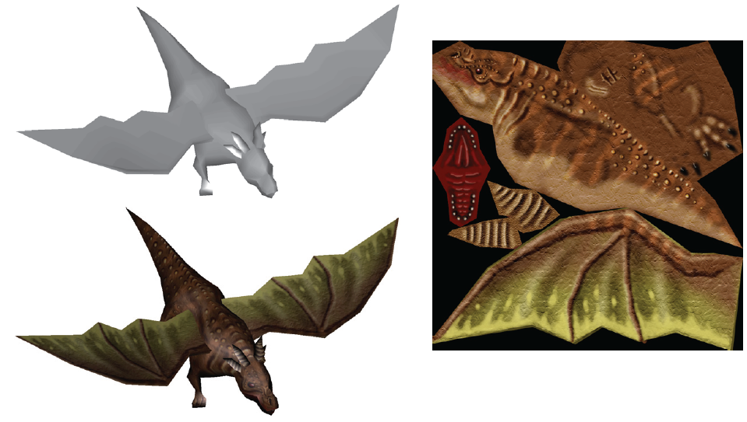

We can see that the texture used on the model looks set out in a manner not useful for just displaying an image of a dragon. What we need to do is work out which parts of the texture attach to which parts of the model. This is where texture coordinates come into effect.

Each of our vertices can have texture coordinate information attached to them. These coordinates are 2D vectors which relate to a position on the texture, ranging from $<0,0>$ to $<1, 1>$. We use these coordinates to create triangles of the texture to attach to the model’s triangle. The fragment shader then uses these coordinates to determine our final pixel colour.

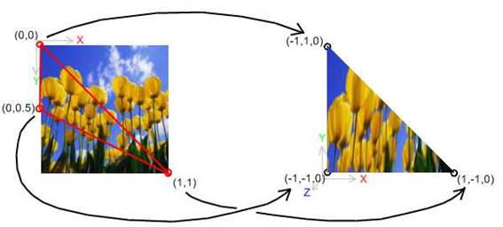

Texturing can be thought of as wrapping the particular texture around the defined geometry – almost like wrapping it in paper. This isn’t quite true, and we are doing mapping rather than mapping. Each defined piece of our geometry will have a piece of the final image attached to it. The GPU can easily work out the required piece of the image and place it on the geometry.

We are going to cover a few other parts of the texturing pipeline over the next few lessons. However, at the moment let us get acquainted with a new library to allow us to load images – the Developer’s Image Library (or DevIL).

# Getting Started with DevIL

OpenGL doesn’t really understand the different image formats that we might want to load, much like it doesn’t really understand matrices and other mathematical functions that we use GLM to provide. OpenGL does understand the concept of a block of memory representing a collection of colours, so what we have to do is go from an arbitrary image format to this memory representation. That is where DevIL comes in.

## Getting DevIL

DevIL can be downloaded from <http://sourceforge.net/projects/openil/>. You should be familiar enough with setting up libraries by now to get everything to work. If not, then ask.

## Testing DevIL

We need to write a small application to test whether DevIL is working. The most basic application is as follows:

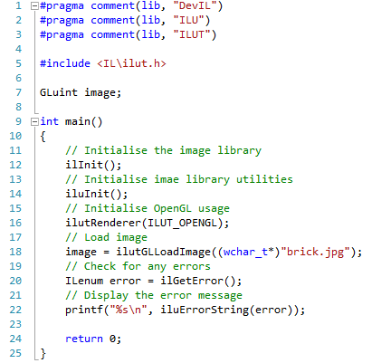

We have a few new pragmas defined at the top of the file. There are three libraries in total being used for DevIL. On line 5 we also define the header we are using.

We have one attribute – a GLuint called image (line 7). Textures in OpenGL are just buffers, and therefore they are numbered accordingly. Recall that we used GLuint to define our other buffer objects as well.

There are a number of stages to using DevIL. First, like GLFW and GLEW before it, we need to initialise DevIL (line 12). We also need to initialise DevIL’s utilities (line 14). Finally, for initialisation, we also need to tell DevIL what type of renderer we are using (line 16). The one advantage of DevIL is that we can use it in DirectX as well if we like.

We are now ready to load an image. This is done using the ilutGLLoadImage operation (line 18). This actually takes care of a lot of behind the scenes operations which we will need to use later. For the moment however, ilutGLLoadImage is sufficient. Also notice that we have to do a weird cast of our filename to a wchar_t*. wchar_t is a 16 bit character type, rather than the standard 8 bit characters that C/C++ supports. We have to do this here as the way the library was built was possibly a bit incorrect – requiring us to change the type of the characters (but not really). You should also download an image of your choice, and change the filename on line 18 accordingly. The file will have to sit in your main project folder.

Finally, we check for any errors (line 20) and print if there are any (line 22). To run this program, use **Debug 🡪 Start Without Debugging** to see if any errors occur. Hopefully you get no error message. If you do, try and fix the problem or ask for help.

# Texture Coordinates

We are now ready to try and texture an object. You will need your rendering framework as it stands at the moment, although we will be changing our main a bit for the following couple of lessons. Our goal here is to add texture coordinates to our box, and work from there.

## Updating Geometry

The first thing we need to do is update our geometry.h file so that the geometry struct definition supports texture coordinates. Our updated geometry struct is as follows:

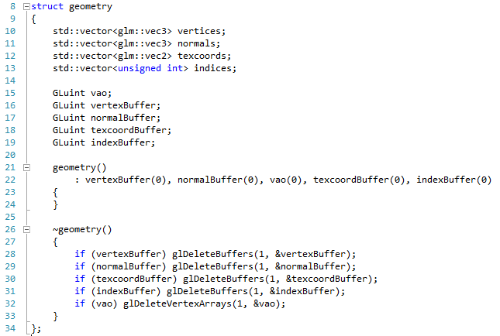

We have now added line 12, a new vector of type vec2 of that will store our texture coordinates. We also add a buffer to store our texture coordinates (line 18), initialise it to 0 in our constructor (line 22), and also ensure that we delete it when we are finished with it (line 30). Let us now consider how we fill in texture coordinates for our box.

## Updating Box Creation

The first thing we need to do is add texture coordinates for our box. Let us define these along with the other box values in geometry.cpp:

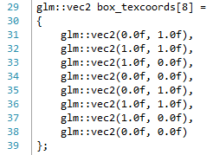

If you compare these to our eight vertexes defining our cube, you should see how we attempting to texture the object. You might also see a problem. We will look at this later.

Now we need to modify create box so that it fills the texcoords vector we defined in geometry. Our new createBox operation is as follows:

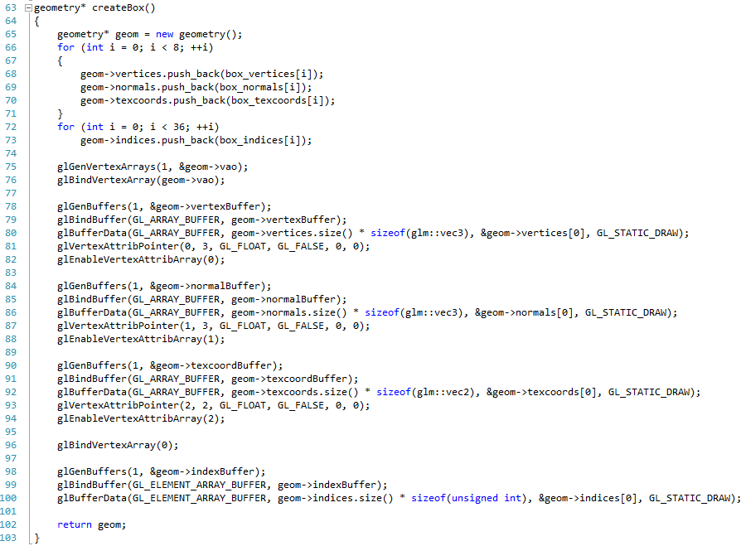

On line 70 we fill in the texture coordinates. This should be fairly straight forward. The other new lines are just 90 to 94. We generate a buffer (line 90), and bind it for use (line 91). We then define the buffer data (line 92) and then set up the attribute pointer (the channel into the shader we send the data) as 2, and enable this channel.

## Updated Material

We are going to store our texture information in our material structure. This is the standard method of storing textures – they form part of the material of the object. We therefore need to update our material struct in material.h:

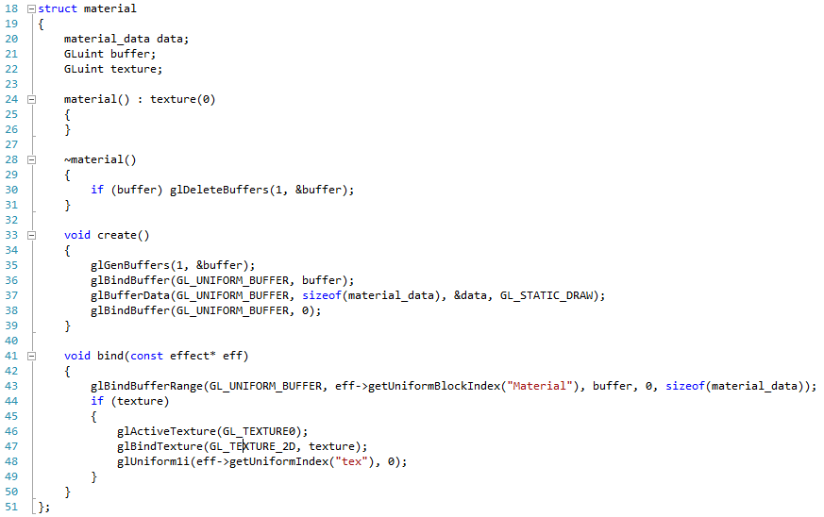

There are a few new items here. Firstly, we add a new attribute, texture (line 22), to store the texture buffer. We set this to 0 in the constructor (line 22). These are the obvious parts.

We have also updated our bind method. On line 44 we check to see if there is a texture (in other words, texture is a value other than 0). If there is, we set the active texture (line 46) as GL_TEXTURE0 (we can have GL_TEXTURE1, GL_TEXTURE2, etc.). We then bind our texture (line 47) using GL_TEXTURE_2D. The interesting new line is 48. Here, we are binding a uniform of type 1i (single integer). We then get the uniform index for a uniform called tex (where we are storing the texture in the shader we will write), and using the value 0. 0 here relates to the GL_TEXTURE0 value. We have bound the texture to 0, and then associated texture 0 with the tex uniform in the shader. If we had used GL_TEXTURE1, we would use 1, etc. This means we can apply multiple textures in a shader if we wish (and we will do in a few lessons times).

## Texture Shader

Let us now look at the shader we will use for texturing. We will look at each shader part in turn.

### Texture Vertex Shader

Our vertex shader has no real work to do, and just looks as follows:

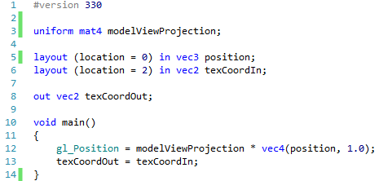

This is a very minimal shader. We only have the modelViewProjection matrix (line 3) as a uniform. We take in two values – the position on location 0, and the incoming texture coordinate of location 2. Our only outgoing value is the texture coordinate. Our main operation simply sets gl_Position, and then just sets the incoming texture coordinate as the outgoing coordinate.

### Texture Fragment Shader

The fragment shader is where more work actually takes place:

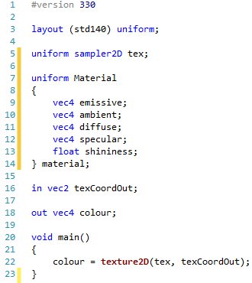

The interesting new line initially is line 5 where we define a new uniform. The uniform has type sampler2D. This is how a texture is referred to in a shader. We use it to take samples of colours from. We have our incoming texture coordinate (line 16), and we use this in a new GLSL operation, texture2D (line 22). texture2D takes a sampler (the tex part) and extracts a colour from it using the relevant texture coordinate. This is the standard method to extract colour from the texture.

## Updating Main

We are now ready to update our main application. First of all, make sure that the top of your main file looks like this:

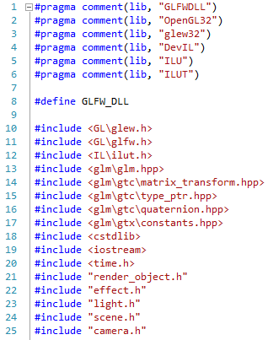

The order of the header includes is important. This is the final time we will ever change our headers until the last week where we work with models.

The main attributes we will have is as follows:

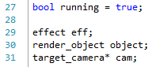

We only have an effect, a render object, and a target camera. Now let us look at our initialise:

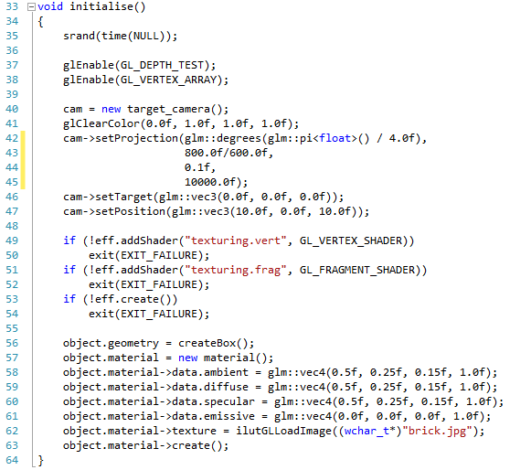

We have changed slightly here at the bottom (lines 56 to 63). Instead of using the scene file, we are creating the geometry ourselves. This is to make our life a bit easier. Notice on line 62 we use the ilutGLLoadImage to load a texture (you might want to change the name here).

We simplify our update to just let us rotate our object:

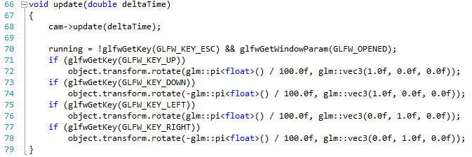

We also simplify our object render method:

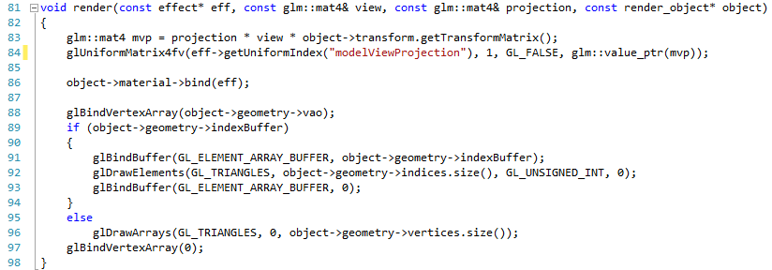

And our main render:

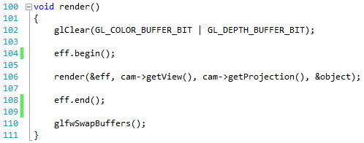

And finally our main operation:

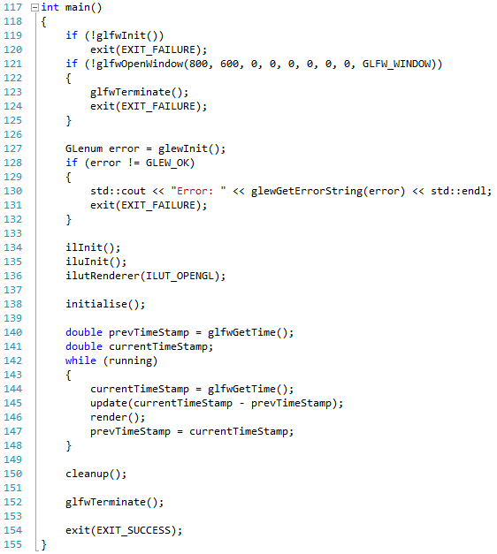

We have just added the three lines to initialise DevIL here (lines 134 to 136). The changes to main we will be reversing when we look at loading textures in our scene files. If you run this application, you will get the following:

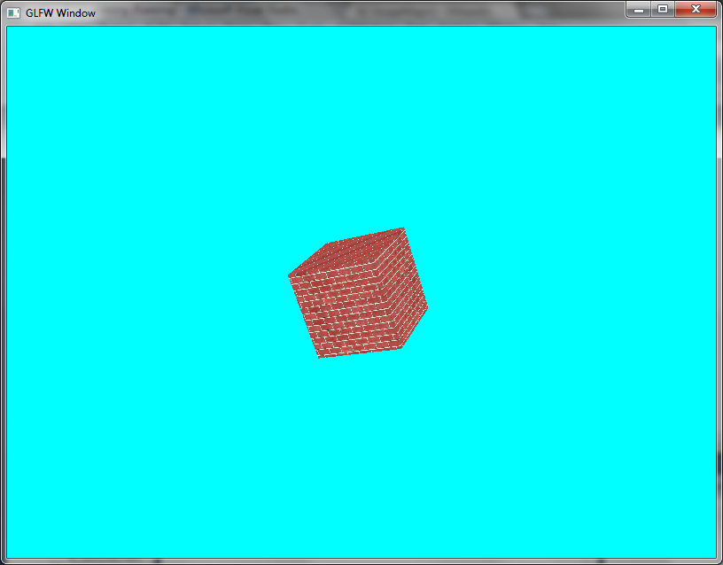

Which does look pretty horrendous. We will get round to fixing this in a few lessons time.

## Exercise

Try loading different image types and seeing what you various textures look like. There are different qualities of textures, and they have different effects on your final image.

# Better Box Texture Coordinates

If you rotated the box around enough in the previous lesson you will have noticed that the top and bottom of the box looked a bit weird. This is because we are sharing the texture coordinates across our eight vertexes. If you consider how we defined our texture coordinates, the top of the box had a triangle with texture coordinate <1, 1>, <0, 1>, <0, 1>. That doesn’t seem right. Let us try and fix this by modifying our box definitions.

## New Texture Coordinates

The problem we are having is caused by our use of indexing. Indexing itself isn’t a problem – it is good to reuse data. However, bad indexing can cause issues with texturing such as we have seen. We will have to adopt a slightly different approach for creating our box. First, modify the texture coordinates to the following:

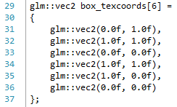

Now we only have six – the six that are required to make the two triangles that define a side. Next, we have to change our createBox operation to the following:

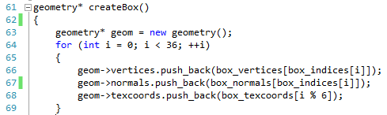

This is only the top part of the code. The rest of the code remains the same **EXCEPT** you need to remove the part which creates the index buffer. We don’t need that anymore.

We are now defining our box differently. We loop round the 36 possible vertexes (six sides, two triangles per side, three vertexes per triangle), and push the following data into the vectors:

* The vertex indicated by the box index at the current value of i. This is just like looking at the index buffer and picking out the right vertex position.
* The normal indicated by the box index at the current value of i.
* The texture coordinates of i % 6. This means we pick texture coordinates 0, 1, 2, 3, 4, 5, 0, 1, 2, 3, 4, 5, 0, … In other words, for each face of the cube, we pick the six texture coordinates in order.

If you run this version, you will see the following:

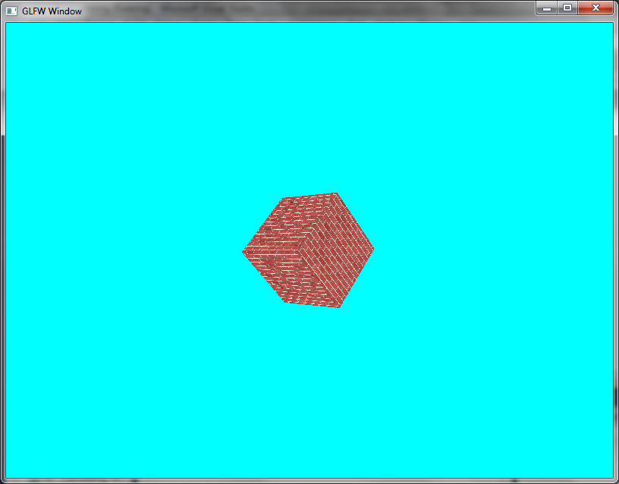

OK, it still looks terrible, but at least the top and bottom are fixed.

# Textured and Lit

# Multiple Shader Files

# Calculating Texture Coordinates

# Textured and Lit Scene

# Multi-texturing

# Blended Textures

# Mipmaps

# Anisotropic Filtering

# Texture Class

Shader class

Texture class

# Error Handling

# Refactor Time 2

# Tiled Texturing

# Dissolve Shader

OpenGL superbible 6.15

Dissolve in and out

# Cell Shading

OpenGL SB – texels (after dissolve)

Exercise – general solution for colours

# Cube Maps

# Skyboxes

# Reflective Skybox

# Tarnished

OpenGL SB 7.6

# Point Sprites

OpenGL SB

# Framebuffer Objects

# Renderbuffer Objects

# Texture Buffer Objects

# Post-processing

# Outputting to Memory

# Your First Post-process – Greyscale

# Using gDebugger

# Your Second Post-process – Blur

# Masking

# Normal Mapping

# Displacement Mapping

# Shaders in Scene Files

# Procedural Texture Generation

# Challenge – Checked Texture

# Terrain

# Water Effects

# Stencilling

# Shadowing

# Shadow Maps

# Meshes

# Procedural Mesh Generation

# Mesh Hierarchies

# Transforming Meshes

# Loading OBJ Models

# Using AssIMP

# Picking

# Frustum Culling

# Particle Effects

# Geometry Shaders

# Instancing

# Procedural Content

# Soft Body Effects

# Scene Graphs

# OpenGL Frameworks – Using OpenSceneGraph

# Spatial Partitioning

# Ambient Occlusion

# Fractals

# Noise

# Havok

# Scripting with Lua

# Tessellation

# Animation

Slerp quaternions

# Ray Tracing

# Volumetric Rendering

# Marching Cubes

# OpenCL

References

[1] D. Shreiner and E. Angel, *Interactive Computer Graphics: A Top-Down Approach with Shader-Based OpenGL*, 6th ed. Pearson Education, 2011.

[2] E. Lengyel, *Mathematics for 3D Game Programming and Computer Graphics*, 3rd Revised ed. Delmar Cengage Learning, 2011.

[3] T. Akenine-Moller, E. Haines, and N. Hoffman, *Real-Time Rendering, Third Edition*, 3rd ed. A K Peters/CRC Press, 2008.